Workplace Based Assessment

Initial Accreditation Submission




  - A template for submitting a request for workplace based assessment accreditation with the Australian Medical Council.

January 2026

Contents

Contents 2
Figure 1: Application for initial accreditation as a WBA provider 1
Fees for accreditation assessment 2
How to use this template 2
Organisation Details 4
Verify this report has been reviewed 4
Summary information on the proposed program 5
Provider response to accreditation standards - Standard 1: Context 6
Standard 2: Independence 9
Standard 3: Selection of candidates for WBA programs 10
Standard 4: Workplace Based Assessment plan, methods and blueprinting 11
Standard 5: Standard of the assessment and outcome of assessment 19
Standard 6: Reporting and recording procedures 21
Standard 7: Selection, training and calibration of assessors 24
Standard 8: Review and Evaluation 28
Standard 9: Annual reporting 29

About the process

Figure 1: Application for initial accreditation as a WBA provider
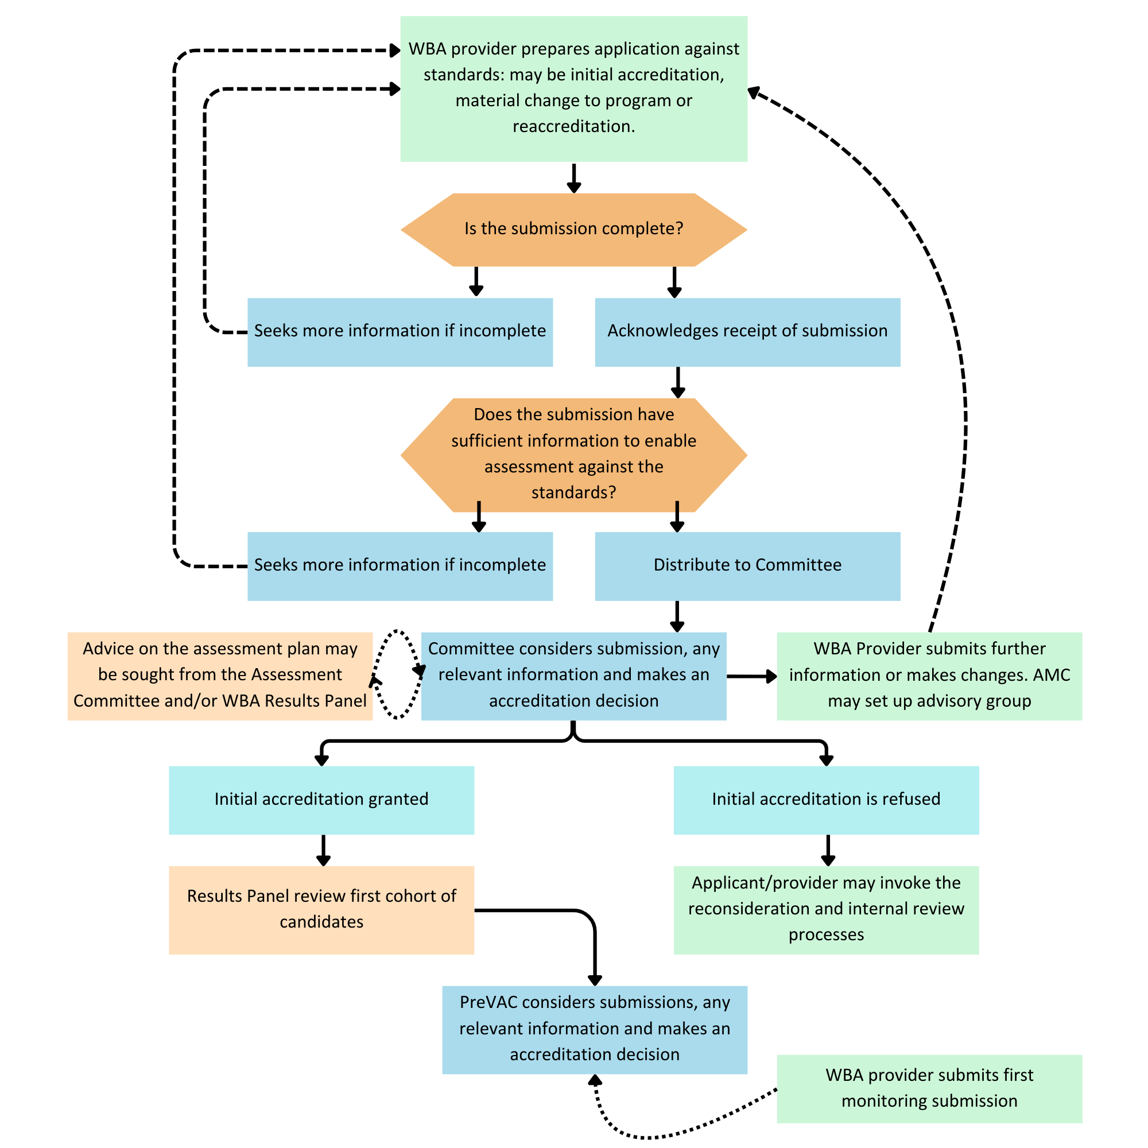The assessment of the WBA program detailed in this submission will follow the process set out in the Standards and Procedures for Accreditation of Workplace Based Assessment Providers, Part B: Procedures for AMC accreditation of WBA providers.
The AMC asks organisations intending to seek accreditation as a WBA provider to advise the AMC early of their intentions so the Prevocational Standards Accreditation Committee can give general advice on the accreditation standards and the AMC can complete all the accreditation steps before the program is scheduled to begin. The AMC expects to receive notification of an organisation’s intention when WBA program planning begins and at least nine months before implementation.
The organisation seeking accreditation lodges a submission addressing the standards for accreditation, stating the proposed locations, the length of the program and the proposed candidate numbers, and describing the assessment plan.
The Prevocational Standards Accreditation Committee assesses the application against the accreditation standards. The Committee may seek advice from the Assessment Committee Chair and/or the AMC WBA Results Panel on the assessment plan.
The AMC may decide that an advisory group should be established. Any written advice will be provided by the Prevocational Standards Accreditation Committee not the advisory group.
The AMC will not grant initial accreditation of a new provider and program unless the applicant can provide access to assessment in all required clinical areas.
The Committee makes a decision on accreditation of the provider and its assessment plan.
This template sets out the information required of Workplace Based Assessment providers seeking initial accreditation with the Australian Medical Council (AMC).

Fees for accreditation assessment
The AMC undertakes accreditation assessments on a cost recovery basis. The initial charge for an accreditation assessment of a new WBA provider is $2,500 (Excl. GST).
Additional charges may apply if the AMC needs to provide additional advice to the provider. See section B8 of the AMC Accreditation of Workplace Based Assessment Providers: Standards and Procedures.
Once a provider is accredited, there is an annual monitoring of $1,000 (Excl. GST).
Reference documents
Standards and Procedures for Accreditation of Workplace Based Assessment Providers

How to use this template
This template has two main sections
Summary information on the proposed program
This section provides an overview of the intended program.
Provider response to accreditation standards
This section requests information under each standard as relevant specific to the individual provider about its proposed WBA program and arrangements to implement it. Under each standard, the AMC provides guidance on the types of evidence that should be provided in order to address the standard.
How to submit this report
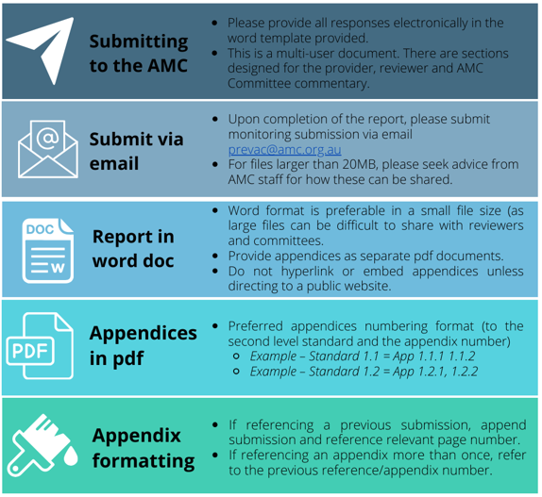
Please submit the report electronically via email to prevac@amc.org.au. Guidance on submission is provided in the following image.
Seek advice from AMC staff
If you have any questions about the information required, please contact Tahlia Christofersen.
Tel: (02) 6270 9707 Email: prevac@amc.org.au

Organisation Details

Provider Name:
Address:
CEO/Executive staff member name and position:
Telephone number:
Email:

Officer to contact concerning the report:
Telephone number:
Officer to contact concerning the report:
Telephone number:
Email:

Information for display on the AMC website once accredited:
Locations:
Contact Name
Contact Role:
Phone:
Email:
Website:

Verify this report has been reviewed
Program director/executive staff responsible for the WBA program | I verify that the information presented to the AMC is a complete and accurate response to the standards.  ☐ Check box to verify

Summary information on the proposed program

Information requested | Provider response
Program Lead:
Evidence of permission to engage in the provision of WBA program in the relevant health service(s):
Length of program:
Location(s) of program:
Planned program cohort intake:
Planned cohort start dates:
Planned size of initial cohort:
Planned maximum size of cohorts in the next 5 years:
Planned employment level of candidates:
Planned number of assessors for the initial cohort:
Planned number of assessors for the initial cohort:
Planned candidate fee (excl. GST.):

Provider response to accreditation standards - Standard 1: Context
Standard 1 | Response should include the following details as well as any other information relevant to the standard | Provider response | Documents to be appended.  Please also reference any additional relevant attachments. | AMC Commentary | Finding
1.1 The provider is an organisation with appropriate governance structures, expertise and resources to conduct WBA and manage a WBA program, including designated responsibility for:  - the selection and appointment of eligible candidates;  - the selection, training and calibration of assessors;  - the selection of patients and case records for assessment;  - the assessment blueprinting process;  - awarding provisional results;  - management of relevant records including candidate records and records of relevant committee meetings. | Provide a brief description of the organisation seeking accreditation as a WBA provider, including its purpose, and profile. Provide evidence of permission to engage in provision of the Workplace Based Assessment program in the relevant health service(s). Provide the most recent annual financial report of the provider (or a weblink to the report) as evidence of resources to conduct WBA. |  | Att 1.1a Annual report
 | Describe the provider’s governance structures and functions for WBA and indicate how these link to the overall governance structure. Who has authority and responsibility for the planned WBA program? |  | Att 1.1b Governance Chart showing names and titles of key responsibilities.
 | List the committees and or individuals responsible for the following WBA program-related functions, indicate whether these are new committees and/or individuals or existing structures/staff with changed roles:  - the selection and appointment of eligible candidates,  - the selection, training and calibration of assessors,  - the selection of patients and case records for assessment,  - the assessment blueprinting process, awarding provisional results and  - the management of relevant records including candidate records and records of relevant committee meetings. |  | Att 1.1c Terms of reference for each relevant committee.
 | Describe the expertise and resources available both in the provider and sourced externally to implement a WBA program that satisfies the AMC accreditation and assessment requirements. Critically review the adequacy of these resources. Include in this review whether these resources also support other teaching, training and supervision of medical students or junior medical staff.
 | If the provider has accreditation for PGY1 and PGY2 training, summarise any accreditation conditions or provisos on the provider, and provide a copy of the most recent accreditation decision.
1.2 The provider has defined the types of positions for which it will conduct WBA (e.g. hospital and/or GP positions). | Provide a description outlining the planned rotations for individual candidates demonstrating the breadth of assessment across the required clinical areas and domains and the health service location of the assessments (this could be provided in a table as an attachment) |  | Att 1.2 Planned candidate rotations
1.3 The provider has ongoing capacity to conduct WBA, demonstrated by adequate resources and support from the sponsoring health services for the WBA program.  Note: A new provider should have evidence of permission to engage in provision of the Workplace Based Assessment program in the relevant health service(s) and be able to present a budget demonstrating adequacy of resources. | Provide your analysis of the financial resources necessary to implement and sustain the program, and your risk assessment of your capacity to sustain the program financially.  Some programs have faced challenges in securing sustainable resources. How will your WBA program be funded? Will the candidate fee revenue cover all costs or are program management, assessor time or other costs funded fully or partly by your health services? |  | Att 1.3 Financial summary
1.4 The provider works effectively with the Medical Board of Australia/AHPRA, and has partnerships with its own stakeholders including employers and recruiters as relevant to ensure that: * stakeholders are aware of, and accept responsibilities for, their various roles to support workplace based assessment; * the responsibilities for leading interactions between the stakeholder and the WBA provider are stated. | Provide evidence of working with the Medical Board of Australia/AHPRA, and partnerships with stakeholders including employers and recruiters addressing:  - how stakeholders are informed of their various roles to support workplace based assessment and their acceptance of these responsibilities will be confirmed  - the responsibilities for leading interactions between the stakeholder and the WBA provider.
1.5 The provider has an appropriate profile of professional and administrative staff to manage the WBA program. | List the profile of professional and administrative staff to manage the WBA program. For each staff member list the major functional area and area of work, as well as the FTE to be devoted specifically to the WBA program. |  | Att 1.5 List of staff including FTE to be devoted specifically to the WBA program
1.6 The provider has processes to ensure that the duties, working hours and supervision of candidates, balanced with the requirements of workplace based assessment are consistent with the delivery of high quality, safe patient care. | Describe processes to ensure that the duties, working hours and supervision of candidates, are balanced with the requirements of workplace based assessment and are consistent with the delivery of high-quality, safe patient care.
1.7 The provider recruits and uses educational expertise in the development, management and continuous improvement of its assessment processes.  Note: Providers might show educational expertise through using local educators from relevant academic and clinical backgrounds or through twinning arrangements with other providers. The AMC sees particular value in these arrangements for new providers. | Describe the educational expertise available and/or proposed to support the development, management and continuous improvement of the assessment processes. Indicate whether you are building on existing expertise in the provider, seeking new staff, or building capacity with support from an external provider (and if so who).
Overall finding for this standard
In 2026 this set of standards was found to be:
AMC Commentary:

Standard 2: Independence
Standard 2 | Response should include the following details as well as any other information relevant to the standard | Provider response | Documents to be appended.  Please also reference any additional relevant attachments. | AMC Commentary | Finding
2.1 The provider makes decisions related to the operation of the WBA program independent of undue influence from any stakeholder. | Practices employed to support the independence of the decisions of the WBA program, such as:  - Any agreements or regulations that help to define the independence of the WBA provider’s decision making regarding the WBA program.  - Internal structures or processes that specifically contribute to independence of decision making, for example:  - Delegation or defined processes for staff or committee decision making  - Relevant elements of the WBA provider’s risk management plan
2.2 The WBA provider has developed and follows procedures for identifying, managing and recording conflicts of interest in decision making about the WBA program and outcomes.  Note: Conflict of interest documentation should show the processes in place to ensure that the assessments are clear of any conflict of interest on the part of the employer, the assessors, supervisors and the candidates. | Procedures for managing conflicts of interest in the work of the WBA provider.  Procedures for identifying, managing and recording conflicts of interest in decision making about the WBA program and outcomes. |  | Att 2.2a Procedures/policy for managing conflict of interest within the health service.  Att 2.2b Procedures/policy for managing conflict of interest specifically within the WBA program
Overall finding for this standard
In 2026 this set of standards was found to be:
AMC Commentary:

Standard 3: Selection of candidates for WBA programs
Standard 3 | Response should include the following details as well as any other information relevant to the standard | Provider response | Documents to be appended.  Please also reference any additional relevant attachments. | AMC Commentary | Finding
3.1 The provider verifies that applicants for the WBA assessment pathway have passed the AMC CAT MCQ examination before accepting the applicants as WBA program candidates. | Describe the process for verifying that applicants for the WBA assessment pathway have passed the AMC CAT MCQ examination before accepting the applicants as WBA program candidates.
3.2 The provider must state any additional pre-requisites, for example in relation to previous experience as a medical practitioner. | Describe any additional pre-requisites, for example in relation to previous experience as a medical practitioner.
3.3 The provider has selection processes that are appropriate for selection into WBA programs, and are fair and transparent. | Describe the processes for selection into the WBA program, including mechanisms to ensure these processes are fair, transparent and consistent over multiple sites.  Describe how the selection process will be made available/communicated to potential applicants |  | Att 3.3 The selection and information material available on the WBA program to be provided to applicants
3.4 Candidates must have a contract for the entire period of the program.
Overall finding for this standard
In 2026 this set of standards was found to be:
AMC Commentary:

Standard 4: Workplace Based Assessment plan, methods and blueprinting
Standard 4 | Response should include the following details as well as any other information relevant to the standard | Provider response | Documents to be appended.  Please also reference any additional relevant attachments. | AMC Commentary | Finding
4.1 The assessment plan:  - comprises a range of tools appropriate to the clinical domains being assessed;  - lists reliable and validated methods of assessment for the clinical setting including: direct observation, to assess the clinical skills domain which may also cover aspects of other domains; indirect methods, such as structured supervisors’ reports, case-based discussions, multi-source feedback.  Notes: Assessments based on direct observation (Mini-CEX, DOPS and day to day supervision) provide reliable measures of clinical performance, so long as sufficient encounters are observed. The provider should be able to demonstrate that the instruments used can produce reliable results for the number of encounters assessed within the total observation time.  Direct observation methods assess the interaction between the candidate and the patient but they may not assess other skills that affect work performance, such as team work. Their strength is in the provision of feedback after each patient encounter.  The various assessment methods will take place across different time frames. Some of the directly observed methods such as Mini-CEX, for example, take place over a short period (20 to 30 minutes including immediate feedback) and cannot cover all the required domains in a single assessment. Each of these assessments would thus focus on a sample of the required domains across the clinical areas so that over the course of the WBA program for the particular assessment tool each candidate is assessed across the full range of domains and clinical areas. For each assessment event it is important that the candidate knows the dimensions being assessed and the clinical areas covered. | Provide the assessment plan using the WBA Assessment Plan Template provided below.  Then provide a detailed rationale for the assessment plan proposed. The rationale should:  - Explain how the plan was developed and methods and approaches chosen.  - Explain how the provider will demonstrate how the combination of assessment methods will provide a reliable judgement of the candidates’ satisfactory completion of the program  - Indicate the experience of the provider in using the methods proposed  - Highlight any new or locally developed assessment methods. Indicate how they have been chosen, piloted and evaluated.
4.2 Direct observation assessment methods: the WBA program assesses the clinical skills dimension by direct observation, using reliable and validated assessment methods. The direct observation assessment covers the clinical skills and the clinical areas listed in the detailed guidance under this standard.  Notes: The case-based discussions must be derived from the review or audit of the records of a patient with acute/chronic conditions managed by the candidate. | Identify in the assessment plan which direct observation tools will be used for each of the domains and clinical areas
4.3 Indirect observation assessment methods: the WBA program assesses clinical judgment, communication skills, ability to apply aspects of public health relevant to clinical settings, cultural competence, teamwork, professionalism and attention to patient safety using indirect assessment methods such as supervisors’ reports, case-based discussions, multisource feedback or audit. These domains can also be included in the direct observation. | Identify in the assessment plan which indirect observation tools will be used for each of the domains and clinical areas
4.4 Assessment documentation: The provider’s documentation on the WBA program should:  * indicate the period over which assessment will be conducted;  * distinguish the purpose of performance appraisal for employment from that of Workplace Based Assessment, although common tools may be used;  * indicate the period over which direct observation assessment encounters are spread and the number of encounters and total observation time to be undertaken;  * indicate the frequency of indirect assessment reports;  * describe the processes in place to give feedback to candidates and to provide remedial assistance if appropriate;  *demonstrate how patient consent and privacy will be addressed. | Please provide the WBA program assessment documentation which is available for supervisors and for candidates. As well as including the assessment plan, the document should address the following:  - Distinguish clearly between the Work Based Program and performance appraisal processes of employers.  - Describe the processes to give feedback to candidates and to institute performance improvement programs if required.  - Indicate how patient consent and privacy will be addressed  - Explain procedures for review and approval of results. |  | Att 4.4a Assessment documentation available for candidates (Candidate Handbook)  Att 4.4b Assessment documentation available for assessors (Assessor Handbook)
4.5 The WBA provider develops blueprints documenting each Workplace Based Assessment method, and how each is used to assess the clinical domains and clinical areas  Notes: See below | Provide the proposed blueprint for individual candidates which indicates the clinical areas and assessment domains measured by each assessment method and the purpose of each method in the overall program |  | Att 4.5 Assessment blueprint  Please note a blueprint template is included below detailing the required information. This template has been developed to include the three required assessment methods (Mini-CEX, CBD and MSF). If a provider wishes to include additional assessment methods, these can be added to the blueprint in a similar format.  Should accreditation be granted, the AMC requests individual candidate blueprints in annual monitoring.

4.5 Detailed notes on the assessment plan, methods and blueprinting
The workplace based assessment plan must cover the following domains:
- clinical skills: applying clinical knowledge and skills, including a suitable approach to each patient and the ability to take a history, conduct a physical examination, order investigations, interpret physical signs and investigations, formulate diagnostic and management plans, prescribe therapies, perform procedures, counsel patients and apply aspects of public health care relevant to clinical health settings
- clinical judgment: synthesising information obtained about and from a patient to prioritise investigations and treatment, demonstrating the safe and effective application of clinical knowledge and skills within Australian healthcare settings; and demonstrating safe practice when dealing with unfamiliar conditions or contexts
- communication skills: demonstrating effective oral, non-verbal and written communication skills, including effective listening skills
- ability to work as an effective member of the healthcare team: demonstrating respect, teamwork and effective communication
- Indigenous health and cultural competence: cultural competence requires an awareness of cultural diversity and the ability to function effectively, and respectfully, when working with and treating people of different cultural backgrounds. Cultural competence means a medical practitioner has the professional qualities, skills and knowledge needed to achieve this. A culturally competent medical practitioner will acknowledge:
  - that Australia has a culturally diverse population
  - that a doctor’s culture and belief systems influence his or her interactions with patients and accepts this may impact on the doctor-patient relationship.
- professionalism: respect, compassion and empathy for the patient; working effectively within Australian legal and ethical guidelines for practice; recognising the limitations of one’s own knowledge and skills; recognising the need for continuing professional development; and meeting the responsibilities of positions within the Australian healthcare setting, including teaching responsibilities
- national patient safety and quality of care standards applied to everyday health care.
All domains need to be assessed for each candidate and sampled across the clinical areas of:
- Adult Health – Medicine
- Adult Health – Surgery
- Child Health
- Emergency Medicine
- Mental Health
- Women’s Health.
These clinical areas must include health promotion, disease prevention, and acute and chronic management.
Assessment methods vary in their ability to assess different aspects of performance in different contexts. Validated methods of assessment that can be applied to assessment within the clinical setting include:
(i) Assessments based on direct observation
These methods provide reliable measures of clinical performance, provided sufficient numbers of encounters are observed.
Assessments based on direct observation include:
- mini-clinical evaluation exercise (Mini-CEX)
- direct observation of procedural skills (DOPS)
- day to day direct supervision of practice.
(ii) Assessments based on collective opinion
Supervisors’ reports are a common assessment method. Reports may include information obtained from third parties, such as residents and registrars, as the supervisor may have more limited opportunities to observe directly the candidate’s clinical work.
Assessment based on collective opinion however should include direct observation of, or interaction with, the candidate with a patient, for example:
- in-training assessment (ITA)/supervisor reports (including observation by medical colleagues)
- multi-source feedback (MSF): The resource tool http://wbaonline.amc.org.au/ provides additional guidance about assessment by multi-source feedback. As a guide, in an AMC-accredited WBA program, two rounds of multi-source feedback should be completed. The first round should be formative assessment with feedback and the second round summative assessment. It is recommended that a minimum of six and up to twelve suitable assessors in each category of assessor should complete the feedback for each candidate in each group, for example, six medical colleagues and six co-workers. Greater numbers are required when using patients.
(iii) Assessment based on the medical record or chart review/audit
A case-based discussion (CBD) uses data recorded by the candidate on a real patient. It involves a comprehensive review of a patient’s clinical situation based on a discussion between the candidate and their trained WBA assessor. The candidate is given feedback from the WBA assessor across a range of areas relating to clinical record keeping, clinical assessment, management, and clinical reasoning.
In relation to the CBD method, assessment plans must include a total of six assessment events. Candidates must reach a passing standard in at least five of these six CBDs. To achieve an adequate sampling, providers must assess a minimum of three different clinical areas across the six CBD events. Assessments in clinical areas in which the candidate is not primarily employed may be achieved with comorbidities of patients in their care. For example, a CBD may be conducted in the clinical area of mental health for a patient on a maternity ward who suffers from depression. Alternatively, rotation to other settings such as the Emergency Department or General Practice that enables the candidate to participate in the management of, and record keeping for, a wider range of patients may be required. [For implementation by providers from January 2021]
(iv) Assessments in a simulated environment
Methods such as simulations may have a place in assessing some advanced procedural skills or teamwork in complex situations in specialised centres.
(v) Assessment of a portfolio or log books
This type of assessment draws on evidence from multiple sources, including those methods listed above, and may also include elements of reflective practice. Assessment must be undertaken across the multiple clinical areas according to a defined assessment blueprint. Table 1 indicates the range of assessment tools that might be used (ü) and suggests possible clinical settings.

WBA Assessment Plan Template
Summative assessment plan
Please indicate the planned assessment plan by filling in the highlighted sections in the table below. The information provided in red font indicates the AMC standardised assessment requirements that cannot be altered. The remaining assessment methods (DOPS, OTHER, ITA, OTHER-indirect) listed in the table below are given as an example, and not all methods are required to be used.
Important: Your plan will be used by the AMC WBA Results Panel when considering candidate results. Candidates may be required to undertake additional assessments if your plan has not been followed. Examples of situations where additional assessments have been required by the Panel include where assessments have been clustered and not spread as described by the plan and where the CBD assessments have not covered three different clinical areas.

 |  |  | Direct |  |  |  |  | In-direct
Summative assessment plan |  | 12 | Mini-CEX | # | DOPS | # | OTHER  E.g. Logbook, External assessor report  Please name | 6 | CBD  Candidates must undertake six CBDs across at least three clinical areas | # | MSF | # | ITA | # | OTHER  E.g. Final supervisor report  Please name
Content |  | 2 | Adult Health – Medicine | # | Adult Health – Medicine | # |  | # | Adult Health – Medicine | e.g. 1 summative round with six assessors  (a minimum of six assessors per round is recommended) |  | # |  | #
 |  | 2 | Adult Health – Surgery | # | Adult Health – Surgery | # |  | # | Adult Health – Surgery
 |  | 2 | Child Health | # | Child Health | # |  | # | Child Health
 |  | 2 | Mental Health | # | Mental Health | # |  | # | Mental Health
 |  | 2 | Emergency Medicine | # | Emergency Medicine | # |  | # | Emergency Medicine
 |  | 2 | Women’s Health | # | Women’s Health | # |  | # | Women’s Health
Domains | Clinical skills | Assessed Y/N |  | Assessed Y/N |  | Assessed Y/N |  | Assessed Y/N |  | Assessed Y/N |  | Assessed Y/N |  | Assessed Y/N
Domains | Clinical judgment | Assessed Y/N |  | Assessed Y/N |  | Assessed Y/N |  | Assessed Y/N |  | Assessed Y/N |  | Assessed Y/N |  | Assessed Y/N
Domains | Communication skills | Assessed Y/N |  | Assessed Y/N |  | Assessed Y/N |  | Assessed Y/N |  | Assessed Y/N |  | Assessed Y/N |  | Assessed Y/N
Domains | Working in a healthcare team | Assessed Y/N |  | Assessed Y/N |  | Assessed Y/N |  | Assessed Y/N |  | Assessed Y/N |  | Assessed Y/N |  | Assessed Y/N
Domains | Indigenous health & cultural competence | Assessed Y/N |  | Assessed Y/N |  | Assessed Y/N |  | Assessed Y/N |  | Assessed Y/N |  | Assessed Y/N |  | Assessed Y/N
Domains | Professionalism | Assessed Y/N |  | Assessed Y/N |  | Assessed Y/N |  | Assessed Y/N |  | Assessed Y/N |  | Assessed Y/N |  | Assessed Y/N
Domains | Applies national patient safety/quality care standards | Assessed Y/N |  | Assessed Y/N |  | Assessed Y/N |  | Assessed Y/N |  | Assessed Y/N |  | Assessed Y/N |  | Assessed Y/N
Pass rates |  | 9 out of 12 with at least one pass in each clinical area |  | [Please describe] |  | [Please describe] |  | 5 out of 6 |  | [Please describe] |  | [Please describe] |  | [Please describe]
Timing of assessments |  | [Please describe, e.g. months 3 – 6] |  | [Please describe] |  | [Please describe |  | [Please describe] |  | [Please describe] |  | [Please describe] |  | [Please describe]
Duration of assessments |  | [Please describe] |  | [Please describe] |  | [Please describe |  | [Please describe] |  | [Please describe] |  | [Please describe] |  | [Please describe]
Remediation options |  | [Please describe] |  | [Please describe] |  | [Please describe] |  | [Please describe] |  | [Please describe] |  | [Please describe] |  | [Please describe]
Re-sit policy |  | Re-sits should only be offered under the conditions of the provider’s formal grievance and appeals procedure. |  | Re-sits should only be offered under the conditions of the provider’s formal grievance and appeals procedure. |  | N/A |  | Re-sits should only be offered under the conditions of the provider’s formal grievance and appeals procedure. |  | N/A |  | N/A |  | N/A
Assessors used (e.g. GP, emergency physician) |  | [Please describe] |  | [Please describe] |  | [Please describe |  | [Please describe] |  | [Please describe] |  | [Please describe] |  | [Please describe]
Formative assessment plan
Please indicate the planned assessment plan by filling in the highlighted sections in the table below. Text in red font indicates the required assessment methods. The remaining assessment methods listed in the table below are given as a guide, not all methods are required to be used.
 |  |  | Direct |  |  |  |  | In-direct
Formative assessment plan |  | # | Mini-CEX | # | DOPS | # | OTHER  E.g. Logbook, External assessor report  Please name | # | CBD | # | MSF | # | ITA | # | OTHER  E.g. Final supervisor report  Please name
Content |  | # | Adult Health – Medicine | # | Adult Health – Medicine | # |  | # | Adult Health – Medicine | # |  | # |  | #
 |  | # | Adult Health – Surgery | # | Adult Health – Surgery | # |  | # | Adult Health – Surgery
 |  | # | Child Health | # | Child Health | # |  | # | Child Health
 |  | # | Mental Health | # | Mental Health | # |  | # | Mental Health
 |  | # | Emergency Medicine | # | Emergency Medicine | # |  | # | Emergency Medicine
 |  | # | Women’s Health | # | Women’s Health | # |  | # | Women’s Health
Domains | Clinical skills | Assessed Y/N |  | Assessed Y/N |  | Assessed Y/N |  | Assessed Y/N |  | Assessed Y/N |  | Assessed Y/N |  | Assessed Y/N
Domains | Clinical judgment | Assessed Y/N |  | Assessed Y/N |  | Assessed Y/N |  | Assessed Y/N |  | Assessed Y/N |  | Assessed Y/N |  | Assessed Y/N
Domains | Communication skills | Assessed Y/N |  | Assessed Y/N |  | Assessed Y/N |  | Assessed Y/N |  | Assessed Y/N |  | Assessed Y/N |  | Assessed Y/N
Domains | Working in a healthcare team | Assessed Y/N |  | Assessed Y/N |  | Assessed Y/N |  | Assessed Y/N |  | Assessed Y/N |  | Assessed Y/N |  | Assessed Y/N
Domains | Indigenous health & cultural competence | Assessed Y/N |  | Assessed Y/N |  | Assessed Y/N |  | Assessed Y/N |  | Assessed Y/N |  | Assessed Y/N |  | Assessed Y/N
Domains | Professionalism | Assessed Y/N |  | Assessed Y/N |  | Assessed Y/N |  | Assessed Y/N |  | Assessed Y/N |  | Assessed Y/N |  | Assessed Y/N
Domains | Applies national patient safety/quality care standards | Assessed Y/N |  | Assessed Y/N |  | Assessed Y/N |  | Assessed Y/N |  | Assessed Y/N |  | Assessed Y/N |  | Assessed Y/N
Pass rates |  | [Please describe] |  | [Please describe] |  | [Please describe] |  | [Please describe] |  | [Please describe] |  | [Please describe] |  | [Please describe]
Timing of assessments |  | [Please describe, e.g. during first month of program] |  | [Please describe] |  | [Please describe |  | [Please describe] |  | [Please describe] |  | [Please describe] |  | [Please describe]
Duration of assessments |  | [Please describe] |  | [Please describe] |  | [Please describe |  | [Please describe] |  | [Please describe] |  | [Please describe] |  | [Please describe]
Remediation options |  | [Please describe] |  | [Please describe] |  | [Please describe] |  | [Please describe] |  | [Please describe] |  | [Please describe] |  | [Please describe]
Assessors used (e.g. GP, emergency physician) |  | [Please describe] |  | [Please describe] |  | [Please describe |  | [Please describe] |  | [Please describe] |  | [Please describe] |  | [Please describe]
Overall finding for this standard
In 2026 this set of standards was found to be:
AMC Commentary:

Standard 5: Standard of the assessment and outcome of assessment
Standard 5 | Response should include the following details as well as any other information relevant to the standard | Provider response | Documents to be appended.  Please also reference any additional relevant attachments. | AMC Commentary | Finding
5.1 The WBA provider sets the standard at that of a graduate of an AMC-accredited medical program at the end of PGY1. | Outline the processes employed for ensuring that PGY1 standards are applied across IMGs and assessors.
5.2 The WBA provider documents the passing standard for both the direct and indirect methods of Workplace Based Assessment and how this passing standard was derived, including:  - what the candidate must achieve in both direct and indirect methods of assessment to pass overall. This might include, for example, the number of encounters that must be satisfactory in the direct observation methods;  - the maximum number of summative attempts for observed encounters. | Describe the passing standard for both the direct and indirect methods of Workplace Based Assessment and how this passing standard was derived, including:  - what the candidate must achieve in both direct and indirect methods of assessment to pass overall. This might include, for example, the number of encounters that must be satisfactory in the direct observation methods  - the maximum number of summative attempts for observed encounters. |  | Att 5.2 The passing requirements and rules for assessment
5.3 The WBA provider indicates how consistency of implementation and application will be maintained across encounters and assessors. | Describe how consistency of implementation and application will be maintained across encounters and assessors.
5.4 The WBA provider has processes to reassess a candidate who is not meeting expected levels of performance. The processes should include planning a course of action, determining a time limit for achieving the requirements and communicating these elements to the candidate concerned. Adequate advance warning is required before any time limit is put into effect. | Describe processes to reassess a candidate who is not meeting expected levels of performance. The processes should include planning a course of action, determining a time limit for achieving the requirements and communicating these elements to the candidate concerned. Adequate advance warning is required before any time limit is put into effect.
5.5 The WBA provider has processes for reporting to appropriate authorities (for example, hospital medical director, Medical Board) negative outcomes of the candidate’s assessment process (for example, falling well short of an expected standard, causing an adverse event). Where serious deficiencies in certain clinical domains / areas are noted and the candidate’s performance on the assessments is deemed to be unsatisfactory, the WBA provide must document what was reported and to whom. | Describe processes for reporting to appropriate authorities (for example, hospital medical director, Medical Board) negative outcomes of the candidate’s assessment process (for example, falling well short of an expected standard, causing an adverse event). Where serious deficiencies in certain clinical domains / areas are noted and the candidate’s performance on the assessments is deemed to be unsatisfactory, the WBA provider must document what was reported and to whom.
5.6 The WBA provider has processes for review of the assessment outcome on a case-by-case basis and appeals processes that adhere to the principles of procedural fairness. | Describe processes for review of the assessment outcome on a case-by-case basis and appeals processes that adhere to the principles of procedural fairness. |  | Att 5.6 Appeals and review policy
5.7 The WBA provider documents the outcomes of candidates’ assessments using AMC forms for the applicable assessment methods.  Note: Failure to use the AMC forms may prevent candidates’ results from being considered by the AMC for the award of an AMC Certificate. | Please confirm you will be using the national forms, unadjusted  http://wbaonline.amc.org.au/forms/  Note: Failure to use the AMC forms may prevent candidates’ results from being considered by the AMC for the award of an AMC Certificate.
Overall finding for this standard
In 2026 this set of standards was found to be:
AMC Commentary:

Standard 6: Reporting and recording procedures
Standard 6 | Response should include the following details as well as any other information relevant to the standard | Provider response | Documents to be appended.  Please also reference any additional relevant attachments. | AMC Commentary | Finding
6.1 The WBA provider has established and maintains a process for entering summative assessment data and tracking the progress of all Workplace Based Assessment candidates. To meet this standard the provider will:  - enable secure storage of the results of assessments;  - provide evidence in support of the assessment outcomes;  - report results in line with the assessment blueprint;  - indicate the duration of contact between the supervisor and the candidate in relation to any supervisor reports used for Workplace Based Assessment;  - enable prompt reporting of outcome results to the employer and the Medical Board;  - report results to the AMC on the prescribed template;  - manage the destruction of data.  Note: The integrity of the assessment processes and outcomes will depend on the reliability and accuracy with which performances and results of individual assessments are recorded. | Describe the planned process for entering assessment data and results, and tracking the progress of all Workplace Based Assessment candidates. If the provider has a system in place for managing other assessments which it will adapt, please explain the process. |  | Att 6.1 Data management policies and procedures (these may include the general policies of the facility or health service, as well as specific policies for WBA program management)
6.2 The WBA provider can demonstrate processes to control the quality of data entry and collation. These processes include:  - a statement indicating data ownership and the purposes of data collection, including how the data will be used and who may use it;  - the level of security applied;  - a clear chart to show personnel authorised to (1) change data and (2) read only data;  - a tracking of past and current versions of the database. | Describe processes to control the quality of data entry and collation, including data ownership and control policies. |  | Att 6.2 A chart to show personnel authorised to (1) enter and change and (2) read assessment data
6.3 The WBA provider has procedures for complying with state/territory privacy laws and for obtaining patient consent. These procedures include:  - a clear statement listing compliance with relevant privacy laws;  - arrangements and timelines for archiving data, retrieving data and destroying data. | Describe how the WBA provider’s procedures comply with state/territory privacy laws and for obtaining patient consent, which will include:  - a clear statement listing compliance with relevant privacy laws  - arrangements and timelines for archiving data, retrieving data and destroying data. |  | Att 6.3 Evidence of compliance with relevant privacy laws (this may include institution-wide policies).
6.4 The WBA provider has procedures to meet AMC data requirements regarding recording, storage and data disposal. These procedures include:  - a stated decision to either enter assessment results data directly onto the AMC WBA portal OR upload data from a provider-specific database;  - a process to enter/upload assessment results within two weeks of the assessment encounter;  - a process to lock the assessment results on the AMC WBA portal within two weeks after entering/uploading the assessment result;  - a process, that meets jurisdictional requirements, to destroy all assessment data held at the provider when the candidate assessment results are confirmed by the AMC and to provide written confirmation of this destruction. | Describe how the WBA provider will ensure that it meets AMC data requirements regarding recording, storage and data disposal and who will be responsible for ensuring this occurs.

Overall finding for this standard
In 2026 this set of standards was found to be:
AMC Commentary:

Standard 7: Selection, training and calibration of assessors
Standard 7 | Response should include the following details as well as any other information relevant to the standard | Provider response | Documents to be appended.  Please also reference any additional relevant attachments. | AMC Commentary | Finding
7.1 The provider maintains an up to date pool of appropriately qualified assessors. | Describe the processes for and progress in recruiting, selecting and training a pool of appropriately qualified assessors, this should include consideration of how the pool will be maintained over time. |  | Att 7.1 Recruitment and selection policy for assessors
7.2 The provider documents selection criteria for assessors and follows its stated selection process.  Notes: The AMC expects detailed documentation to show that the provider has defined the knowledge and experience required of clinicians appointed as assessors. It also expects documentation to show assessors’ preparation for taking on the role including consultation with assessor clinicians, and their commitment to the Workplace Based Assessment processes.  For direct observation of clinical performance, assessors should be medical practitioners with general and/or specialist registration who have successfully completed four years of experience in the Australian healthcare environment; or assessors who have equivalent experience and have trained in a Medical Board of Australia designated Competent Authority. AMC candidates are not to be included as assessors or patients. For direct observation of procedural skills, assessors may also be registered nurses with appropriate clinical assessment experience.  For indirect observations there are clear statements of the expertise and experience required for the appointment of assessors. In the case of the multi-source feedback the candidate and/or the WBA provider may choose to include other members of the healthcare team with whom the candidate is working. | Provide documentation to show that the provider has defined the knowledge and experience required of clinicians appointed as assessors. This should include assessors’ preparation for taking on the role including consultation with assessor clinicians, and their commitment to the Workplace Based Assessment processes.  - For direct observation of clinical performance, assessors should be medical practitioners with general and/or specialist registration who have successfully completed four years of experience in the Australian health care environment; or assessors who have equivalent experience and have trained in a Medical Board of Australia designated Competent Authority. AMC candidates are not to be included as assessors or patients. For direct observation of procedural skills, assessors may also be registered nurses with appropriate clinical assessment experience.  - For indirect observations there are clear statements of the expertise and experience required for the appointment of assessors. In the case of the multi-source feedback the candidate and/or the WBA provider may choose to include other members of the health care team with whom the candidate is working.
7.2.1 The WBA provider has sufficient assessors to enable each candidate to experience multiple assessors across all of the observed encounters. | Describe how the WBA provider will ensure it has sufficient assessors to enable each candidate to experience multiple assessors across all of the observed encounters. Please complete the Table: Additional Information on the planned assessor pool, below.
7.3 The WBA provider requires assessors to complete a training program prior to taking part in the Workplace Based Assessment.  Notes: The provider should be able to show the AMC details of the training programs (when run, by whom, training methods used) for assessors of:  - direct observation of clinical performance  - indirect methods of assessment.  The provider should be able to show the plans for maintaining the program, such as the training of new assessors and coordination of supervisory responsibilities.  For further information for assessment methods and assessor training for WBA, visit the AMC website. | Describe plans to ensure that assessors complete a training program prior to taking part in the Workplace Based Assessment. The provider should be able to show the AMC plans for the training programs (when run, by whom, training methods used) for assessors of:  - direct observation of clinical performance  - indirect methods of assessment.  The provider should be able to show the plans for maintaining the program, such as the training of new assessors and coordination of supervisory responsibilities.  Attach presentations for planned training if available.
7.4 The WBA provider undertakes regular calibration of all assessors involved in:  - direct observation of clinical performance; and/or;  - indirect methods of assessment.  Note: Calibration refers to a process that is used to ensure that all assessors are applying assessment criteria and standards consistently. It should occur at least every 12 months. Workplace Based Assessment relies on assessment by multiple assessors. It is important that all assessors understand what is being assessed, the standard of the assessment, and that they are able apply these standards consistently | Describe plans for regular calibration of all assessors involved in:  - direct observation of clinical performance; and/or  - indirect methods of assessment.
7.5 The WBA provider makes assessors aware of their professional responsibilities to provide accurate and complete information about a candidate’s performance. | Describe how the WBA provider will make assessors aware of their professional responsibilities to provide accurate and complete information about a candidate’s performance. The responsibilities covered should include how assessors take responsibility to prevent any harm to patients.
7.6 The provider ensures that assessors are indemnified for these activities, and are informed of the indemnity provisions | Describe indemnification processes for assessors for these activities.

Table: Additional information on the planned assessor pool
Please note the planned number of assessors for each clinical area. For Programs with more than one location, please provide the assessors per site.
 | Adult Health – Medicine | Adult Health – Surgery | Child Health | Mental Health | Emergency Medicine | Women’s Health
Total number of assessors for each clinical area
For Site 1
Name
For Site 1
Name
Please add rows for each additional site
Overall finding for this standard
In 2026 this set of standards was found to be:
AMC Commentary:

Standard 8: Review and Evaluation
Standard 8 | Response should include the following details as well as any other information relevant to the standard | Provider response | Documents to be appended.  Please also reference any additional relevant attachments. | AMC Commentary | Finding
8.1 The WBA provider regularly reviews and updates structures, functions and policies relating to Workplace Based Assessment to rectify deficiencies and meet changing needs including:  - tracking overall income and expenditure associated with the Workplace Based Assessment program;  - tracking the training status of assessors. | Describe how the WBA provider will ensure regular reviews and updates of structures, functions and policies relating to Workplace Based Assessment to rectify deficiencies and meet changing needs including:  - tracking overall income and expenditure associated with the Workplace Based Assessment program  - tracking the training status of assessors.
8.2 The WBA provider has processes to review and evaluate the assessment programs implemented, including plans to:  - collect and record the outcomes of the Workplace Based Assessments;  - compile statistics (or descriptive information for small numbers of IMGs) on the outcomes of the assessments;  - analyse and review the assessment information/ statistics;  - identify and act on areas that need attention. | Describe planned processes to review and evaluate the assessment programs implemented, including plans to:  - collect and record the outcomes of the Workplace Based Assessments  - compile statistics (or descriptive information for small numbers of IMGs) on the outcomes of the assessments  - analyse and review the assessment information/statistics  - identify and act on areas that need attention.
Overall finding for this standard
In 2026 this set of standards was found to be:
AMC Commentary:

Standard 9: Annual reporting
9.1 The AMC-accredited WBA provider submits an annual report to the AMC.
9.1.1 The report:
- gives assurance of the provider’s continuing ability to deliver the Workplace Based Assessment program consistent with the accreditation standards
- notifies of any program changes
- addresses any issues identified by the AMC Prevocational Standards Accreditation Committee or the AMC Assessment Committee
- addresses any other concerns raised in the delivery of the program.
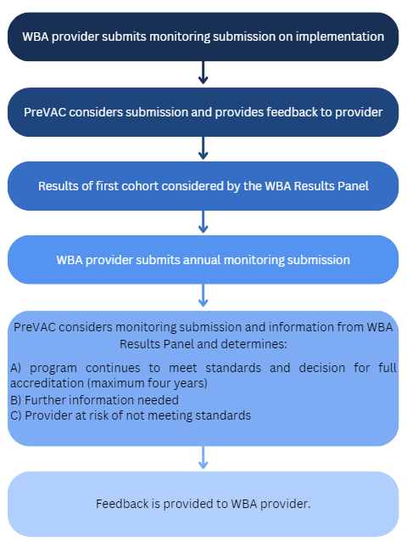
Note the reporting cycle for providers with initial accreditation is:

The provider is not required to comment on Standard 9 for an initial accreditation submission. The provider meets Standard 9 by submitting a high quality monitoring submission to the AMC each year to demonstrate progress towards meeting any standards that have not yet been fully met and to provide an update on changes to the program that may affect the way the provider meets the accreditation standards.

