Model Procedures




  - for specialist medical college accreditation of training settings
  - Final v1.1
  - September 2025

Contents

Contents 2
Introduction 3
Glossary 5
1. Accreditation process overview 7
2. Roles and responsibilities 8
3. Managing conflicts of interest 12
4. Application requirements 12
5. Initial documentation review 13
6. Site visit 13
7. Assessment against the criteria 14
8. Decision-making processes 15
9. Draft and final report 19
10. Communicating the final decision 20
11. Policy/process to review an accreditation decision 20
12. Trainees impacted by accreditation being revoked 21
13. Training setting withdrawal from the accreditation process 21
14. Confidentiality 21
15. Monitoring 22
16. Raising a concern about an accredited training setting 24
17. Data and reporting 25
18. Review of accreditation procedures 25
19. Training 25
20. Further information 25
Appendix A – Indicative site visit schedule 26
Appendix B – Accreditation decision-making flowchart 27
Appendix C – College accreditation report template 29

Introduction
Note (for deletion when colleges create their final procedures document)
- Colleges can choose to adopt the model procedures document in its entirety OR incorporate content from the model procedures to update their own documentation to ensure NHPO college-specific recommendations are met.
- Colleges can change the content of the model procedures to suit their own governance arrangements, accreditation approach and timelines. Items that are most likely to need to be amended are highlighted in blue.
- The following key aspects must be incorporated by all colleges and not be changed:
  - Terminology for assessing a criterion (met, substantially met and not met) and their definitions (in section 7)
  - Accreditation Risk Matrix and Risk Rating Outcomes (in section 8)
  - Terminology for accreditation outcomes (provisionally accredited, accredited, conditionally accredited, not accredited (refused), not accredited (revoked)) (in section 8)
  - Elements of the model procedures relating to procedural fairness, including the definition in the glossary, information in section 3 relating to conflicts of interest and information in section 9 relating to ensuring the training setting has the opportunity to respond to the draft report.
Specialist medical colleges must have a clear process and criteria to assess, accredit and monitor facilities, posts and programs as training settings. The process and criteria must be linked to the outcomes of their specialist medical program.
This procedures document:
- outlines the steps the <name of medical college> follows to accredit training settings.
- provides training settings with clear guidance on how the accreditation assessment works.
- should be read in conjunction with the <name of medical college> Accreditation Standards (College to add hyperlink to standards doc on website).

Context of Accreditation
Accreditation of training settings takes place in the context of a joint endeavour between colleges, training providers, their training settings, and governing health departments, in which all parties have the shared goal of achieving high-quality specialist medical training that is responsive to the needs of the communities of Australia and Aotearoa New Zealand.
The context in which accreditation takes place is complex. It involves different legislative environments across Australia and in Aotearoa New Zealand, a variety of training settings, and parties that have multiple obligations. When engaging in accreditation, colleges, training providers and their settings, and health departments should acknowledge this complexity and respect each party’s wider obligations. These include the maintenance of high standards in specialist medical practice, as well as service delivery obligations to a diverse range of communities.
Accreditation can foster communication and be the foundation for engagement, continuous quality improvement and innovation. The parties should approach accreditation in good faith, acknowledging that, in addition to its assessment role, accreditation provides an opportunity to discuss and resolve problems in a constructive manner and share information about issues for which both colleges and training providers have responsibilities. This will enhance outcomes for trainees, patients and consumers and support the long-term sustainability of the specialist medical workforce.

Glossary

Accredited | Official college approval that a specialist medical training setting has met/substantially met the required accreditation standards.
Accreditation standard | Defines the outcome that must be achieved at the training setting. A standard consists of a series of criteria which are the measurable components of the standard.
College | An organisation accredited by the Australian Medical Council to provide specialist medical education and training. Where a college arranges another body to carry out all, or some, of its accreditation functions, the term ‘college’ includes that other body in so far as it carries out those functions.
Commendation | A training setting’s area of strength relevant to the delivery of the training program.
Condition | A qualification attached to the granting of accreditation at a training setting which requires action within a defined timeframe.
Fellow | A medical practitioner who has successfully completed a recognised medical specialty training program and has been awarded fellowship of the college.
Jurisdictional health department | An Australian State or Territory government department, or ministry, reporting to a minister for health, or the Aotearoa New Zealand Ministry of Health, as well as government in general.
Procedural fairness | A legal principle to act fairly without bias (real or apprehended) in administrative decision making. It includes the right to a fair hearing, including the opportunity to respond to allegations.  Steps associated with ensuring procedural fairness include:  - providing the affected person with reasonable notice that an adverse decision may be made, including details of any issues being discussed and the information available to the decision maker.  - an opportunity for the affected person to directly address the issue/s being decided on.  - ensuring that conflicts of interest are declared and managed appropriately.
Recommendation | A non-mandatory action to improve trainee experience and/or outcomes at the training setting.
Supervisor | An appropriately qualified and trained medical practitioner, senior to the trainee appointed, approved or accredited by a college, who guides the trainee’s education and/or on the job training on behalf of the college. The supervisor’s training and education role will be defined by the college, and may encompass educational, support and organisational functions. Colleges may or may not appoint the main supervisory role. Colleges frequently define a number of supervisory roles.
Trainee | A doctor in training completing a specialist medical program.
Training program | The curriculum, the content/syllabus, and assessment and training that leads to independent practice in a recognised medical specialty or field of specialty practice, or in Aotearoa New Zealand, in a vocational scope of practice. It leads to a formal award certifying completion of the program.
Training provider | The entity legally responsible for the administration of the training setting. This may be a government provider (government department), statutory corporation (local health district, statutory hospital, statutory health service), a for-profit corporation, a not-for-profit corporation (charity), a partnership (a general practice partnership), or any other entity legally responsible for the training setting.
Training setting | The place or position accredited, or applying for accreditation, by the college. This includes sites, posts, practices and networks (which are composed of multiple settings). Where colleges accredit networks or programs, these standards will apply, recognising that various settings will contribute to meeting the standards overall.

Accreditation process overview
Figure 1 shows an overview of the steps in the accreditation process (Colleges may use this diagram, amend it or add their own diagram e.g. ‘send final report to relevant health jurisdictions’ step will not be relevant to colleges that do not accredit public hospitals).
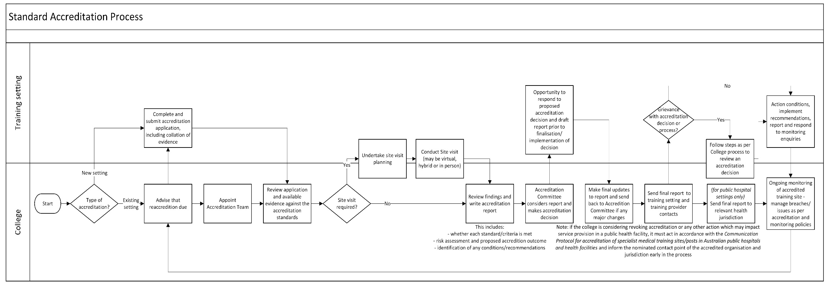
Figure 1 – Steps in the accreditation process

Roles and responsibilities
The following groups are involved in the accreditation process: Note: This is an example table with headings as per what the NHPO has asked to be included, as well as example best practice content based on reviewing existing college documentation. Colleges can update this table based on their own governance arrangements and designated responsibilities.

Role  College to update terminology/add other groups as relevant | Accreditation responsibilities  College to amend/update below based on own terms of reference | Composition | Process for appointment
College
Board  (only include if Board has a role) | - Makes final decision where Accreditation Committee recommends to refuse or revoke a training setting’s accreditation. | College to add the composition i.e. who sits on the Board – can point to intranet page which identifies the Board members | College to add the appointment process (may link to existing document on internet if published)
Accreditation Committee  (College to amend name of committee as required) | - Reviews and considers proposed accreditation recommendations and training setting accreditation reports (as submitted by Accreditation teams) and makes accreditation decisions  - Escalates any cases to the Board for review and final decision where a training setting’s accreditation is proposed to be refused/revoked  - Monitors accredited and conditionally accredited training settings to ensure they continue to meet the accreditation standards and any conditions that have been imposed  - Provides advice and support to new training settings  - Provides advice and support to training settings that may have had accreditation revoked, and/or are seeking to be reaccredited  - Reviews and improves the effectiveness of accreditation policies, systems and procedures  - Provides advice (as required) to the Board on accreditation matters. | College to add the Committee composition i.e. who sits on the Committee – may link to website/document which identifies the information, if published  As per NHPO recommendation, consider whether to include requirements related to consumer representation and legal or regulatory expertise | College to add the appointment process (may link to existing document on website, if published)
Accreditation Team | - Reviews evidence (including undertaking site visits where required) to determine whether a training setting meets the Accreditation Standards  - Provides an overall recommendation to the Accreditation Committee on whether a training setting should be accredited  - Writes the accreditation report detailing the recommended decision, performance against each standard, areas for commendation and quality improvement recommendations, and any conditions on accreditation. | - Chair  - Up to XX experienced clinicians from the medical college  - College trainee representative (optional)  - Jurisdictional Health Department representative (optional)  - Community representative (optional) | College to add the appointment process e.g. if done via Expression of Interest
Accreditation Team Chair | - Chairs team meetings  - Manages any conflicts of interest  - Leads the questioning of interviewees  - Leads the writing of reports  - Leads the development of overall recommendations and recommended accreditation decision  - Escalates any identified risks to training settings  - Ensures due diligence e.g. fact checking of reports. | - Appointed by the college | College to add the appointment process e.g. if done via Expression of Interest
College Accreditation Secretariat | - Collates documentation for the Accreditation Team  - Makes arrangements to support the accreditation assessment (e.g. logistics of site visits)  - Advises the Accreditation Team on the application and interpretation of the Accreditation Standards and processes  - Ensures reports have appropriately addressed the Accreditation Standards and are within the scope of the college’s accreditation function  - Ensures the report of the Accreditation Team’s assessment is submitted to the Accreditation Committee for consideration  - Records minutes and outcomes of relevant meetings  - Maintains an up-to-date record of training settings, including accreditation conditions and status. | - Identified member(s) of college staff | Allocated as per internal staff processes
Training setting
Training Setting Lead Contact | - Liaises with college and training provider on all relevant matters such as dates, interviews, distribution of information etc.  - Collates all relevant evidence to demonstrate the setting is meeting the standards  - Submits applications for accreditation/reaccreditation of the setting  - Works with College Accreditation Secretariat to support the accreditation assessment (e.g. logistics of site visits)  - Meets with the Accreditation Team as part of site visits  - Provides additional information/evidence as required  - Reviews the draft accreditation report and provides feedback  - Communicates the outcomes of accreditation to trainees, supervisors and other relevant stakeholders at the training setting  - Facilitates oversight of implementation of actions to meet any conditions on accreditation  - Provides monitoring submissions as defined by the college. | Identified staff member at the training setting, normally the XX (College to update e.g. Director of Training, Director of Education, Head of Department, lead supervisor or practice manager) | Determined by training setting
Supervisors, educators and other staff | - Provide information to support the accreditation assessment, including:  - responding to relevant surveys  - meeting with accreditation teams as part of site visits. | N/A | College will work with the Training Setting Lead Contact to identify supervisors and other staff to be involved in the accreditation assessment.
Trainees | - Provide information to support the accreditation assessment, such as:  - responding to trainee surveys  - meeting with accreditation teams as part of site visits. | N/A | College will contact trainees to complete accreditation survey and/or refer to data from previous trainee surveys. Data will be provided directly to the College Accreditation Team.  Training Setting Lead Contact identifies trainees to be involved in interviews.

Managing conflicts of interest
To support procedural fairness, conflicts of interest must be declared and managed appropriately.
Potential assessment team members must advise the College Accreditation Committee of any personal or professional interest that may, or may be perceived, to impact their ability to be an impartial assessor. The College may require the team member to step aside from a particular accreditation process.
Where there is a perceived or potential conflict of interest, the college will disclose this to the training setting and training provider and seek their comments on the accreditation team membership. The Accreditation Committee will consider any declared interests as well as the training setting’s comments when finalising the appointment of the team.
If an accreditation team member becomes aware that they may have an actual or perceived conflict of interest during an assessment, the Accreditation Team Chair will determine an appropriate course of action. This may include replacing the team member, changing the responsibilities of the team member, e.g. requiring them to abstain during relevant discussions, or altering the site visit program. Any such conflicts, and the course of action taken, will be reported to the Accreditation Committee.
Members of the Accreditation Committee will declare any conflicts of interest at the beginning of meetings and may be asked to leave a meeting while that item is discussed or excuse themselves from decisions. College staff members involved in the accreditation process should also declare any conflicts of interest at the beginning of the process. Further information is contained in the College’s conflict of interest policy (College to add link to policy).

Application requirements
Training settings applying for accreditation must complete either:
  - The application form (College to add hyperlink) for accreditation of a new training setting.
  - The application form (College to add hyperlink – group with above and update wording if only use one form for new and existing settings) for reaccreditation of a training setting.
The application form includes the training setting’s self-assessment against the accreditation standards and outlines what supporting evidence should be provided (College to delete if not in its application form, however it is recommended that this be added) to demonstrate how the setting is meeting the Accreditation Standards.
The application form should be completed by the Training Setting Lead Contact and submitted to: College to add generic email used for receiving forms.
Settings applying for accreditation for the first time are recommended to start the application process at least six months (College to update to own timeline e.g. 6/9/12 months) before they would like training to begin.
The college will contact accredited training settings approximately six months (College to update to own timeline e.g. 6/9/12 months) before their existing accreditation expires to remind them to start the reaccreditation process. The college may also advise the training provider and jurisdictional health department (College to delete this sentence if it does not work with public hospitals).

Initial documentation review
The Accreditation Team will review the application form and evidence provided by the training setting, along with any data about the training setting held by the college. This may include trainee and supervisor survey data, prior monitoring submissions, ePortfolio data, complaints received and other relevant correspondence.
The Accreditation Team may request that the training setting clarifies details or provides additional information.
(Refer also to the Model standards for specialist medical college accreditation of training settings, section: Evidence supporting assessments and decisions)

Site visit
Note: Colleges can update this section based on how they undertake site/virtual visits, as may be different for smaller colleges/sites.
The College will confirm if a site visit is required as part of the accreditation assessment (it may not always be required, depending on the circumstances). The Accreditation Team may be asked for advice.
Site visits are used to verify information from the application form, hold interviews as well as make observations and clarify any matters raised during the review.
Site visits may be physical, virtual or hybrid.
    - Physical visits involve the Accreditation Team attending in person to conduct an accreditation assessment.
    - Virtual visits involve the Accreditation Team using video and teleconferencing technology to conduct an assessment.
    - Hybrid visits involve an Accreditation Team using both a physical and virtual visit to conduct the accreditation assessment.
The site visit is arranged in consultation with the Training Setting Lead Contact.
Training settings will be required to:
    - ensure interviewees are available and aware of their interview time (the college may provide advice on any trainee, supervisors or other staff members the Accreditation Team would like to interview)
    - organise interview rooms and/or video conferencing facilities
    - inform the college of any issues with interviews or logistics as soon as possible
    - provide site maps, internet access and catering for the Accreditation Team where the team is attending in person.
A site visit will usually occur over a period of XX days/hours (College to add based on standard timeline for a visit).
An accreditation visit schedule must be developed by the training setting, in consultation with the Accreditation Team Chair and College Accreditation Secretariat.
An indicative schedule (for guidance purposes only) is available at Appendix A. Each schedule will vary depending on the availability of interviewees and issues identified by the Accreditation Team prior to the visit.
The schedule should provide time for:
    - discussions with supervisors, educators, trainees, hospital executives/practice manager/site managing body (delete as appropriate) and other staff involved in training so they can present their views and for the Accreditation Team to verify statements
    - the Accreditation Team to view relevant facilities
    - confidential team discussions, review and reflection.
Supervisor and other relevant staff interviews will form the bulk of the visit for a setting seeking to become accredited. The Accreditation Team will explore the reasons for seeking accreditation and confirm the college’s expectations for the training program.
Trainees will also be interviewed where a setting is being reaccredited. The Accreditation Team will focus on reviewing how the training program has been running and any improvements or issues faced since the last accreditation assessment.
It is important that interviewees are encouraged to give free and frank answers to questions from the Accreditation Team. Groups with different interests should be interviewed separately i.e. supervisors and trainees.
The Accreditation Team will limit its interactions with staff and stakeholders to only what is relevant for the accreditation assessment, ensuring that a professional perspective is maintained, and that unbiased, defensible and fair outcomes are delivered.
Additional meetings may be requested to address issues that may arise during the visit.

Assessment against the criteria
The Accreditation Team will use information gathered from the application form, surveys, documentation review, data analysis and the site visit to assess and evaluate the training setting against each criterion in the standards.
Each criterion will be assessed and given one of the following findings:
Finding against criterion | Definition
Met | There is evidence that the criterion has been fully met.
Substantially met | Some but not all aspects of the criterion have been met. For example, there is alignment of policy/intent but evidence of delivery is not yet available, or there is some misalignment of policy/intent that needs to be addressed.
Not met | The criterion has not been met i.e. there is a gap or significant misalignment of outcome or policy with the criterion.
It is noted that new settings may not be able to meet all accreditation criteria because they do yet have trainees at the setting, or for other relevant reasons.
Where colleges accredit networks or programs, these criteria will apply, recognising that various settings may contribute to meeting the criteria overall.
The Accreditation Team will record the rationale for its decision and any other comments in the draft report.
The accreditation report also allows for the inclusion of conditions and recommendations. Conditions are a qualification attached to the granting of accreditation at a training setting which requires action within a defined timeframe, whilst recommendations are intended to support continuous improvement. Unlike conditions, training settings are not required to act on a recommendation, however acting on the recommendation demonstrates a commitment to quality improvement.
The Accreditation Team may also make commendations in the report where it has found the training setting is significantly exceeding the minimum requirements for accreditation. The college may share the commendations with other training settings to promote best practice.

Decision-making processes
Decision making is driven by the following principles:
    - Accreditation is focused on the training setting’s ability to deliver the training program and to provide a safe learning environment for trainees.
    - Accreditation findings and decisions relate to the accreditation standards and do not extend to areas outside of this scope.
    - Accreditation decisions will be risk based and proportionate.
    - A consistent approach is used for assessing risk and determining the accreditation outcome and any subsequent actions, using the risk assessment framework for accreditation (see Accreditation Risk Matrix and Risk Rating Outcomes below).
    - Where an urgent response to an issue is required to protect a trainee’s health and safety, the college will communicate the matter appropriately to the accredited training setting/provider to allow for all parties to meet their workplace health and safety obligations. If this includes actions that affect the trainee’s employment (for example, removing the trainee from the risk by providing immediate leave, moving the trainee to another setting), the parties will cooperate and coordinate actions to allow this to occur, noting that the agreement of the college, employer and trainee will be needed.

Accreditation Risk Matrix and Risk Rating Outcomes
Where a training setting has a finding of ‘met’ for all criteria within the standards, accreditation will be granted.
Where a training setting has a finding of ‘substantially met’ or ‘not met’ for any criteria within the standards, a risk assessment will be conducted (using the Accreditation Risk Matrix at Figure 2). The outcome of this assessment will guide the college’s response and accreditation decision.
The Accreditation Risk Matrix (Figure 2) is used to determine the level of risk based on reviewing the totality of the criteria that are substantially met and not met against the following dimensions:
- the impact on training at the training setting, noting that this has consequences for patient safety. This includes considering the impact on current and future trainees.
- the likelihood that actions will be implemented to meet the criterion/a within a reasonable period.

 |  | Likelihood of the training setting/training provider being ABLE to implement actions to meet the criterion/criteria within a reasonable period
 |  | Rare | Unlikely | Possible | Likely | Almost certain
Impact on  training | Insignificant | Low | Low | Low | Low | Low
Impact on  training | Minor | Medium | Medium | Low | Low | Low
Impact on  training | Moderate | High | High | Medium | Low | Low
Impact on  training | Major | Extreme | High | High | Medium | Low
Impact on  training | Severe | Extreme | Extreme | High | Medium | Medium
Figure 2 – Accreditation Risk Matrix
The college will use the risk rating in the Accreditation Risk Matrix to help guide the accreditation approach, outcome and monitoring requirements (see Risk Rating Outcomes at Figure 3 below).
Conditions may be provided at the individual criterion level or address multiple criteria. The college will determine what monitoring activities and contact is required based on the risk assessment outcomes (refer to section 15 for more information on monitoring).

Note: Refer to the Application of the risk framework and development of conditions: Guidance for specialist medical colleges for more information regarding using the risk matrix, including definitions, scenarios, application of conditions and monitoring requirements.
Risk rating | Approach | Outcome
Risk rating | Approach | New settings | Existing settings
Low risk | - Determine if conditions are required. Where they are required:  - impose conditions against the criteria  - outline what the conditions are, the timeframes for showing progress and how they will be monitored, including any reports that need to be provided.  - Will likely require some ‘light touch’ monitoring and there might be more flexibility on timelines for the condition to be met (e.g. within 6-12 months).  - There will likely be limited need for ongoing review or intervention. | Provisionally Accredited | Accredited  OR Conditionally accredited
Medium risk | - Impose conditions against the criteria.  - Outline what the conditions are, the timeframes for showing progress and how they will be monitored, including any reports that need to be provided.  - May require a more formal monitoring approach with specific timelines for completion (e.g. within 6 months). This might include more than one review point to check in on progress towards meeting the conditions. | Provisionally Accredited | Conditionally accredited
High risk | New setting: Do not grant accreditation (accreditation is refused).  Existing setting:  - Impose conditions against the criteria.  - Outline what the conditions are, the timeframes for showing progress and how they will be monitored, including any reports that need to be provided.  - Due to the high-risk nature of the criteria that have not been met, the timeframes for demonstrating progress may need to be shorter and more rigorous than for medium risk (e.g. within 3 months). | Not accredited (refused) | Conditionally accredited
Extreme risk | New setting: Do not grant accreditation (accreditation is refused).  Existing setting: Move to revoke accreditation.  - Outline what requirements must be met in the future to be considered for accreditation/reaccreditation, including timeframes for showing progress.  - Note: For existing settings, colleges may take an active management approach with the training setting to help it take immediate steps to lower the risk which in turn moves the setting back to a conditionally accredited pathway rather than revocation. The situation should be carefully deliberated between the college, training setting and training provider, noting that each case will be different. | Not accredited (refused) | Not accredited (revoked)
Figure 3 – Risk Rating Outcomes

Accreditation outcomes
The period for which accreditation will be granted is outlined below.
Decision | Alignment to risk framework | Duration of accreditation awarded and any other impacts
New training settings
Provisionally accredited | A new training setting that:  - meets all of the accreditation criteria OR  - does not meet all of the accreditation criteria but has the potential to meet them once trainees are in place. The overall risk assessment is rated as low or medium with conditions required. | Provisionally accredited for up to 12 months, subject to satisfactory routine monitoring submissions.  The setting can appoint trainees but will be subject to an assessment within 12 months that will include confirming if any conditions have been met. At this point, training settings will be considered an ‘existing training setting’ for accreditation purposes.  If no trainees are appointed within 12 months, the college will decide if provisional accreditation status should lapse or remain in place for a further period of time. If lapsed, the college will determine if the setting is required to submit a new accreditation application before trainees can be appointed.
Not accredited (refused) | A new training setting that does not meet all of the accreditation criteria. The overall risk assessment is rated as high or extreme. | Accreditation not granted.  Any requirements that must be met in the future will be outlined. Once requirements have been met, the setting may be required to submit a new accreditation application providing assurance that it continues to meet all other accreditation criteria at the time of reapplication.
Existing training settings
Accredited | An existing training setting that:  - meets all of the accreditation criteria OR  - does not meet all of the accreditation criteria but the overall risk assessment is rated as low and it has been determined conditions are not required. | Accredited for XX years (e.g. five years - update based on college), subject to satisfactory routine monitoring submissions.
Conditionally accredited | An existing training setting that:  - does not meet all of the accreditation criteria and the overall risk assessment is rated as low, medium or high with conditions required. | Accredited for XX months to XX years (e.g. five years - update based on college) depending on the severity of the risk and:  - conditions being addressed within the defined timeframe  - satisfactory routine monitoring submissions  - meeting any other specific monitoring requirements.
Not accredited (revoked) | An existing training setting that:  - does not meet all of the accreditation criteria and the overall risk assessment is rated as extreme with conditions required.  Note: this accreditation outcome should only be applied in the final accreditation report if, since the initial accreditation assessment was undertaken, steps to actively manage the training setting to a conditionally accredited pathway have been unsuccessful. | Accreditation not granted.  Feedback and timeframes for reconsidering reaccreditation will be provided, including what criteria the training setting needs to address.  The date the accreditation will be revoked will be set. Prior to this, trainees may continue to complete their training term at the setting unless their safety is at immediate risk. From the revocation date:  - trainees at the setting will not be able to count training towards their training program unless specific arrangements are made  - no new trainees can be appointed.  A new application for accreditation must be submitted once requirements have been met (the setting must also be continuing to meet all other accreditation criteria at the time of submitting the application).
Figure 4 – Accreditation Outcomes
A flow chart of the decision-making process for new and existing training settings is available in Appendix B.

Draft and final report
The accreditation report template is available in Appendix C. Interviewees must not be named in reports without their consent.
The Accreditation Team will present the draft report with the proposed decision, conditions, recommendations and commendations to the Accreditation Committee for its review. The Accreditation Committee can endorse or modify the report and any proposals, noting it should not change the text of the report without the agreement of the Accreditation Team Chair.
To ensure procedural fairness, the college will then notify the training setting/training provider of the proposed decision, providing a copy of the draft report as well as any reasons for its proposed decision. (Note: some colleges undertake this step before it goes to the Accreditation Committee. If so, please rewrite this section accordingly and update the process map diagram in section 1).
The training setting/training provider has 10 business days to review the draft report and to provide a response. This can include highlighting any factual inaccuracies that require fixing for the final report, as well as any additional evidence that it wishes to be considered.
The training setting/training provider and/or the college may wish to discuss the draft report to further explore the issues and propose possible solutions.
If, after the above discussion, the college is considering any of the actions below for a public health facility, it must act in accordance with the Communication Protocol for accreditation of specialist medical training sites/posts in Australian public hospitals and health facilities, which requires colleges to inform the nominated contact point of the accredited organisation and jurisdiction if:
    - accreditation is to be revoked
    - any other action is to be taken that is likely to significantly impact the training setting/training provider’s ability to provide services to patients and the public.
Any responses from the training setting/training provider and jurisdiction will be considered by the Accreditation Committee and Accreditation Team (where required) before making a final decision.
The Accreditation Committee will then finalise the report and accreditation decision. The Board may make the final decision where the Accreditation Committee recommends to refuse or revoke a training setting’s accreditation (delete this sentence if not relevant to college).
The final report will include acknowledgement of any responses to the draft report, including how feedback has been considered in the making of the final decision.

Communicating the final decision
The college will provide the final report to the following stakeholders:
Stakeholder and order of notification | Timeline for provision of the final report
- Training Setting Lead Contact and General Manager/Chief Executive (or equivalent) of the training provider  - Training network lead (if the setting is part of a network) (delete for colleges that don’t have networks) | To be provided once final decision made by Accreditation Committee.  Includes information on the college’s policy/process to review an accreditation decision (see section 11).
- Relevant jurisdictional health department (e.g. NSW Health) (for colleges with public hospital based trainees only, otherwise delete) | To be provided once the training setting and provider have had time to prepare advice to the health department if required. Noting for potential decisions to revoke accreditation, the jurisdictions will already have been informed earlier as per process in section 9.
Training settings and colleges should consider appropriate ways of informing trainees and supervisors about accreditation decisions.

Policy/process to review an accreditation decision
Disagreements or dissatisfaction about an accreditation decision or a proposed accreditation decision should be resolved as early as possible. These model procedures set out requirements for procedural fairness to be observed in relation to the making of accreditation decisions, including early discussions with the training setting on how matters may be resolved prior to a final accreditation decision being made (see Section 9). This could include discussions with the site about appropriate steps that the setting could put in place to resolve the college’s concern.
There will be circumstances where resolution as part of the accreditation process is not possible. Where this occurs and a training setting does not agree with a decision outcome, it should follow the college’s policy and process to review an accreditation decision (this may be the college’s Reconsideration, Review and Appeals (RRA) policy) (College to add hyperlink to its Review Policy). Accreditation decisions that are subject to review under the policy include:
    - refusal to grant provisional accreditation
    - refusal to grant accreditation to an existing training setting (reaccreditation)
    - time period for which accreditation is granted
    - imposition of a new accreditation condition
    - terms of an accreditation condition (including timeframe to meet the requirements of a condition).
Where the setting applies for a review of an accreditation decision, it should still be the aim of both parties to determine if the matter can be resolved at the earliest possible stage of the process. This requires a flexible approach.

Other complaints about accreditation (not related to the accreditation decision itself) may be covered under the college’s complaints policy (College to add hyperlink to relevant Complaint(s) policy), for example, if the training setting considers the accreditation decision to be appropriate but the processes were not timely or were inefficient.

Trainees impacted by accreditation being revoked
The college will work with the relevant training setting/training provider to develop a plan and support pathway for impacted trainees and any other relevant matters as soon as the setting/provider receives the draft report outlining there is a possibility of accreditation being revoked. The plan will consider how any actions resulting from the accreditation being revoked will support duty of care and continuity of training for trainees, as well as impacts on the service delivery obligations of the training provider.

Training setting withdrawal from the accreditation process
A training setting can withdraw from the accreditation process at any stage, up until a final accreditation decision has been made by the Accreditation Committee. All requests to do so must be made to the college in writing.

Confidentiality
The accreditation process is confidential to the participants. To undertake its accreditation role, the college requires detailed information from training settings. This typically includes sensitive or commercial-in-confidence information such as plans, budgets, appraisals of strengths and weaknesses and other confidential information. The college requires members of Accreditation Teams, members of the Accreditation Committee, Board members and staff to keep confidential all material provided to the college by training settings for the purpose of accreditation of their programs.
The confidentiality of individuals interviewed as part of an accreditation visit (e.g. trainees, supervisors, staff members) should be respected. Interviewing a variety of individuals at a setting, where this is practicable, may assist in protecting confidentiality as feedback can be aggregated. However, this may not be possible in smaller sites and judgment will need to be exercised regarding the disclosure of information that is relevant to accreditation. Obligations to protect individuals from serious and imminent harm or work health and safety obligations may require identifying information to be disclosed in certain circumstances (see Framework for managing concerns and complaints about accredited training settings* for further information. (* guidance for colleges expected mid-2026)).
Information collected through the accreditation process is to be used only for the purpose for which it is obtained, unless disclosure is otherwise required by law.
The draft and final accreditation decisions will be kept confidential (with the exception of steps identified in sections 9 and 12) until the final decision has been shared with the stakeholders identified in section 10.

Monitoring
Once accreditation has been granted, all training settings will be monitored. Monitoring:
- ensures a training setting is continuing to comply with the standards
- ensures the training setting is progressing towards meeting any conditions and picks up on non-compliance with any conditions set (the type and frequency of monitoring requirements will depend on the assessment of risk associated with non-compliance with the standards – see Section 8)
- helps detect any potential new issues between accreditation assessments
- provides proactive guidance to training settings experiencing challenges
- identifies and acknowledges high-performing settings.
College could look at adding a summary statement of what monitoring it does, then provide more detail in table below. The college undertakes the following monitoring activities:
Type of monitoring | Activity  Colleges to review the table and amend/delete/add further detail based on their processes (e.g. names of the surveys) | Frequency
Routine monitoring (all settings) | Review of results of annual trainee survey data | - College to update e.g. annual
Routine monitoring (all settings) | Review of results of trainee rotation survey data | - College to update
Routine monitoring (all settings) | Review of results of trainee exit survey data (as they enter fellowship) | - College to update
Routine monitoring (all settings) | Review of results of supervisor survey data/feedback reports | - College to update
Routine monitoring (all settings) | Review of relevant data/information available in the college’s internal IT systems (e.g. procedural numbers, workplace-based assessment (WBA) completions and quality of supervisor feedback within the WBAs, complaints) | - College to update
Routine monitoring (all settings) | Review of the changes at the training setting that could impact effective and safe delivery of training programs, including:  - changes to a training setting’s services, support, resources, infrastructure or opportunities  - changes to a training setting’s governance and management  - increases in trainee numbers and/or decreases in supervisor numbers  - revisions to the training program  - the absence of staff or roles which impact training and have been left vacant for an extended period  - roster changes which alter access to supervision and/or training opportunities  - anything that could impact the training setting’s integrity or capacity to deliver the training program. | - Responsibility of training setting to proactively provide this information to the college when it occurs, it will then be reviewed.
Routine monitoring (all settings) | Review of results of annual setting census return/monitoring report | - Annual
Additional specific monitoring | Request for additional monitoring reports from training setting and review of how it is progressing with meeting conditions. | - As set out in the accreditation report.
Additional specific monitoring | Review of training setting data held by the college relevant to monitoring progress against conditions. | - As required, set out in the accreditation report where possible.
Additional specific monitoring | Meeting with the training setting to assess progress against conditions. | - As required.
Additional specific monitoring | Request for information and/or meeting with the training setting based on a specific issue/concern that has been raised (e.g. direct feedback from training supervisors or other clinicians, lodged complaint(s), correspondence or media articles). | - As required.
Additional specific monitoring | Review of relevant training setting data. | - As required.
Additional specific monitoring | Conduct of virtual, on site or hybrid site visit(s). | - As set out in the conditions of the accreditation report  - Where the college is not satisfied imposed conditions are being addressed within a reasonable period of time  - Where monitoring, data or concerns raised indicate the training setting may no longer be meeting the accreditation standards.  - This may be a focused assessment, looking at specific criteria or conditions rather than all.
Additional specific monitoring | Conduct of a full, unscheduled accreditation assessment. | - Where the college is not satisfied imposed conditions are being addressed within a reasonable period of time  - Where monitoring, data or concerns raised indicate the training setting may no longer be meeting the accreditation standards.

Monitoring changes and conditions
The college will review information gained from monitoring activities, including any information sent by training settings, and decide if the risk rating of a criterion should be reviewed and if conditions have been met. The college may also ask for more information or activities to help inform decisions.
Resulting from this, the college (if this role is done by a governance group such as the Accreditation Committee, please replace ‘college’ with name of that Committee) may change the training setting’s accreditation status, as follows:
- If all criteria are now ‘met’, the training setting will move from ‘conditionally accredited’ to ‘accredited’.
- If one or more criterion that were previously met are now ‘substantially met’ or ‘not met’ or a condition has not been met within the required timeframe or is unlikely to be met within the required timeframe (e.g. no work has started on it) , a risk assessment will be completed (section 8). The risk assessment result will inform next steps, which may include imposing further conditions, extending the timeline of existing condition(s) and conditional accreditation, changing the scope of the existing condition(s) or moving to revoke accreditation. The monitoring requirements for these will also be outlined.
An updated accreditation report will be provided to the training setting if there is a change to its accreditation status or conditions. This may be an update to the full accreditation report or a monitoring report (colleges to insert what they would normally do here). Reporting and appeals will follow the process in sections 9 to 11.

Lapsed and voluntarily withdrawn accreditation
If an existing accredited training setting has no trainees for a period of time (e.g. 12 months), the college will decide with the training setting as part of monitoring activities if the accreditation status should lapse or remain in place for a further period of time. If lapsed, the college will determine if the setting is required to submit a new accreditation application before trainees can be appointed.
Training settings can also choose to lapse or voluntarily withdraw from being an accredited training setting. This may be because their circumstances have changed/they feel they are no longer able to meet the standards, or they no longer want to provide training.

Raising a concern about an accredited training setting
Any individual who is concerned that an accredited training setting is not meeting the accreditation standards can:
- speak to a member of college staff or relevant college representative (e.g. Fellow, Trainee representative)
- raise a concern using the college’s complaint management process (College to add link to documentation on how to do this)
- others TBC – Note: this aspect of the model procedure may be updated once work on Recommendations 13 of the NHPO report has further progressed.
The college will review these concerns during monitoring (see section 15).

Data and reporting
The college publishes a list of accredited training settings on its website (College to add hyperlink).
The college submits collated training setting accreditation data to the Australian Medical Council annually which will be further collated with data from the other specialist medical colleges and shared with jurisdictional health departments. Some data will be published on the AMC’s website.

Review of accreditation procedures
These accreditation procedures will be regularly reviewed (at least every five years) and updated based on feedback from participants and assessors, and on benchmarking with other accreditation processes and activities.

Training
All Accreditation Committee and Accreditation Team members will receive training from the college to ensure accreditation processes and policies are understood and delivered appropriately. College to describe here what training it offers (e.g. what activities accreditors need to attend/undertake)
The following resources about the accreditation process are available online:
- College to add any relevant resources such as FAQs, e-learning modules developed – if none available, delete this paragraph. Include if the resources are available via college internal access or public access.

Further information
If you have any questions or need more information about accreditation, please contact:
(Name and Role for Manager of Accreditation or similar, be general where possible so don’t need to update this document if that person leaves)
Name of College
Generic Email
Phone number

Appendix A – Indicative site visit schedule

College to add

Appendix B – Accreditation decision-making flowchart

New settings

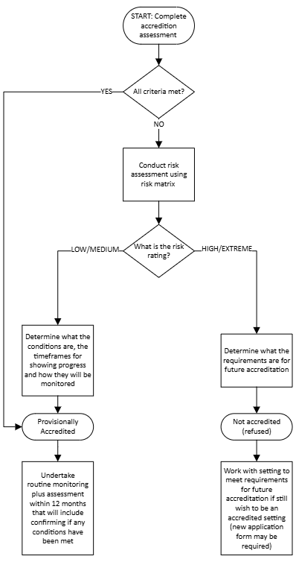

Existing settings
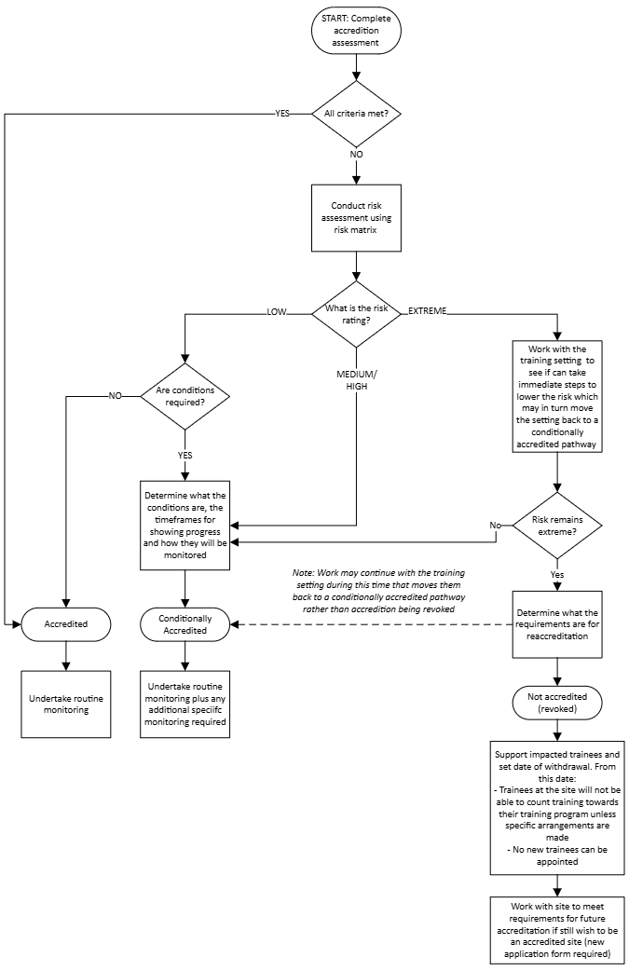

Appendix C – College accreditation report template

College to add – should be updated to reflect model report template and guidance



Standard 8.2, Standards for Assessment and Accreditation of Specialist Medical Programs by the Australian Medical Council 2023
Note that under the Communication Protocol Accreditation of specialist medical training sites/posts in Australian public hospitals and health facilities, colleges are to provide health departments an advance timetable of accreditation visits that are planned for sites/posts in accredited organisations in their jurisdiction for the coming year, cl.6.3
Informing health departments of these matters in relation to private health facilities (e.g. GP training settings) is not required.

