Request for Tender: Process Improvement Project

Subtitle: Part A – Detailed Requirements



May 2025



Contents

1. Approach to Market – Services 3

2. Background 3

3. Statement of Requirement 4

4. Rights Reserved by AMC 6

5. Statement of requirements for Stage 1 and Stage 2: 7

6. Stage 3 – Requirements for this RFT 15

7. AMC values 16

8. Standards 17

9. Evaluation of Tenders 17

Appendix 1: Organisational Context 21

1. Overview of Departments Undergoing Process and System Improvement 21

2. Accreditation Department 21

3. Assessment Services business areas 24

4. Use of Monday.com in Accreditation and Assessment 27

5. Stakeholder Management Contacts Database 27

6. Current State Architecture 29

7. Application Services 29

8. Baseline Application Components 30

9. Logical Baseline Data Architecture 32

Appendix 2: Sample for Process Map Level of detail 33

1. Part A – Detailed Requirements

# Approach to Market – Services

The Australian Medical Council (AMC) is seeking submissions for the provision of process improvement consulting services (the Requirement) as described in this AMC Request for Tender (RFT).

This project aims to:

### Build long-term capability for resilient and scalable processes and systems for long-term operational excellence.

### Ensure appropriate connections between core business processes and related functions—such as document management, contacts, and finance—through integrated system design and interoperability.

### Select and implement software solutions that best align with the AMC’s needs while ensuring seamless system integration.

### Establish a system architecture that is adaptable to future changes, supporting both process evolution and technology upgrades.

### Adopt a balanced change management approach that integrates business processes, data governance, and system functionality.

### Ensure that project practice and process are congruent with AMC Values and the AMC Strategic Plan.

If successful, the Applicant is required to enter into a contract in the form of the draft Contract at Part D, subject to negotiations with the Applicant*.*

# Background

The AMC

Introduction

### The AMC is a national standards body for medical education, training and assessment. Its purpose is to ensure that the standards of education, training and assessment of the medical profession promote and protect the health of the Australian community. The AMC is also dedicated to enhancing health outcomes for Aboriginal and/or Torres Strait Islanders and Māori Peoples. Further information about the AMC is available on the AMC’s website: <https://www.amc.org.au/>.

### The AMC’s core business encompasses the accreditation of medical education providers and the assessment of international medical graduates. As Australia’s accreditation authority for medical education, the AMC ensures that medical schools and postgraduate training programs meet standards that promote quality and safety in healthcare. This involves reviewing educational institutions, courses, and clinical training settings.

### In addition, the AMC assesses international medical graduates seeking to practice in Australia, evaluating their qualifications and competencies to ensure they meet the required standards for safe and effective medical practice.

### To support its mission, the AMC is seeking to engage a consultant to guide and assist with a comprehensive project focused on redesigning and optimising core business processes alongside the selection and implementation of information technology systems. This initiative aims to deliver transformative improvements to efficiency, effectiveness, adaptability, and stakeholder satisfaction while aligning technology investments with strategic goals.

### Potential stakeholders involved:

#### **Internal Stakeholders**: AMC business units, including Accreditation, Assessment Services, the ICT team, the Indigenous Policy and Programs section, Finance Section as well as the Board of Directors and a range of Committees with medical professional representation. These stakeholders will be involved in the project directly or else receive progress reports on the project.

#### **External Stakeholders**: International Medical Graduates, education providers, the Medical Board of Australia, Australian Health Practitioner Regulation Agency (AHPRA), federal government and jurisdictions, process consultants, ICT consultants and vendors. These stakeholders will benefit from either improved experience, improved assurance, or from commercial engagement with the project.

### The overall project’s **primary objectives** include:

#### Efficient and effective core processes that reduce workload, eliminate unnecessary manual handling, and free staff to engage in value-adding activities.

#### Workflows that are adaptable to future changes, including regulatory changes, scalability, and advancements in operational practices, with modular designs allowing independent functionality and seamless integration.

#### IT systems that support process automation, adaptability, and support for a culture of continuous improvement through configurability, updates and enhancements.

#### IT systems that provide robust data collection and analysis, ensuring compatibility with AMC databases and providing actionable insights for business decision-making.

#### IT systems which can leverage future technological innovations, particularly advancements in artificial intelligence and its expanding role in process management.

#### Comprehensive integration between processes and IT systems, with user-centric designs that maximise user adoption and change management strategies to support smooth transitions and sustained improvements.

# Statement of Requirement

**The overall project objectives**

The project will be conducted in three separate stages outlined below.

**Stage 1: Process Mapping (Current State)**

**Objective:** Provide a comprehensive understanding of current processes, workflows, inefficiencies, and interdependence within Accreditation and Assessment sections of AMC.

The Applicant will be required to undertake a review of the current workflows, including through conducting surveys, interviews and workshops, to understand pain points and inefficiencies, and prepare a report which documents the findings.

The purpose of the surveys, workshops and interviews is to collect information from AMC personnel about the AMC processes, work, current forms and templates and the AMC’s specific requirements and use that information to prepare a design of the solution and to assist with the selection of a configurable product which will achieve the AMC’s objectives in clause 2.1.6.

**Deliverables:**

#### Document “as-is” or current state workflows.

#### Analysis of pain points and inefficiencies.

#### A stakeholder engagement report which documents the workflows and the Applicant’s findings, including any preliminary findings or recommendations prior to Stage 2.

**Stage 2: Process Redesign (Target State)**

**Objective:** Develop efficient, adaptable processes to meet AMC’s goals.

**Deliverables:**

#### Detailed “to-be” workflows and process improvement recommendations.

#### AMC stakeholder validation of proposed workflows.

#### Modular designs ensuring scalability and appropriate levels of adaptability to future change.

#### IT system requirements documentation; and

#### detailed set of specifications for the proposed solution and solution design.

**Stage 3:** **Software selection and Solution Implementation**

**Objective:** Select and deploy IT systems that align with redesigned processes and strategic objectives, ensuring integration and long-term adaptability based on the outcomes of Stages 1 and 2.

**Deliverables:**

#### Evaluation and selection report identifying the most suitable IT solutions based on findings and recommendations from Stage 1 and Stage 2; software and system compatibility; and consistency with AMC IT strategy.

#### Detailed specifications and solution design of the selected IT solution.

#### Implementation roadmap and system integration plan to ensure smooth deployment and interoperability with existing and future systems.

#### Change management strategy to facilitate adoption, training, and stakeholder engagement.

#### Deployment of selected IT solution(s), including configuration, integration, and initial operational testing.

#### After deployment training and support (period to be determined).

**Scope of this RFT**

This RFT is designed to select a suitable consultant for Stage 1 (Process Mapping) and Stage 2 (Process Redesign).

However, the RFT also invites Applicants to provide information about Stage 3 (System Implementation) to allow the AMC to ensure the selected Applicant has a clear understanding of the AMC’s requirements for all three stages.

While the information provided for Stage 3 will be evaluated as part of the AMC selection process. AMC expects that Applicants will not be able to provide a detailed response for Stage 3. AMC therefore reserves the right to work with the Applicant selected for Stages 1 and 2 to add Stage 3 to their project (by way of a variation or new contract) or to go back to the market to select a suitable consultant for Stage 3.

# Rights Reserved by AMC

In determining any future engagement for Stage 3, critical factors would be:

#### the Applicant’s performance during Stage 1 and Stage 2, including the quality of the deliverables, adherence to timelines, and collaboration with AMC stakeholders;

#### the proposed solution for Stage 3, including its suitability for the Requirements, meeting AMC’s objectives, the cost, including ongoing support and maintenance costs and licencing fees, the level of development or configuration required; and

Upon successful completion of Stage 2, the AMC reserves the right to:

### engage the successful Applicant for Stage 1 and Stage 2 for Stage 3 (System Implementation) through direct negotiation, subject to:

#### the AMC’s assessment of the performance of the Applicant in providing Stages 1 and 2;

#### AMC’s confirmation that the deliverables in Stages 1 and 2 will meet the requirements and achieve its objectives and are consistent with the contract; or

#### conduct a further procurement process allowing the current Applicant and other providers to participate.

# Statement of requirements for Stage 1 and Stage 2:

The Applicant must assign a project manager who will work closely with the AMC allocated project manager in a collaborative project management approach for both Stage 1 and Stage 2 (and potentially Stage 3).

**Stage 1: Process Mapping (Current State)**

The Applicant must:

### Conduct comprehensive process mapping and analysis to identify inefficiencies and areas for improvement.

### Collaborate closely with AMC staff and stakeholders to ensure alignment with organisational goals.

### Conduct surveys and interviews with AMC staff and stakeholders to identify the current state of the workflows and to identify any gaps, pain points or issues currently faced by AMC staff or relevant stakeholders.

### Provide regular updates and opportunities for feedback throughout the process mapping stage.

### Deliver detailed documentation that provides clear, structured and visually comprehensive current state process maps, including annotations on inefficiencies, redundancies, and potential improvement opportunities.

### Produce process mapping reports highlighting interdependencies between processes, systems and data flows.

### Provide high-level recommendations to guide future stages (process redesign and solution implementation).

**Stage 2: Process Redesign (Target State)**

The Applicant must:

### Develop optimised targeted state workflows that enhance efficiency, adaptability, and integration with future IT solutions.

### Ensure that redesigned processes are scalable, modular, and future-proof.

### Conduct stakeholder engagement workshops, surveys and interviews to validate and refine redesigned workflows.

### Provide a high-level system requirements framework, outlining key considerations for IT system selection in Stage 3.

### Deliver a Process Redesign Report, including:

#### final future-state process maps;

#### recommended workflow improvements and rationale;

#### implementation considerations; and

#### a transition plan and change management strategies for moving from the current to redesigned processes.

#### Develop a detailed set of specifications and solution design for the proposed IT system to implement the recommendations from this stage.

The AMC will:

### Provide access to existing process documentation, relevant resources, and personnel.

### Provide an AMC Project Manager to work closely with the selected consultant’s allocated Project Manager.

### Facilitate workshops and meetings with stakeholders to support process mapping and IT system selection.

### Participate in feedback and alignment sessions throughout the project lifecycle.

### Make internal teams available to support implementation and adoption phases.

**Meetings**

### The Applicant will be required to attend regular fortnightly meetings with AMC to discuss project deliverables and gather required information for the duration of the contract.

**AMC Contact**

|  |  |
| --- | --- |
|  |  |
| Name | Tatenda Chitsungo |
| Email address | PSI@amc.org.au |
|  |  |

**Project Milestones**

The milestones and deliverables outlined in this RFT are provided as a guide to assist Tenderers in understanding the expected scope, level of detail, and support required for the Process and Systems Improvement Project. These are not intended to be prescriptive or exhaustive and may be subject to further refinement and negotiation with the successful provider.

AMC recognises that different methodologies and approaches may yield more effective outcomes. As such, alternative or enhanced milestones and deliverables that reflect the nature and complexity of this work will be welcomed.

Tenderers are invited to use their expertise and professional judgment to propose modifications or additions that they believe will best support the successful delivery of the project objectives.

**Stage 1: Process Mapping (Current State)**

|  |  |  |
| --- | --- | --- |
| **Project milestone** | **Description** | **Deliverables** |
| Kick off meetings with AMC team | Initial meetings with the AMC team to confirm project scope, objectives and timelines. | * **Meeting agenda –** Outline of discussion points to be shared in advance. * **Meeting minutes –** Summary of key discussions, agreements, and next steps. * **Project scope confirmation –** Alignment on scope, objectives, and priorities. * **High-level project timeline –** Overview of key milestones and deadlines. * **Stakeholder engagement approach –** Agreement on how stakeholders will be involved. * **Action items & responsibilities –** Defined next steps and assigned tasks. |
| Regular ongoing reports with AMC Project Manager/team (Frequency to be agreed on) | Continuous reporting and check-ins with the AMC Project Manager/team to track progress, address challenges, and ensure alignment with project objectives. These reports provide visibility into key activities, stakeholder engagement, and emerging insights from the process mapping phase. | * **Progress reports** – Regular written updates summarising completed activities, key findings, and next steps. * **Meeting agendas & minutes** – Documentation of discussions, decisions, and action items from project team meetings. * **Issues & Risks Log** – A continuously updated record of identified risks, challenges, and proposed mitigation strategies. * **Process mapping status updates** – Interim updates on the progress of process mapping, including preliminary findings. * **Action Item Tracker** – A document to monitor assigned tasks, responsibilities, and deadlines. |
| Project approach and plan | Development of a detailed plan outlining the methodology, stakeholder engagement strategy, and timeline for process mapping. | * **Project plan document –** A structured plan detailing objectives, approach, methodologies, and key activities. * **Process mapping methodology –** Documentation of the approach, techniques, and tools used to capture and analyse current-state workflows. * **Project timeline & milestones –** A high-level timeline detailing key phases, deliverables, and dependencies. * **Roles and responsibilities matrix –** A document defining project roles, responsibilities, and key points of contact. * **Risk assessment & mitigation plan –** Identification of potential risks and proposed mitigation strategies. * **Communication plan** – Guidelines on how project updates, stakeholder feedback, and findings will be shared. |
| Stakeholder Engagement for Process Mapping | Conduct workshops, surveys, and interviews with key stakeholders to gather insights on existing workflows, pain points, and operational challenges. This phase ensures that the process mapping exercise is informed by those who interact with the processes daily. | * **Stakeholder engagement plan/strategy** – A structured plan outlining engagement methods, target participants, and timelines. * **Workshops conducted –** Summary report detailing the number of workshops, key discussions, and participant feedback. * **Surveys delivered & analysed** – Distribution of surveys, including response rates and key insights. * **Interviews conducted –** List of interviewees, discussion topics, and key takeaways. * **Raw data & feedback repository –** Compilation of survey responses, workshop notes, and interview transcripts for reference. |
| Process mapping report | A detailed report summarising findings, including “as-is”/current state process maps, inefficiencies and high-level insights to inform subsequent stages. | * **Process mapping report** – A structured document summarising all key findings from the process mapping phase. * **Final “As-Is”/current state process maps** – Refined and validated visual representations of current workflows. * **Inefficiencies & bottlenecks register** – A categorised list of process inefficiencies, pain points, and operational challenges. * **Process interdependency analysis –** A report highlighting dependencies between workflows, teams, and IT systems. * **High-level insights summary** – Key themes and strategic takeaways from stakeholder engagement and process analysis. * **Preliminary recommendations for process improvement** – High-level suggestions for addressing inefficiencies, to guide Stage 2 (Process Redesign). * **Presentation of findings** – A summary deck for stakeholders including meeting via Zoom/face to face presentation, outlining major findings and insights. |

**Stage 2: Process Redesign (Target State)**

|  |  |  |
| --- | --- | --- |
| **Project milestone** | **Description** |  |
| Kick-off Meetings for Process Redesign (Stage 2) | Initial meetings between the consultant and AMC team to align on expectations, scope, methodology, and next steps for the Process Redesign (Stage 2) phase. | * **Meeting agenda** - Outline of key discussion points to be shared in advance. * **Meeting minutes & key takeaways** – Summary of discussions, agreements, and action points. * **Process redesign approach overview** – Initial framework detailing methodologies, guiding principles, and expected outcomes. * **Preliminary project timeline for Stage 2** – Key milestones, deadlines, and dependencies mapped out. * **Risk and Issue register (Initial Version)** – Identification of potential risk, Issues, and considerations for process redesign. * **Action plan & next steps** – Clear outline of tasks, responsibilities, and upcoming activities leading into the next phase. |
| Regular ongoing reports with AMC Project Manager/team (Frequency to be agreed on) | Continuous reporting and check-ins with the AMC Project Manager/team to track progress, address challenges, and ensure alignment with project objectives. These reports provide visibility into key activities, stakeholder engagement, and emerging insights from the process mapping phase. | * **Progress reports** – Regular written updates summarising completed activities, key findings, and next steps. * **Meeting agendas & minutes** – Documentation of discussions, decisions, and action items from project team meetings. * **Issues & Risks Log** – A continuously updated record of identified risks, challenges, and proposed mitigation strategies. * **Process mapping status updates** – Interim updates on the progress of process mapping, including preliminary findings. * Action Item Tracker – A document to monitor assigned tasks, responsibilities, and deadlines. |
| Initial assessment and framework for Process Redesign | Conducting detailed Future-State Process Design Workshops, the consultant must establish a structured framework to guide the redesign process, ensuring alignment with AMC goals, IT integration, and best practices. | * **Process redesign framework document** – A structured approach outlining key principles, methodologies, and expected outcomes for the future-state design. * **Evaluation of process improvement opportunities** – A high-level analysis identifying critical areas for enhancement based on Stage 1 findings. * **Preliminary future-state process criteria** – Defined characteristics and key success factors for redesigned workflows (e.g., efficiency, scalability, compliance). * **Stakeholder engagement plan** – A structured approach detailing how stakeholders will be involved in co-designing future processes. * **Technology & integration considerations report** – Initial assessment of IT and system integration requirements to support process redesign. * **Workshop preparation materials** – Draft presentations, templates, and discussion guides to facilitate collaborative design sessions. |
| Future-State Process Design Workshops/Surveys/Interviews | Conduct workshops with stakeholders to collaboratively design optimised “to-be”/targeted state workflows. | * **Workshop plans & schedule** – A structured plan detailing workshops objectives, target participants, agenda, and timeline. * **Workshop presentation & materials** – Supporting documents, templates, and reference materials for effective stakeholder engagement. * **Survey design & distribution report** – Copies of survey questions, target audience, and distribution method. * **Survey response analysis** – Summary of key findings, trends, and insights gathered from stakeholder responses. * **Interview guide & questions** – Structured questions tailored to extract meaningful input from process owners and end-users. * **Interview summary reports** – Consolidated findings, key takeaways, and stakeholder concerns. * **Preliminary “To-Be”/targeted state Process Maps (Draft Version)** – Initial designs of the future-state workflows developed based on stakeholder input. * **Change impact analysis (Initial Draft)** – Identification of expected changes, potential risks, and dependencies resulting from process modifications. * Stakeholder feedback summary report – Consolidation of key insights from workshops, surveys, and interviews to validate process redesign direction. |
| Preliminary Process Redesign Concepts | Develop initial process redesign concepts based on findings from Stage 1 (Process Mapping) and stakeholder input, ensuring workflows are more efficient, adaptable, and aligned with business needs. These preliminary concepts will serve as a foundation for further refinement and validation. | * **Draft Future-state process models** – High-level visual representations of redesigned workflows. * **Process flow comparisons (Current vs. Future State)** – A structured comparison highlighting key improvements, reductions in inefficiencies, and added value. * **Efficiency & adaptability assessment** – An analysis of how the proposed workflows address pain points, enhance flexibility, and improve operational efficiency. * **Preliminary role & responsibility matrix** – Initial assignment of roles and accountabilities within the redesigned processes. * **Early-stage business rules & process controls** – Definition of key decision points, automation opportunities, and governance considerations. * **Integration & IT system considerations draft** – Initial recommendations on how future processes should interact with existing and planned IT systems. * **Preliminary change impact analysis** – Initial assessment of potential operational, cultural, and system changes resulting from the redesigned workflows. * **Stakeholder feedback summary (Initial Review)** – A structured overview of stakeholder responses to early redesign concepts. * **Validation criteria for final process redesign** – A framework defining key performance indicators (KPIs) and success factors to evaluate process improvements. * Presentation of preliminary concepts – A structured presentation to key stakeholders, summarising proposed changes and gathering feedback. |
| Stakeholder Validation and Refinement | Engage key stakeholders to review, provide feedback, and refine the preliminary process redesign concepts to ensure they are practical, efficient, and aligned with organisational needs and strategic objectives. | * **Stakeholder Engagement Plan for Validation** – Outline of approach, participants, and methodology for gathering feedback. * **Validation surveys, workshops and feedback sessions** – Facilitation of surveys, workshops and sessions where stakeholders review proposed process improvements. * **Stakeholder feedback report** – Consolidated feedback, concerns, and recommendations from workshops, meetings, and discussions. * **Refined future-state process maps** – Updated process workflows based on stakeholder input. * **Change impact analysis (Final Version)** – Detailed assessment of anticipated impacts on people, systems, and operations. * **Process risk & compliance assessment** – Identification of any new risks introduced by process changes and alignment with compliance requirements. * **Revised business rules and process controls** – Adjustments to decision points, automation opportunities, and governance considerations based on stakeholder insights. * **Stakeholder approval sign-off** – Formal acknowledgment from key stakeholders that the proposed process improvements align with business objectives. * Presentation of final refined processes – Summary presentation for key decision-makers, outlining key refinements and next steps |
| Future-State Process Maps | Create detailed process maps for the redesigned workflows, ensuring they align with best practices, regulatory requirements, and IT system capabilities. These maps will serve as the foundation for system integration and future implementation. | * **Finalised future-state process maps** – Detailed visual workflows outlining optimised processes. * **Swimlane diagrams –** Clear representation of roles, responsibilities, and task handoffs across different stakeholders. * **Process decision matrices** – Defined decision points, approvals, and escalation pathways within the workflows. * **IT system integration mapping** – Identification of IT touchpoints and system dependencies for seamless workflow execution. * **Automation and digitisation recommendations** – Identification of tasks suitable for automation, digitalization, or AI enhancement. * **Workflow metrics & performance indicators** – Key metrics for monitoring workflow efficiency and effectiveness post-implementation. * **Process documentation guidelines** – Standardised framework for maintaining, updating, and governing future-state processes. * Training and onboarding materials for new workflows – Initial documentation to support stakeholder understanding and transition readiness. |
| Process Redesign Report | A comprehensive report documenting the finalised future-state workflows, key improvements, stakeholder validation outcomes, and recommendations for implementation. This serves as the final output of Stage 2, ensuring alignment with strategic objectives and IT integration plans. | * **Final process redesign report** – A structured document detailing redesigned workflows, key changes, and expected benefits. * **Implementation Roadmap** – High-level plan outlining steps for transitioning to the new processes. * Executive summary and recommendations – Concise summary for leadership, highlighting key insights and next steps. |
| Final Presentation & Stage Project Close-Out | Conduct a formal presentation to AMC stakeholders summarising the outcomes of Stage 2, including the redesigned workflows, key improvements, and next steps. This milestone serves as the official close-out of the Process Redesign phase and ensures stakeholder alignment before transitioning to implementation. | * **Final Presentation Deck** – A structured summary of Stage 2 findings, redesigned workflows, and key recommendations. * **Stakeholder Presentation & Discussion** – Delivery of findings with an opportunity for stakeholder feedback and final clarifications. * **Stakeholder sign-off & approval** – Formal acknowledgment of the redesigned processes by AMC leadership and key stakeholders. * **Post-presentation minutes** – A brief document capturing final discussions, outstanding concerns, and agreed final steps. |

**Note**: No milestone dates are included in this RFT. It is AMC’s intention to agree these as part of contract negotiations.

# Stage 3 – Requirements for this RFT

Stage 3 requires the Applicant to select and deploy IT systems that align with its redesigned processes and AMC’s strategic objectives, ensuring integration and long-term adaptability based on the outcomes from Stages 1 and 2.

The AMC invites Applicants to provide details in its Tender of the proposed IT solution it proposes for the workflow system. In your Tender response, you should provide:

#### details of the software product you recommend;

#### details of the expected extent or level of effort required to integrate, code, or configure the product (if known);

#### details about the proposed solution’s interoperability with AMC’ systems and IT environment, including any identified risks and how these will be resolved;

#### details about the team, including CVs, who will perform the implementation services and whether this is the same team as for Stages 1 and 2, or if it will be another team, provide details of that team;

#### indicative costs to purchase and implement the software, including details about ongoing support and maintenance costs and licencing fees for the proposed solution;

#### a rate card for the proposed personnel to be utilised on the project; and

#### information about similar projects, including the solution used and how it achieved the client’s objectives.

# AMC values

The AMC’s vision and values are available at <https://www.amc.org.au/about-the-amc/purpose/>.

All AMC procurement decisions are based on achieving best value, that is the benefits of the purchase are weighted against the costs necessary for the optimum result for the AMC. The AMC takes account of issues of quality, cost, accessibility of the service and other factors relevant to the AMC’s vision and strategic objectives.

Non-cost factors considered include organisational alignment or fit with AMC values, and fitness for purpose, quality, expertise, service and support, social benefit, and corporate social responsibility.

Cost-related factors include whole-of-life costs and transaction costs associated with acquiring, using, holding, maintaining and disposing of the goods, services or works.

The AMC has a commitment to achieve a minimum yearly target of 5% of all AMC purchases/expenditure (includes both operating and capital expenditure of AMC) to Indigenous enterprises and the AMC has a commitment to Supply Nation.

The AMC may ask about the Applicant’s support of Indigenous enterprises such as policy and practice considering Indigenous parity, achieving closing the gap targets and intentional reconciliation.

Furthermore, the AMC acknowledges:

### The Aboriginal and/or Torres Strait Islander Peoples as the traditional and current custodians of country in Australia, and the Māori Peoples as the traditional and current custodians of country in Aotearoa New Zealand.

### The status of Aboriginal and/or Torres Strait Islander communities in Australian and Māori communities in Aotearoa New Zealand as the Indigenous Peoples of the Land.

### That due to historical and current colonial processes, protocols and policies, Indigenous Peoples continue to experience disparities in health outcomes.

### That Indigenous Peoples have a right to health equity.

### That Indigenous Peoples have a right to representation as stakeholders within health environments, health organisations and health training programs to ensure their rights to equitable and quality health services, a culturally safe workforce, and an increased Indigenous health workforce.

### That Aboriginal and/or Torres Strait Islander and Māori Peoples are many different and distinct groups, each with their own culture, customs, language, and laws.

### The right to self-determination, and both the acknowledgment of, and commitment to overcoming both historical and present-day injustices towards Aboriginal and/or Torres Strait Islander and Māori Peoples.

### That Aboriginal and/or Torres Strait Islander and Māori Peoples are critical to achieving health equity and ensuring Indigenous aspirations and expectations of well-being are met.

# Standards

The Applicant must ensure that any goods and services proposed comply with all applicable Australian standards (or in its absence an international standard) including any requirements or standards specified in this Statement of Requirement.

**Content accessibility**

The Applicant must ensure that any website, associated material and/or online publications (where applicable) complies with the content accessibility statements of the Australian Government Style Manual: <https://www.stylemanual.gov.au/>.

# Evaluation of Tenders

## Evaluation process

### Tenders will be evaluated on the basis of best value consistent with the AMC Values, in accordance with the selection criteria set out below and the terms of this RFT.

## Minimum Content and Format Requirements

### AMC will exclude a Tender from further consideration if the AMC considers that the Tender does not comply with any one or more of the following minimum content and format requirements:

#### Unless otherwise expressly specified in this RFT, all language in the Tender, including in all attachments and supporting technical data, must be written in English and all measurements must be expressed in Australian legal units of measurement (except for evidence of global insurances, financial guarantees or other similar documents issued by third parties which may be expressed in the currency of the country in which the document was issued); and

#### the Tender must address at least Stage 1 and Stage 2 of the Requirement (i.e. Applicants cannot Tender for only one Stage (e.g. Stage 1)).

## Conditions for Participation

### If the AMC considers the Applicant does not satisfy the following conditions for participation, that Tender will be excluded from further consideration under this RFT:

#### The Applicant must be a legal entity recognised under Australian law at the RFT Closing Time and Date.

## Selection criteria

### The selection criteria to be applied for the purposes of evaluation of Tenders are those set out in the table below.

### Applicants are to address each of the evaluation criteria by completing Part C – Attachment B – Tender Response Form. Applicants should include in their Tender responses:

#### proposed approach to Stage 1 and 2 including methodology to develop deliverables;

#### information required from AMC to develop deliverables;

#### nature of the stakeholders;

#### the steps Applicants will follow to effectively develop and complete the project;

#### Tenders should demonstrate a structured methodology that aligns with the project objectives and ensures successful delivery of Stage 1 (Process Mapping) and Stage 2 (Process Redesign) Applicants should also provide information concerning their proposed approach to Stage 3 (System Implementation).

### Applicants are encouraged to refer to Appendix 1 and Appendix 2 of this Part A, which provide relevant details on the AMC’s organisational context and some key considerations for process and system improvement.

**Note:** Applicants are not permitted to tender for one stage only (e.g. only Stage 1).

|  |  |
| --- | --- |
| Criteria | Weighting |
| 1. Capabilities and expertise  i) Capability and Capacity: The extent to which the Applicant has demonstrated sufficient and appropriate organisational resourcing capability and capacity, including: demonstrated expertise, know-how, and a proven ability to deliver process improvement and IT system integration projects.   ii) Experience  The extent to which the Applicant has demonstrated experience in providing services which are the same or similar to the Services in this RFT, including: skilled and qualified proposed key personnel, relevant past experience and performance in delivering services which are the same or similar to the Services.  iii) Proposed Delivery Methodology  The extent to which the Applicant has a demonstrated delivery methodology that will deliver the outcomes for this RFT, including: the ability to meet the performance, service and project requirements, change management approach and approach to understanding the AMC's business and operating model and its priorities and business direction.  iv) Risk Identification and Mitigation Strategies  The extent to which the Applicant has a demonstrated a thorough understanding of the risks associated with delivery of Stages 1, 2 and 3 and has identified convincing mitigation strategies. | Not Weighted |
| 1. Pricing   An assessment of the Applicant’s total charges for Stage 1 and 2 (and potentially Stage 3) of the Services on a whole of life basis, including the cost for establishment and for ongoing Services.   * the assessment may also consider, as appropriate: * the impact of any scope, approach and solution variances; * the impact of any pricing constraints or caveats identified in relation to the Applicant’s proposal; * indicative pricing for Stage 3 requirements; and * any other financial impacts that may arise from engaging the Applicant to deliver the Services. | Not Weighted |
| 1. AMC values   The extent to which the Applicant’s Tender is consistent with the values of the AMC as outlined in the AMC values section of this document, including the AMC’s Aboriginal and/or Torres Strait Islander and Māori Strategy and relevant procurement targets. | Not Weighted |
| 1. Commercial and Legal Risk   The AMC’s assessment of the level of risk identified with the Applicant or its Tender as a result of the consideration of the selection criteria, including:   * Financial Capacity – An assessment of the Applicant’s financial and corporate capacity to enter into a contract and fulfil its contract obligations. * Compliance with the draft Contract - An assessment of the risk presented by the Applicant’s degree of compliance with the Statement of Requirements, the draft Contract, and the assessed level of risk relating to successfully negotiating a contract acceptable to the AMC. * Risk - The level of risk identified with the Applicant or its Tender as a result of the consideration of the selection criteria, risks identified from sources other than the Applicant(external data such as press releases and sources of information), risks identified as part of conducting the overall risk assessment and other risks (e.g. conflicts of interest or probity considerations) identified during evaluation of the Tender. | Not Weighted |
| Evaluation of showcase / demonstration  *Note: Shortlisted Applicants may be invited for an interview or to provide a short presentation.* | Not Weighted |

## Weighting of selection criteria

### The AMC has not assigned specific weightings to the selection criteria outlined in this RFT. Instead, responses will be assessed holistically, based on value and the overall quality and comprehensiveness of the submission. Each criterion is considered important, and the evaluation will take into account how well the response addresses all criteria collectively in alignment with the AMC’s objectives and requirements and this RFT.

## Length of response

### The AMC does not specify word limits for individual responses to the selection criteria. However, the Applicant's Tender response in Attachment B to Part C should not exceed 40 pages. The page limit does not include:

#### the text contained (including descriptions of the requirements and instructions) in Attachment B; or

#### other supporting documentation (such as general marketing material, credentials or CVs), excluding any material which AMC considers should be included as part of the Tender response in Attachment B, or which is specific to this RFT.

### Responses should be concise, relevant, and clearly address the requirements outlined in this RFT.

### The AMC reserves the right to not consider any additional material or information in a Tender response if it exceeds the page limit set out in clause 9.6.1

## Presentations/interview

### We may invite shortlisted organisations to provide a presentation/response to interview questions to the project team and request for client references who can verify your work in this area (Timing TBD).

Appendix 1: Organisational Context

1. Overview of Departments Undergoing Process and System Improvement
   1. This section provides an overview of the **Accreditation, Assessment Services** departments, and **Stakeholder Management Contacts Database**, which are the key areas undergoing process and system improvement as part of this project. Understanding the functions, structure, and operational scope of these areas will enable potential consultancy organisations to gauge the scale of work involved and submit realistic and well-informed proposals.
   2. By providing insights into the size, complexity, and operational summary of these departments, in this section, the AMC aims to help potential consultancy organisations:
      1. Understand the scale of process improvement required across both Accreditation and Assessment.
      2. Estimate the level of stakeholder engagement needed for mapping current and redesigned workflows.
      3. Develop realistic project proposals with appropriately resourced teams, timelines, and budgets.
   3. Access to Additional Information

To support Respondents in developing informed and fit-for-purpose proposals, the AMC will make available additional information about the departments involved (Accreditation and Assessment), their core processes, relevant policies, and other supporting documentation.

Access to these materials will be granted through a secure SharePoint folder.

To obtain access, Respondents must complete the registration form linked in Part C – Attachment C, Clause 24.1.1 of this RFT. This form must be submitted as part of your registration to participate in this procurement process and includes confirmation of acceptance of AMC’s confidentiality and privacy requirements.

Only those Respondents who have submitted the required form will be granted access to the SharePoint folder.

***Please note:*** *AMC has a single Chief Operating Officer (COO) overseeing both Accreditation and Assessment departments.*

1. Accreditation Department
   1. The AMC develops [standards](https://www.amc.org.au/accredited-organisations/accreditation-standards-and-procedures/) for all phases of medical education and training. In its accreditation processes, it assesses education providers and their medical programs and / or processes against these standards and monitors them to ensure they continue to meet the standards. AMC accreditation processes apply to:
      1. Primary medical education programs provided by university medical schools. (23 education providers).
      2. The internship, the first year after medical school, which is a year of supervised work based training (eight accreditation authorities).
      3. Specialist medical training programs; the education providers for these programs are national specialist medical colleges (16 education providers).
      4. Programs for endorsement of registration of medical practitioners for acupuncture (one program).
      5. Programs for endorsement of registration of medical practitioners for cosmetic surgery (Commencing in 2025).
      6. Continuing professional development (CPD) homes (20 CPD home providers).
   2. Accreditation also assesses workplace-based assessment (WBA) providers (23 programs), and pre-employment structured clinical interviews (PESCI) providers (three providers). Accreditation also manages complaints about education providers to the AMC and annual monitoring of all providers accredited by the AMC.
   3. Three Accreditation committees form the governance structure reporting to AMC Directors:
      * 1. Medical Schools Accreditation Committee;
        2. Prevocational Standards Accreditation Committee; and
        3. Specialist Medical Education Accreditation Committee (including Progress Monitoring and Recognition of Medical Specialties Sub Committees).
   4. Over the last five years, Accreditation has reviewed and is in the process of implementing the Standards for Assessment and Accreditation of Primary Medical Programs (medical schools) and the Domains for assessing and accrediting prevocational training accreditation authorities. The Standards for Assessment and Accreditation of Specialist Medical Programs (specialist medical colleges) are currently under review and is planned to be implemented in 2026.
   5. Since 2023, Accreditation has worked closely with the AMC’s Indigenous Policy and Programs team to develop and incorporate Shared Sovereignty processes, and to support culturally safe processes and Indigenous health standards in the AMC’s accreditation standards and procedures.

Accreditation Core Processes

Listed in October 2024 with volume/incidences for FY22/23

|  |  |
| --- | --- |
| **Assessment and accreditation of programs of study:**   * **Primary medical programs/medical schools,** * **Specialist medical training/specialist medical colleges** * **Programs for endorsement of registration** | **No. in 2022-23** |
| First assessment of new program of study (x3 in 2024) | Nil |
| Accreditation assessments: reaccreditation assessments | 5 |
| Accreditation assessments: follow up assessments | 4 |
| Accreditation assessments: material changes | 2 |
| Accreditation assessments: extension of accreditation | 8 |
| Monitoring – data collection and review of progress on accreditation conditions/provisos | 33 approx. |

|  |  |
| --- | --- |
| **Assessment and accreditation of organisations** | **No. in 2022-23** |
| **Continuing Professional Development (CPD) homes**  *note activity has substantially increased with 21 homes now accredited and follow up assessments being planned | |
| Accreditation assessments: application for initial accreditation | 14 |
| Monitoring – data collection and review of progress on accreditation conditions/provisos | Nil |
| **Pre-Employment Structured Clinical Interview Providers** | |
| Monitoring – data collection (no new organisations on the horizon) | 3 |
| **State-based Prevocational Training accreditation Authorities** | |
| Accreditation assessments: reaccreditation | 1 |
| Accreditation assessments: extension of accreditation | 2 |
| Monitoring – data collection and review of progress on accreditation conditions/provisos | 5 |
| **Workplace Based Assessment (WBA) Providers** | |
| Accreditation assessment: new provider | 11 |
| Accreditation assessment: extension of accreditation | 2 |
| Monitoring – data collection and review of progress on accreditation conditions/provisos | 20 |

|  |  |
| --- | --- |
| **Governance/ accreditation decision-making** | **No. in 2022-23** |
| Accreditation Committee Meetings | 17 |

**Accreditation Organisation Chart (Feb 2025)**

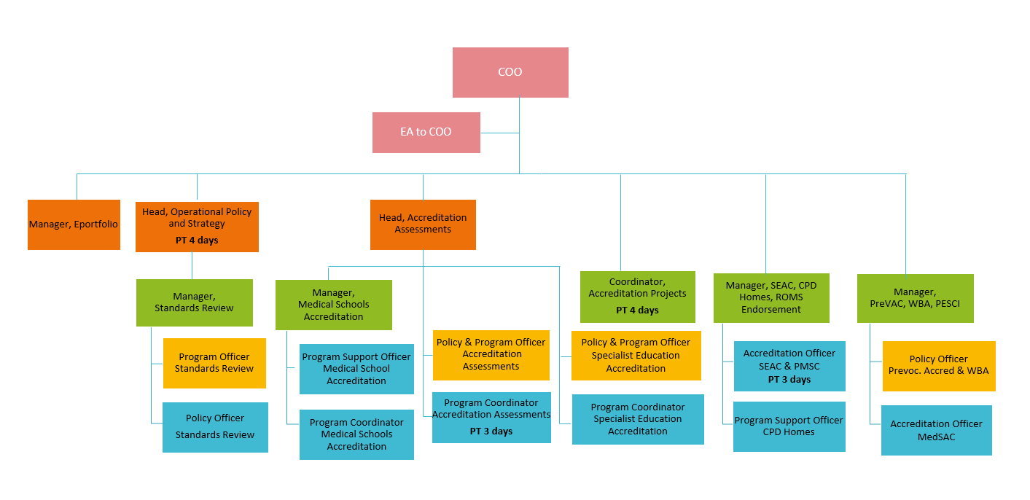

* + - 1. The Accreditation business area reports to the Chief Operating Officer.
      2. There are 20 staff (17 full-time and three part-time) with one staff member currently on parental leave (not including COO and EA).
    1. Fourteen staff manage core business activities (accreditation visits, monitoring and governance) and six staff manage accreditation projects.
  1. **Assessment Department**
     1. The AMC Assessment Services business area is responsible for the assessment and examination of International Medical Graduates (IMGs) seeking registration to practice in Australia. The Assessment Services area is responsible for the development, coordination and conduct of Verification services, MCQ and clinical examination delivery and Workplace-based Assessment (WBA) which are the separate operational areas.
     2. The Assessment Services team works with a range of committees, panels, working groups, stakeholders and other AMC staff to not only manage an AMC candidate’s progress along the pathway to the award of the AMC Certificate, it also works closely with the committees, panels and working groups in the areas of research and data analysis, continuous improvement projects, development and implementation of examination procedures leading to the successful coordination and conduct of exam delivery.

1. **Assessment Services business areas**
   1. **Verifications Area**

**Purpose**

* + 1. The Verification Services area is responsible for the assessment of portfolio applications and to update qualification verification statuses received from ECFMG of IMGs seeking registration to practise medicine in Australia. All IMG information is filtered to the AMC qualifications portal, used by the Medical Board of Australia for registration purposes, and the Australian Specialist Colleges for assessment purposes. The Verification team acts as a first point of contact for IMGs enquiring on the registration pathways and ECFMG requirements.
  1. **MCQ Area**

**Purpose**

* + 1. The MCQ examination team, is responsible for development, coordination, exam content database maintenance, quality assurance, oversee exam security and integrity, exam delivery and continuous improvement projects for the AMCs Multiple-Choice-Question (MCQ) examination. The MCQ team also works closely and coordinates the MCQ panels and writing groups in the areas of exam content development, review and sign-off, continuous improvement projects, development and implementation of examination procedures leading to the successful coordination and conduct of exam delivery.
  1. **Clinical Area**

**Purpose**

* + 1. The Clinical examination team is responsible for the development, coordination, exam content database maintenance, quality assurance, oversee exam security and integrity, exam delivery and continuous improvement projects for the AMCs Clinical examination. The Clinical team work closely with the program team at the AMC test centre in the coordination and delivery of the in-person Clinical exam. The Clinical team also works closely with and coordinates the Clinical panels and writing groups in the areas of exam content development, review and sign-off, continuous improvement projects, and the development and implementation of examination procedures leading to the successful coordination and conduct of exam delivery.
  1. **Workplace Based Assessment (WBA) Area**

**Purpose**

* + 1. The WBA area is responsible for managing the candidates for the WBA programs from the start of the program to the end including result confirmation, liaison with WBA providers, quality assurance of WBA assessments, development and implementation of system (WBA) portal updates and continuous improvement to procedures. The WBA Coordinator works closely with the WBA panel and coordinates the meetings for review and confirmation of WBA program outcomes.

Assessment and Innovation Core Processes

Listed in October 2024 with volume/incidences for FY22/23

|  |  |
| --- | --- |
| **AMC candidate account, portfolio application and primary source verifications** | **No. in 2022-23** |
| AMC initial portfolio applications | 8449 |
| Additional qualifications added to portfolios | 3493 |
| Primary source verification of medical degrees (primary qualifications) | 7848 |
| Primary source verification of postgraduate qualifications | 2625 |
| Update contact details | 5132 |
| Upload of new photo | 2764 |
| Upload of evidence | 808 |
| Upload of new signature | 502 |

|  |  |
| --- | --- |
| **MCQ Examination** | **No. in 2022-23** |
| MCQ Examinations | 4468 |
| Panel meetings to confirm results | 10 |
| Content Development – Writing Groups | 18 |
| Panel meetings to review and confirm Exam Content | 8 |

|  |  |
| --- | --- |
| **Clinical Examination** | **No. in 2022-23** |
| Clinical candidates scheduled for Examinations | 2053 |
| Clinical examinations | 88 |
| Respond to candidate enquiries (Emails) | 10,905 |
| Schedule Examiners | 1760 |
| Recruitment and onboarding of new examiners | 20 |
| Examiner Training sessions | 10 |
| Content Writing Group & Development meetings | 27 |
| Clinical Assessment Panel meetings | 8 |
| Clinical Result Panel meetings | 21 |
| Quality assurance of candidate results | 2053 |
| Clinical Appeals applications | 125 |

|  |  |
| --- | --- |
| **Workplace-Based Assessment** | **No. in 2022-23** |
| Number of candidates whose completed workplace-based assessments were reviewed (each candidate completes multiple WBAs) | 209 |
| Number of review meetings | 5 |

**Assessment Organisation Chart (Feb 2025)**

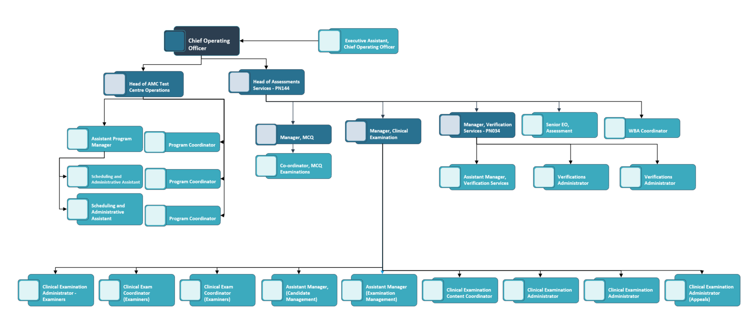

1. **Use of Monday.com in Accreditation and Assessment**
   1. **Purpose**
      1. Within the Accreditation and Assessment departments, Monday.com is widely used as a workflow and task management tool to support both operational and project-based activities.

In Accreditation, Monday.com is used to manage programs of work (ongoing, repeatable processes) through clearly defined process steps, task assignments, due dates, linked documents, and status tracking. Communication is centralised through embedded notes, Outlook push notifications, and visibility tracking, helping teams coordinate efficiently. Templates are used for repeatable processes, and workflows are editable to allow flexibility. The platform also enables communication with external stakeholders through features such as online forms.

In the Assessment area, team members use Monday.com to track and allocate work, monitor the progress of projects, and export data for reporting purposes. The tool is valued for its ease of use and visibility, supporting day-to-day coordination across projects and operational activities.

Monday.com plays an important role in task management, visibility, and cross-team coordination, helping both teams manage their distinct but complementary workstreams effectively.

1. **Stakeholder Management Contacts Database**
   1. **Purpose**
      1. The Stakeholder Management Contacts Database is an existing solution within the AMC Landscape that is responsible for managing internal and external stakeholder data. This enables the AMC to respond to and engage in the key activities necessary for the AMC to operate as an organisation. Maintaining this data is essential for several reasons, including making data-informed decisions, improving client and stakeholder retention as well as remaining compliant with legislation, regulations and best practice.

The AMC Stakeholder Management Contacts Database is used to manage all people and organisations relevant to the AMC. Predominantly, this encompasses the following functions:

* Storage of person and organisation information including their roles and engagement, such as AMC Staff and AMC affiliated individuals, i.e. Examiners, Assessors, Simulated Patients, Invigilators etc.) Provider information is also maintained here (i.e. Medical Schools, Colleges Prevocational Providers etc.)
* Managing Travel Needs and Preferences
* Managing Finance Needs and Preferences
* Providing a repository for Non-Disclosure Agreements (NDAs) and contractual documents for external persons that are not housed in Employment Hero, the HR and Payroll solution adopted by the AMC
* Respectfully managing Indigenous Information, and leveraging Indigenous Data Governance
  + 1. Due to the age of the application, preliminary feedback indicates that it would be beneficial to upgrade the solution to a more modern platform, to increase productivity and enable better maintainability – the database is at end-of-life, hence this is an opportune time to leverage other business initiatives to modernise this core AMC system.
    2. Current project

The AMC has initiated a project that is dedicated to focus on eliciting key questions pertaining to what the Stakeholder Management Contacts Database currently does. Existing pain points will also be identified, along with opportunities for improvement. This information will be synthesised to provide capability, value, information and initial system mappings to identify opportunities for effective change. This project is currently in execution phase and some of its deliverables will be utilised as input into for the process and systems improvement project.

* + 1. Connecting into other AMC systems

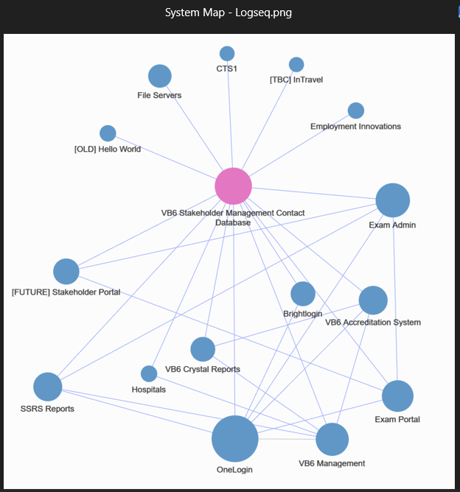

1. **Current State Architecture**
   1. **Application Architecture Models**
      1. The purpose of this section is to demonstrate the application architecture for AMC Accreditation and Assessment departments.

***Please note that this might not be representative of the current state architecture as things might have changed since the development of these diagrams and information provided.***

* 1. **Baseline Application Architecture**
     1. This section provides an aggregated conceptual level view for the baseline application architecture for Accreditation and Assessment departments. This illustrates the application services and their relation to the business services within AMC.

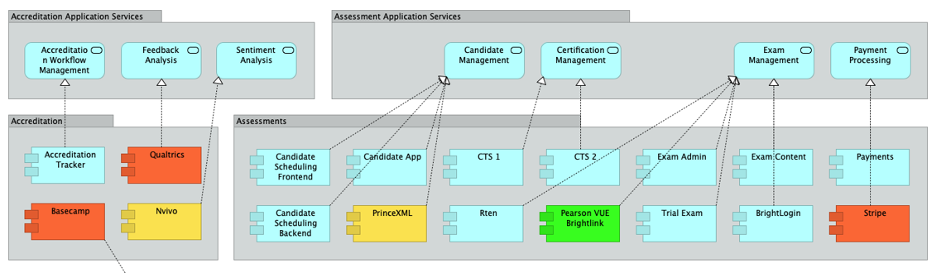

Figure 5: Conceptual Baseline Application Architecture

* + 1. There are two core business units within the AMC in scope with their own applications, with ICT Corporate Services application and services supporting their operations. The ICT Corporate Services applications have been removed from the list.
    2. These business units are:
       1. Assessment Services; and
       2. Accreditation.

1. **Application Services**
   1. This section provides a definition for the application services specific to Accreditation and Assessment Services departments application architecture.

|  |  |  |
| --- | --- | --- |
| Application Service | Application Service Description | Business Unit |
| Accreditation Workflow Management | A service for managing the accreditation workflows | Accreditation |
| Candidate Management | A service for managing assessment candidates | Assessment |
| Certification Management | A service for managing certifications | Assessment |
| Exam Management | A service for managing and scheduling exams | Assessment |
| Feedback Analysis | A service for collecting and analysing feedback | Accreditation |
| Payment Processing | A service for processing online payments | Assessment |
| Sentiment Analysis | A service for opinion mining | Accreditation |

1. **Baseline Application Components**
   1. This section provides a definition for the application components for the application architecture specific to Accreditation and Assessment Services departments.

|  |  |  |
| --- | --- | --- |
| Application Component | Application Components Description | Business Unit |
| Accreditation Tracker | Process map and light workflow engine for accreditation | Accreditation |
| Basecamp | Project Management | Accreditation |
| Brightlink | Clinical exam marking solution | Assessments |
| BrightLogin | Authentication for Brightlink used to create and provision users and mapped back to internal AD through OneLogin | Assessments |
| Candidate Scheduling Backend | Tracks candidate exam placement (Backend) | Assessments |
| Candidate Scheduling Frontend | Tracks candidate exam placement (Frontend) | Assessments |
| Candidate App | Tracks candidate exam results, issue of AMC certificate | Assessments |
| Contacts App | Lightweight CRM of the whole of AMC | ICT Corporate Services |
| CTS1 | Tracks IMG portfolio applications, progress through certification pathway | Assessments |
| CTS2 | Tracks IMG portfolio applications, progress through certification pathway | Assessments |
| Exam Admin | Handles exam blueprinting and scheduling of resources (marshals, invigilators, examiners, simulated patients, and candidates) for clinical exam | Assessments |
| Exam Content | Item Bank for MCQ and Clinical Exams | Assessments |
| Nvivo | Used for qualitative text analysis / sentiment analysis | Accreditation |
| Payments | Payment gateway for MCQ exams and online store | Assessments |
| PrinceXML | Used to generate the PDFs for candidates | Assessments |
| Qualtrics | Survey software | Accreditation |
| Rten | Listens for messages from Pearson VUE for exam results (uses SOAP) | Assessments |
| Stripe | Payment gateway for clinical exams | Assessments |
| Trial Exam | Used for Trial/Practice Exams | Assessments |

1. **Logical Baseline Data Architecture**
   1. The diagram below provides an example view of the data architecture at the logical level which consists of logical data entities and the relationships between them. This illustrates the logical data entities derived from the customer business object.

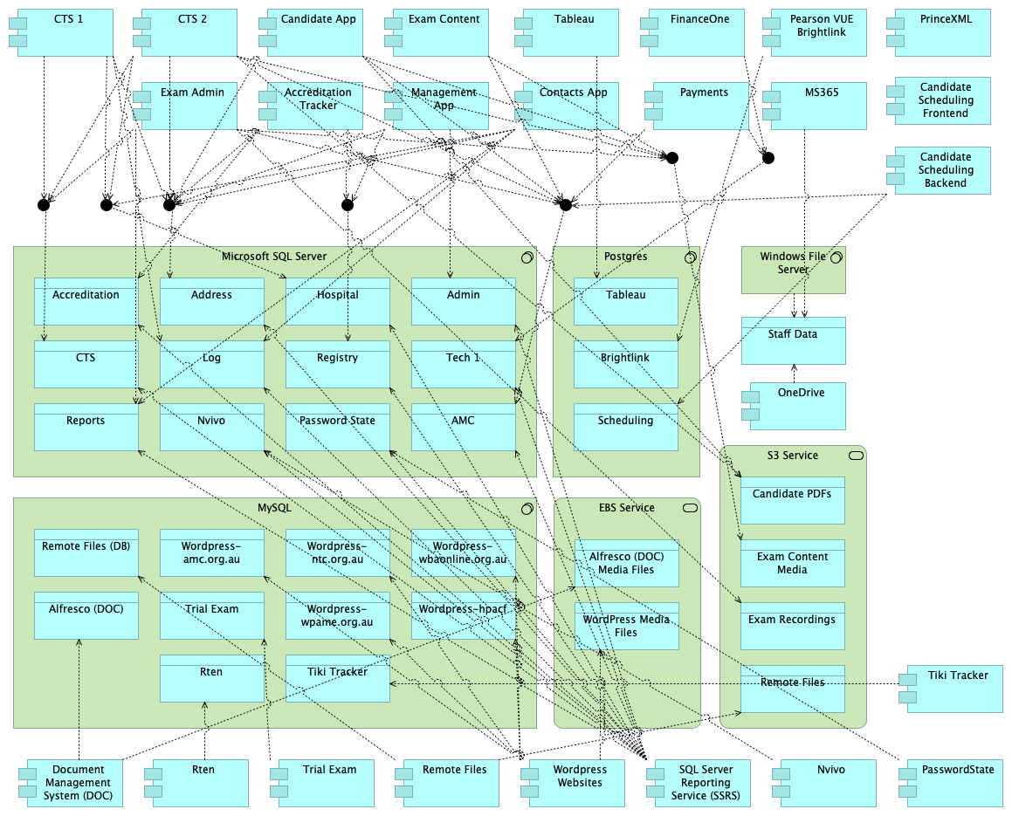

Figure 9: Logical Baseline Data Architecture

Appendix 2: Sample for Process Map Level of detail

This section has been added as a sample of the type and level of process mapping required for this project.

Sample As-is process map: Sample process map: complete process

1. Sample process map: detail

