FACILITATOR GUIDE – EPA ASSESSOR TRAINING
It is important that the content within this module remains consistent with information and resources provided by the AMC. However, this module can be adapted to the length of the workshop or training being delivered, or to include any locally relevant information.
Discussion/reflection questions are provided throughout the module notes that you may choose to include, you may also come up with additional questions.
PMC and/or health service logos may be added to the slides. The AMC logo is to remain.
TABLE 1:
Image | Facilitator notes
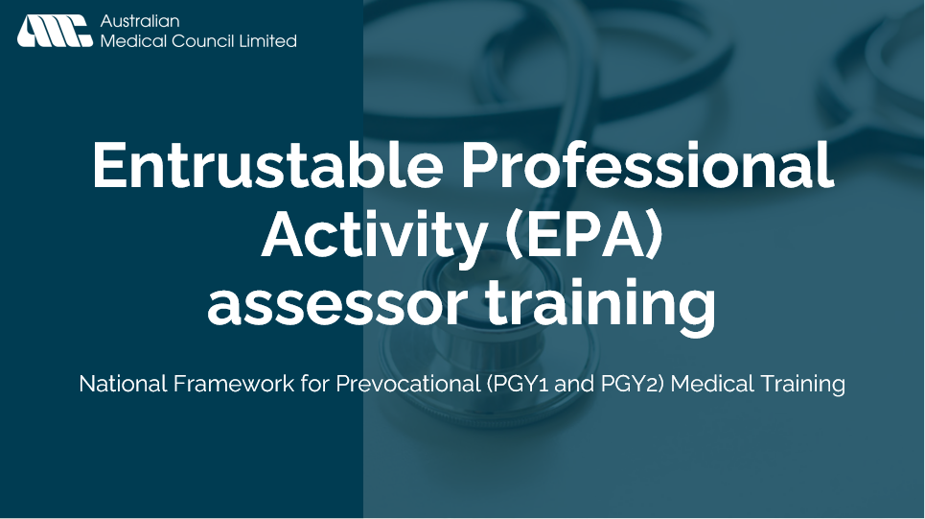 | - Title slide  EPA assessor training - To support the implementation of the National Framework for Prevocational Medical Training.
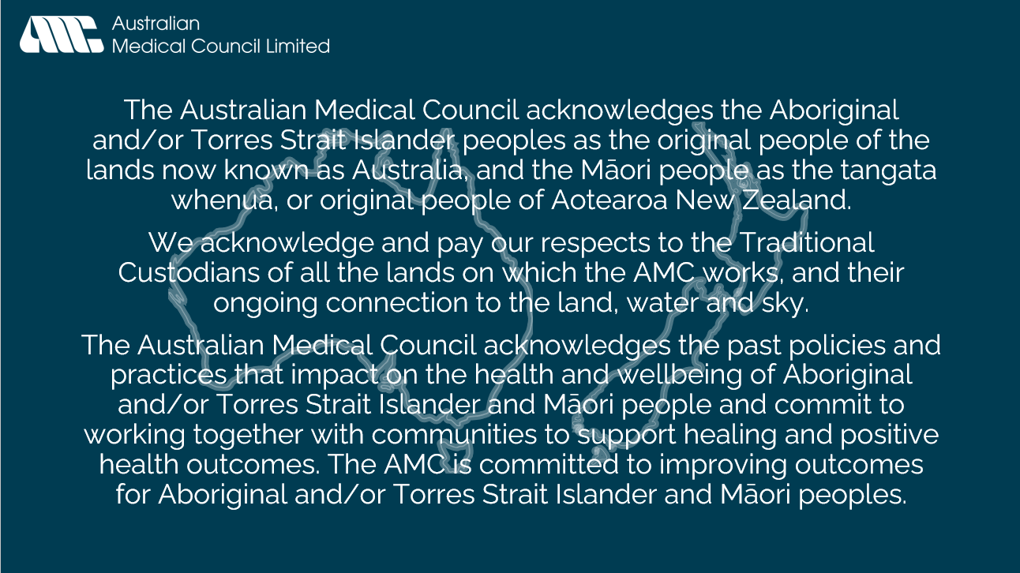 | - Acknowledgement of Country  The Australian Medical Council acknowledges the Aboriginal and/or Torres Strait Islander peoples as the original people of the lands now known as Australia, and the Māori people as the tangata whenua, or original people of Aotearoa New Zealand.  We acknowledge and pay our respects to the Traditional Custodians of all the lands on which the AMC works, and their ongoing connection to the land, water, and sky.  The Australian Medical Council acknowledges the past policies and practices that impact on the health and wellbeing of Aboriginal and/or Torres Strait Islander and Māori people and commit to working together with communities to support healing and positive health outcomes. The AMC is committed to improving outcomes for Aboriginal and/or Torres Strait Islander and Māori peoples.
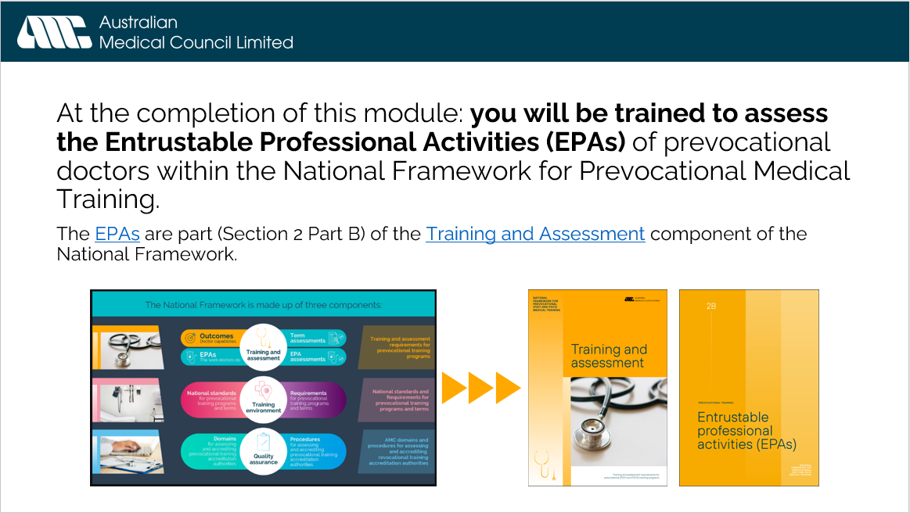 | - Context of module  At the completion of this module: you will be trained to assess the Entrustable Professional Activities (EPAs) of prevocational doctors within the National Framework for Prevocational Medical Training.  The EPAs are part (Section 2 Part B) of the Training and Assessment component of the National Framework.
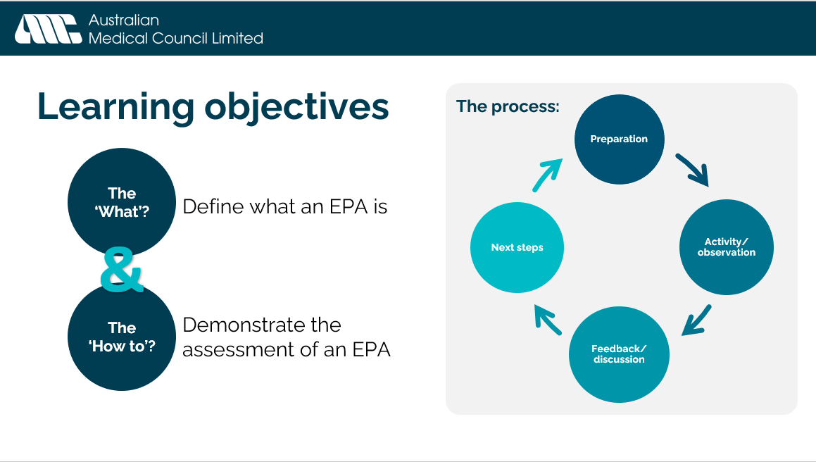 | - Learning objectives  By the end of this module, you will be able to:  - Define what an EPA is – the ‘what’  - Demonstrate the assessment of an EPA – the ‘how to’  The module will follow the broad cyclical process illustrated on screen – Preparation, Activity/observation, Feedback/discussion, Next steps.
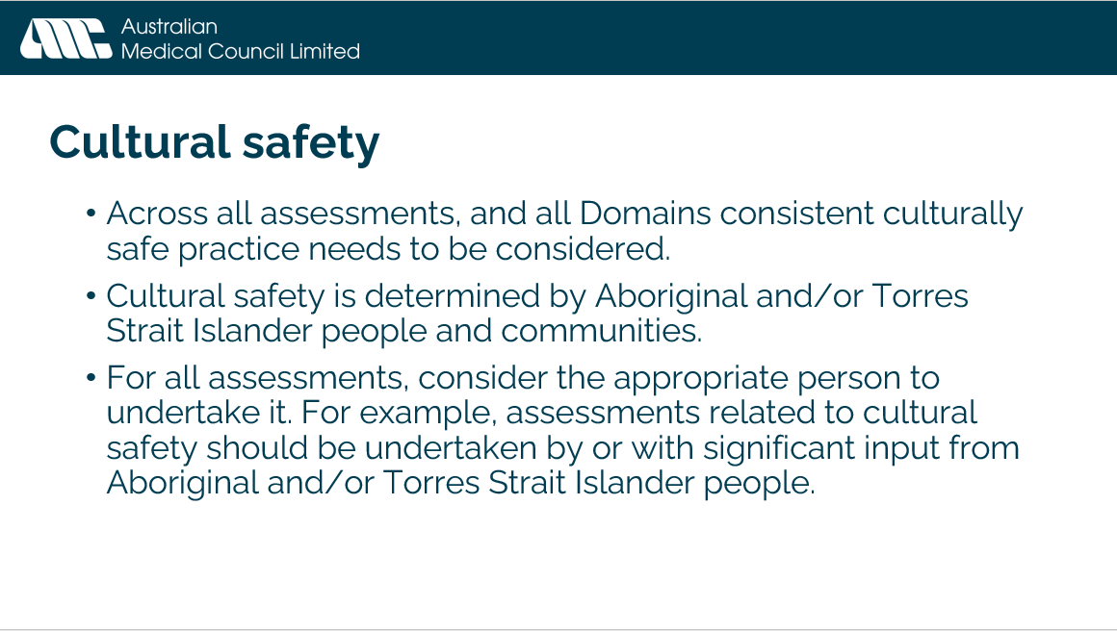 | - Cultural safety  Across all assessments, and all Domains consistent culturally safe practice needs to be considered (even where not explicitly mentioned).  Cultural safety is determined by Aboriginal and/or Torres Strait Islander people and communities.  For all assessments, consider the appropriate person to undertake it. For example, assessments related to cultural safety should be undertaken by or with significant input from Aboriginal and/or Torres Strait Islander people. This consideration could also apply to other marginalised groups.  Where possible, the assessor should consult those with more significant contact with the prevocational doctor, this could be the registrar, DCT, MEOs, Aboriginal and/or Torres Strait Islander health professionals from a range of health disciplines, nurses and other allied health professionals or Aboriginal Hospital Liaison Officers.
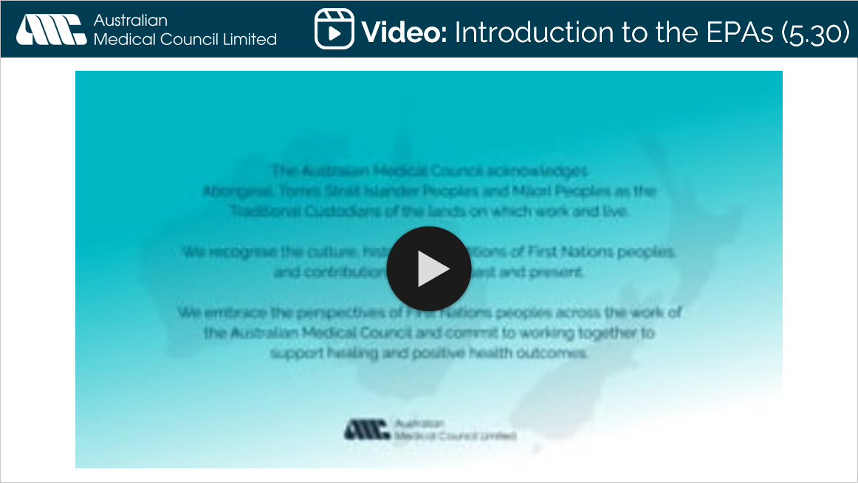 | - Video: Introduction to the EPAs (5:30)  Link: https://www.vimeo.com/user26532563/AMC-Animation-EPAs
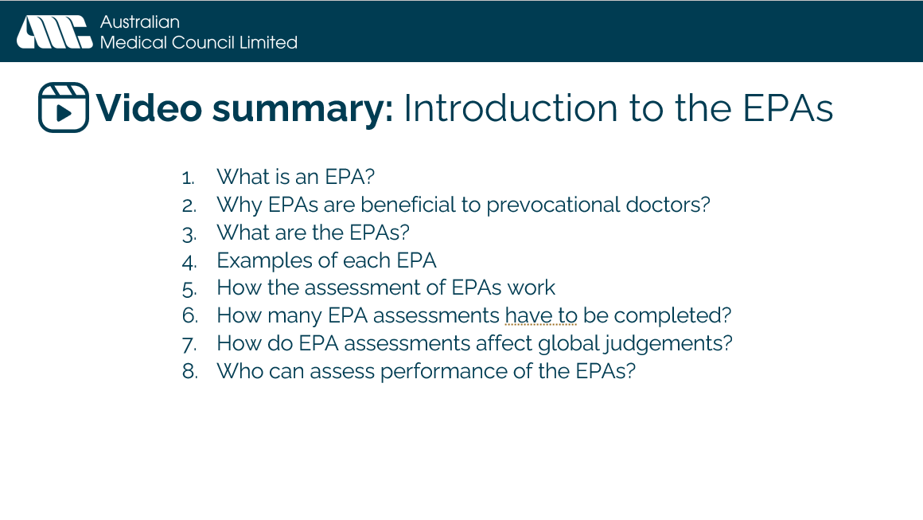 | - Video summary: Introduction to the EPAs  Video contains the following sections:  - What is an EPA?  - Why EPAs are beneficial to prevocational doctors?  - What are the EPAs?  - Examples of each EPA  - How the assessment of EPAs work  - How many EPA assessments have to be completed?  - How do EPA assessments affect global judgements?  - Who can assess performance of the EPAs?  - Place to reiterate: For all assessments, consider the appropriate person to undertake it. For example, assessments related to cultural safety should be undertaken by or with significant input from Aboriginal and/or Torres Strait Islander people. This consideration could also apply to other marginalised groups.
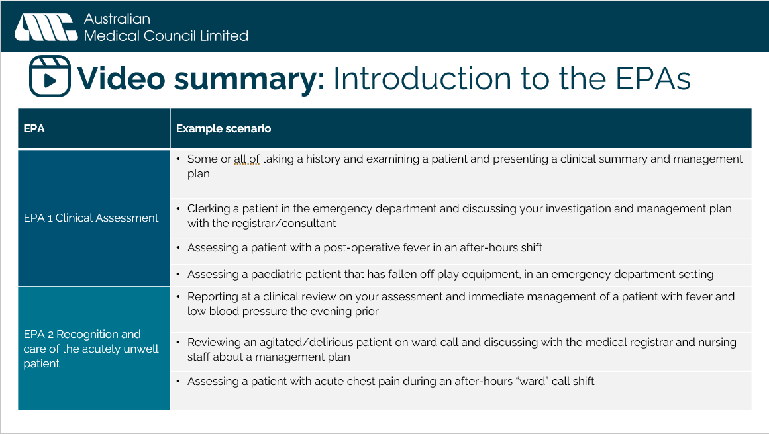 | - Video summary: Introduction to the EPAs – example scenarios for each EPA (1 & 2)  The four EPAs have been deliberately designed to be broad and flexible enough that they are applicable in any clinical setting. This slide and the next provide some examples of each EPA.  EPA 1:  - Some or all of taking a history and examining a patient and presenting a clinical summary and management plan  - Clerking a patient in the emergency department and discussing your investigation and management plan with the registrar/consultant  - Assessing a patient with a post-operative complications in an after-hours shift  - Assessing a child in an Emergency Department setting  - Admitting a patient for surgery or specific procedures  - Assessing a patient’s mental health issues  EPA 2:  - Reporting at a clinical review on your assessment and immediate management of a patient with fever and low blood pressure the evening prior  - Reviewing an patient with agitation or delirium on ward call and discussing with the medical registrar and nursing staff about a management plan  - Assessing a patient with acute chest pain during an after-hours “ward” call shift  - Assessing a patient with abnormal observations, or identified by nursing staff as potentially at risk of deterioration
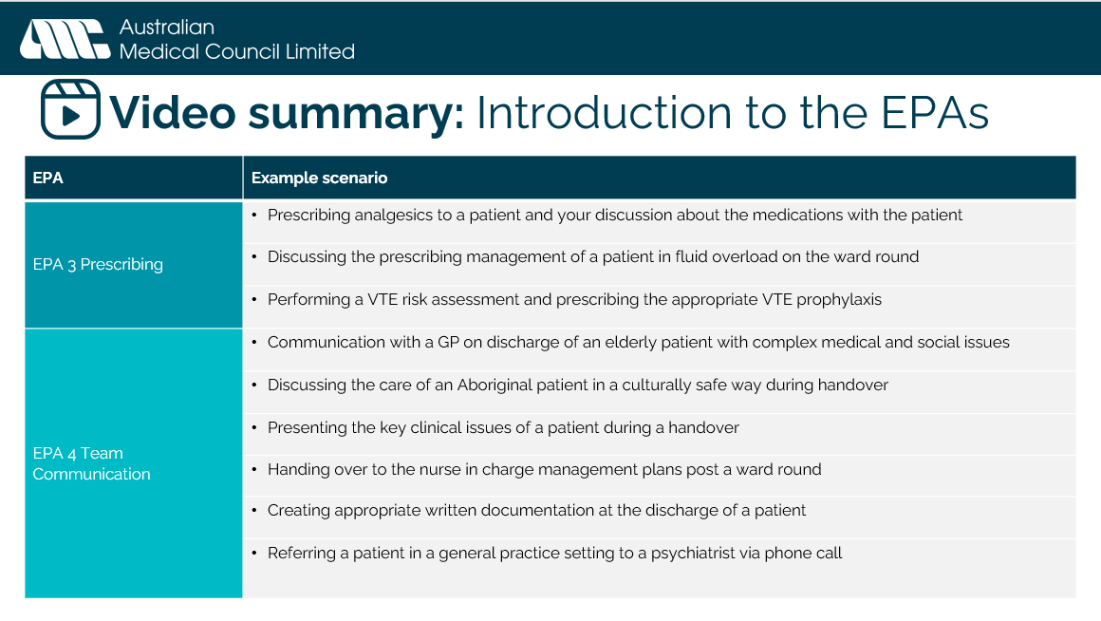 | - Video summary: Introduction to the EPAs – example scenarios for each EPA (3 & 4)  EPA 3:  - Prescribing analgesics to a patient and your discussion about the medications with the patient  - Discussing the prescribing management of a patient in fluid overload on the ward round  - Performing a VTE risk assessment and prescribing the appropriate VTE prophylaxis  - Prescribing appropriate antibiotics for post operative infections  - Medication review with supervisor  EPA 4:  - Writing a consultation referral for a sub speciality  - Discussing a patient requiring registrar review with the registrar  - Communication with a GP on discharge of an elderly patient with complex medical and social issues  - Discussing the care of an Aboriginal patient in a culturally safe way during handover  - Presenting the key clinical issues of a patient during a handover  - Handing over to the nurse in charge management plans post a ward round  - Creating appropriate written documentation at the discharge of a patient  - Referring a patient in a general practice setting to a hospital specialist  Discussion/reflection question: What are some common occurrences in your unit/setting that may facilitate the assessment of an EPA?
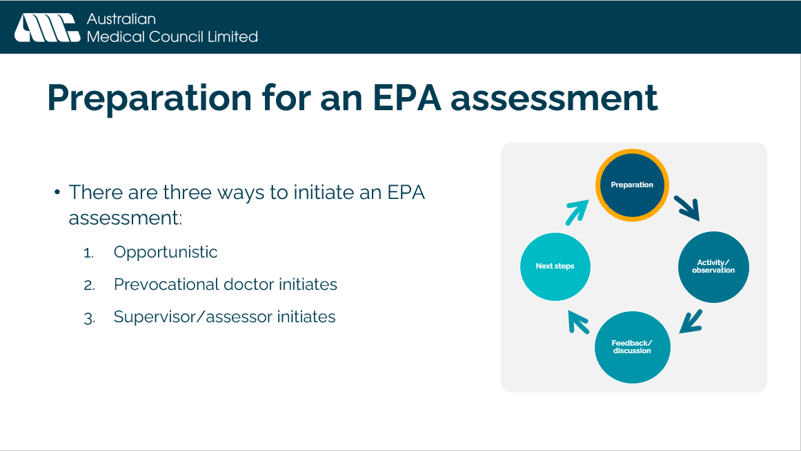 | - Preparation for an EPA assessment  There are three ways to initiate an EPA assessment:  - Opportunistic – regular work day presents an appropriate EPA for assessment (unplanned)  - Prevocational doctor initiates – “I think I need to work on my XXX, would you please watch me do XXX and we can have a discussion about EPA X afterwards?”  - Supervisor/assessor initiates – “It would be good for you to have a bit more practice on XXX, let’s do an EPA X on XXX this afternoon.”  Sometimes assessments are set up proactively, other times retroactively, more often than not, they are initiated opportunistically during the regular activities of the workday.  You may need to set some time aside for a discussion later on if there is going to be a gap between the activity/observation and the feedback/discussion. Although the feedback discussion can happen directly after the activity/observation.  In some circumstances it may be appropriate to tell the patient if an EPA is being observed for the purposes of assessment. Decide between the two of you, who will explain this to the patient and the best way in which to do so.
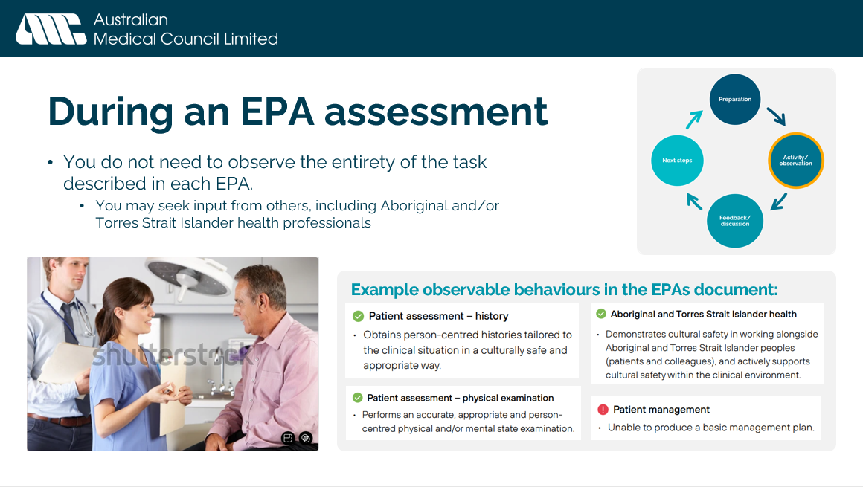 | - During an EPA assessment – Activity/observation  You do not need to observe the entirety of the task described in each EPA.  - You may seek input from others in the team where you would like more information on parts of the task you didn’t observe  - An Aboriginal and/or Torres Strait Islander health professional could provide input on cultural safety behaviours.  - Assessors and those providing additional input in the assessment do not have to be doctors.  EPAs are designed to cover a range of activities. An EPA may involve no direct observation e.g. EPA 4 you may be reviewing written notes and documentation to make an assessment.  The EPAs document includes non-exhaustive lists of observable behaviours that may assist assessors in making an assessment
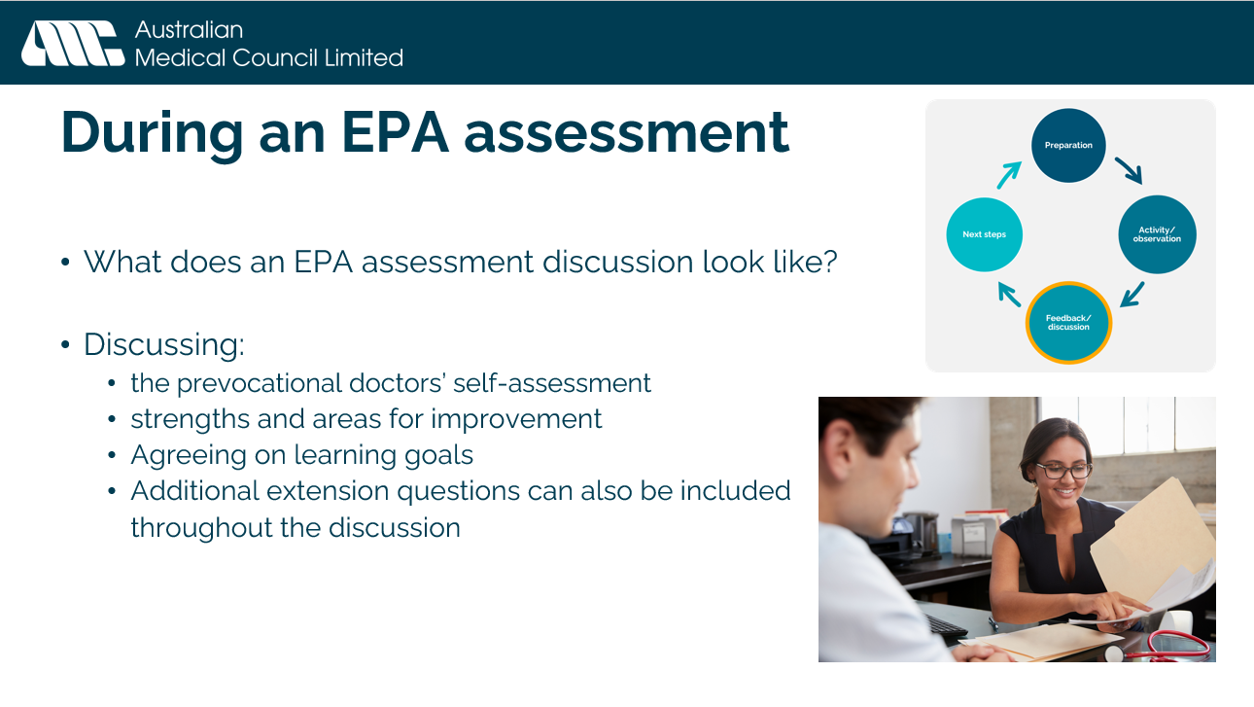 | - During an EPA assessment – Feedback/discussion  - What does an EPA assessment discussion look like?  - Discussion to be had in a quiet area if possible  - Following principles of giving effective feedback, ensuring to ask how the prevocational doctor thinks they performed.  - Discussion will usually take 10 minutes in addition to the time observing the task in the normal workday, however it can take longer if you would like to explore the case in more depth:  - “What would you do if the patient was older?”  - “…was from a non-English speaking background?”  - “…lived alone with no immediate carer support available?”  - “How would you ensure culturally safe care for an Aboriginal and/or Torres Strait Islander patient in this clinical setting?”  - The discussion should include:  - the prevocational doctors’ self-assessment – it is expected and strongly encouraged that a self-assessment is completed as part of the EPA form, however it may not occur in all circumstances, or may occur after the discussion  - strengths and areas for improvement  - agreeing on learning goals  As described in the video earlier in the module. The order of filling out the form, or the items in this list is not important. What matters is the reflection, feedback and discussion had.  Discussion/reflection question: What are some common variables you might ask the prevocational doctor to consider relevant to your unit/setting?
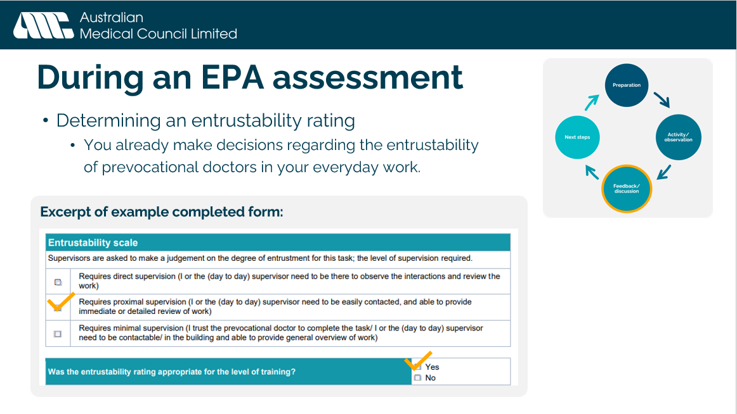 | - During an EPA assessment - Feedback/discussion  - Determining an entrustability rating  - Familiarise yourself with the entrustability scale. You already make decisions regarding the entrustability of prevocational doctors in your everyday work. Do you trust a prevocational doctor to complete this task independently next time? Do you need to be nearby? Do you need to be there during the interactions to review the work as it occurs?  - Was the entrustability rating appropriate for the level of training e.g., direct supervision may be appropriate for a doctor at the beginning of PGY1, but not appropriate for someone mid-way through PGY2.
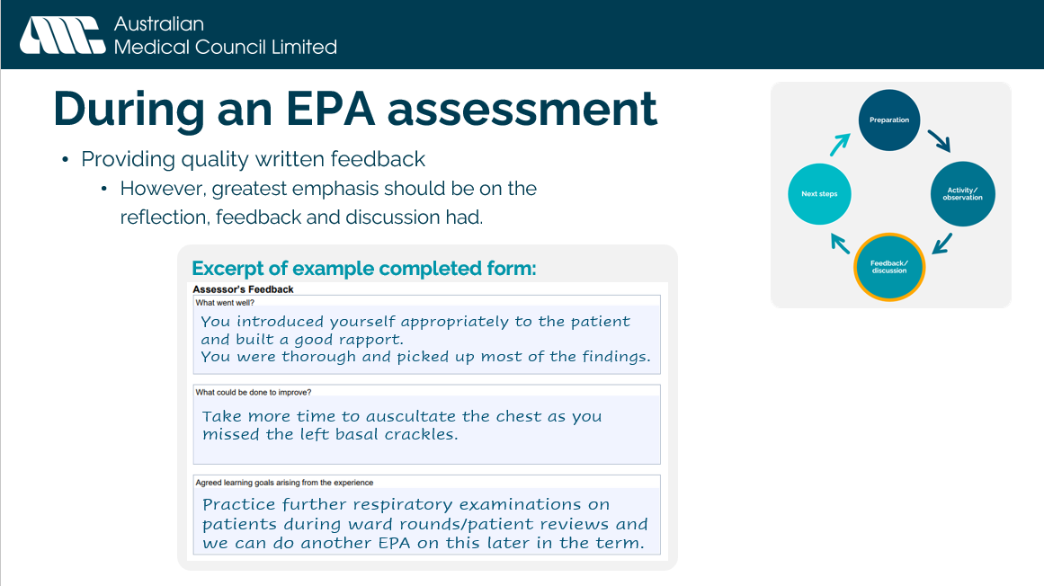 | - During an EPA assessment - Feedback/discussion  - Providing quality written feedback  - Again, as described in the video earlier in the module. The order of filling out the form, or the items in this list is not important. What matters is the reflection, feedback and discussion had.  - However, written feedback should also follow principles of giving effective feedback. Some examples of topics for written feedback:  - You introduced yourself appropriately to the patient and built a good rapport.  - You were thorough and picked up most of the findings.  - Take more time to auscultate the chest as you missed the left basal crackles.  - Practice further respiratory examinations on patients during ward rounds/patient reviews and we can do another EPA on this later in the term.
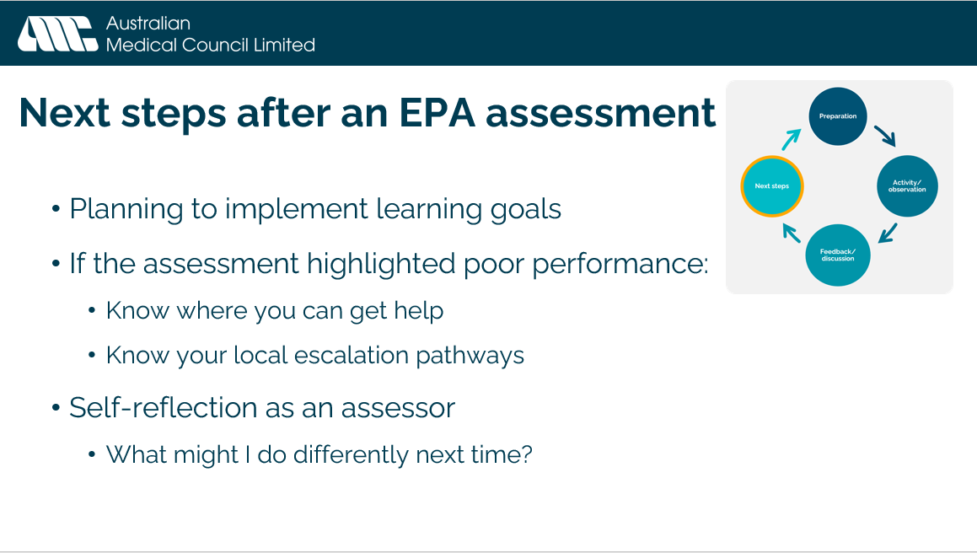 | - Next steps after and EPA assessment  - Planning to implement learning goals  - If the assessment highlighted poor performance:  - Know where you can get help  - Know your local escalation pathways  - [INCLUDE A LOCAL EXAMPLE OF WHAT THE ESCALATION PATHWAYS ARE]  - Self-reflection as an assessor. Questions you may ask yourself include:  - What might I do differently next time?  - What are some of the assumptions you make (for patients and doctors)? How might you manage these assumptions?  - What do you understand about your own skills and abilities? What further training/learning might you need to do in relation to caring for Aboriginal and/or Torres Strait Islander patients?  - Can you describe the networks you’re building to provide safe person-centred care? For example, networks including Aboriginal and Torres strait Islander staff.
Note - discussing case scenarios:
Recommend you discuss a minimum of two example scenarios. Suggest discussing an EPA 1 example, as they need to be conducted once in every term. EPA 4 is helpful to discuss as it is different to the other EPAs.
In group delivery, different breakout groups could discuss different scenarios.
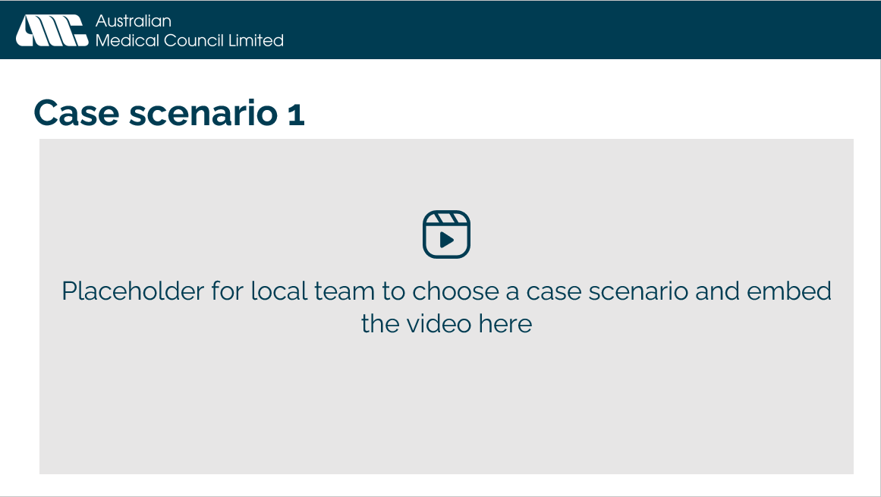 | - Case scenario 1  TABLE 2 in facilitator guide lists videos with links, synopsis of case and discussion questions for each.  Choose a video from the links available to embed on this slide.
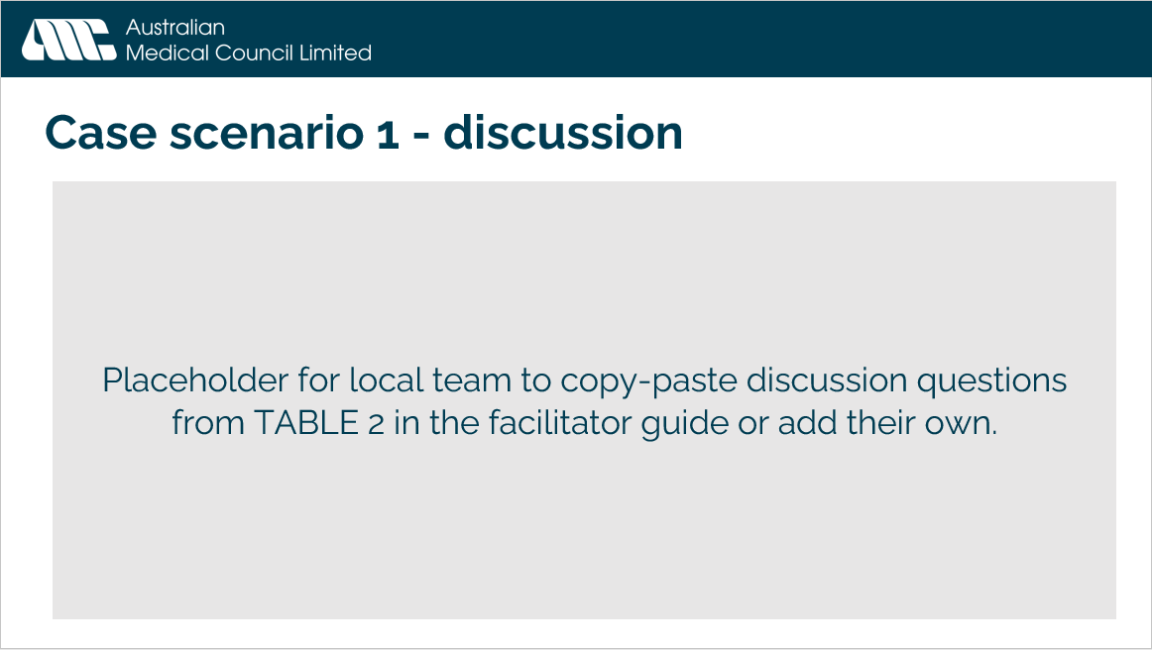 | - Case scenario 1 - discussion  TABLE 2 in facilitator guide lists videos with links, synopsis of case and discussion questions for each.  Copy-paste the relevant discussion questions from TABLE 2 onto this slide or add your own.
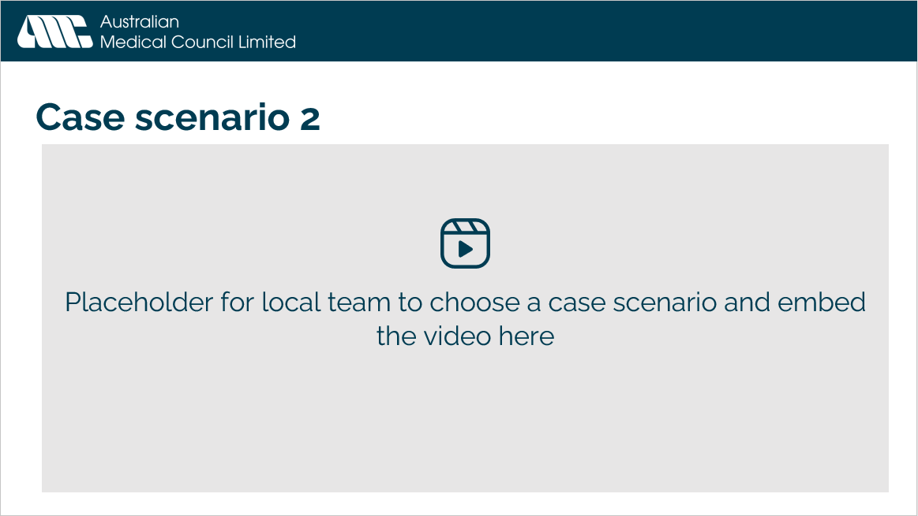 | - Case scenario 2  TABLE 2 in facilitator guide lists videos with links, synopsis of case and discussion questions for each.  Choose a video from the links available to embed on this slide.
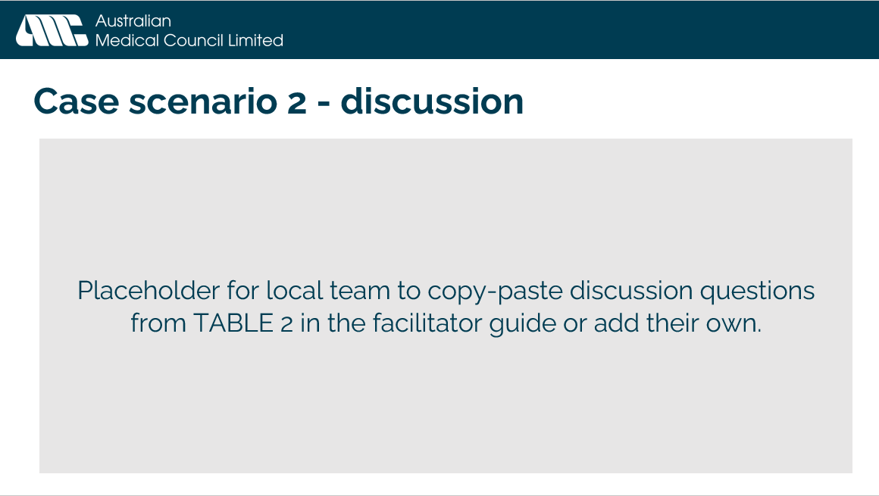 | - Case scenario 2 - discussion  TABLE 2 in facilitator guide lists videos with links, synopsis of case and discussion questions for each.  Copy-paste the relevant discussion questions from TABLE 2 onto this slide or add your own.
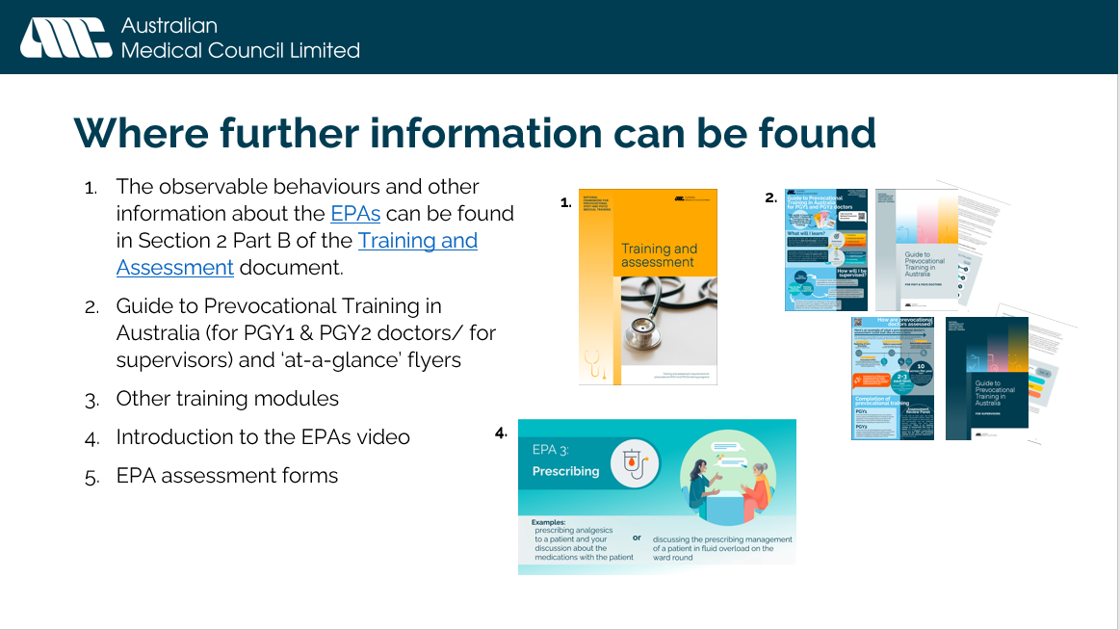 | - Where further information can be found  - The observable behaviours and other information about the EPAs can be found in Section 2 Part B of the Training and Assessment document.  - Guide to Prevocational Training in Australia (for PGY1 & PGY2 doctors/ for supervisors) and ‘at-a-glance’ flyers  - Other training modules  - Introduction to the EPAs video  - Introduction to the National Framework video  - EPA assessment forms

FACILITATOR GUIDE TO EPA SCENARIO VIDEOS
Note: These videos focus on the discussion had between the assessor and prevocational doctor. These example videos are not intended to be ‘perfect’ rather they are realistic examples of how EPA assessments might occur as part of the normal day-to-day work of a prevocational doctor. The videos are not designed to present any specific advice on “best clinical practice” but rather to create discussion and reflection around concepts of how supervisors decide on entrustment as well as modelling how they might give EPA feedback. It is expected that different supervisors will have different opinions on how they might approach the situations described. EPAs are about trust rather than competency and these videos are designed to help supervisors reflect on this.
The videos have been designed to cover different environments and contexts so educators can choose a video that might relate to the specific supervisor group and context. EPA 1 – “patient with a fever” and EPA2- “patient with chest pain” are the most straight forward EPA conversations for short supervisor workshops. The other EPA videos are designed to create deeper discussion. The videos can also be used to facilitate discussion about feedback principles. The aim of supervisor workshops on EPAs is to improve feedback from supervisors to prevocational doctors.
TABLE 2:
EPA | Scenario text on screen at beginning of video | Facilitator further notes (where required)  Discussion questions | Example assessment form | Video
EPA 1 Clinical Assessment | Fever example  James is a PGY1 doctor doing a term with a peri-procedural care classification. During a routine ward round with his term supervisor James presented Mrs Smith, a 74-year-old female patient who was post hemicolectomy. He had been asked to review Mrs Smith during his after-hours shift the previous evening because she had developed a fever. His term supervisor suggested that he complete an EPA1 assessment based on a presentation during the ward round of his clinical assessment of Mrs Smith’s fever  Level of entrustability  Minimal supervision | This is a good example of a very concrete EPA- a classic afterhours task where the Consultant Surgeon has not seen the prevocational doctor do the task but rather assessed their management and thinking during the surgical ward round the next morning. They then have a brief post round discussion. The video demonstrates how to ask reflective feedback questions to get a sense of the prevocational doctor’s approach and then the senior doctor identifies the specifics to reinforce the learning. There is a clear description of the senior doctor using EPA language and explaining what that means. It could be useful to stop the video just prior to the end and ask workshop participants to say what level of supervision they would give in this situation before revealing the final minute of the video.  Discussion questions:  - What level of entrustment might you choose as the assessor in this example?  - How do we decide as supervisors on whether we trust a prevocational doctor’s assessment?  - When do you need to observe the full work of the prevocational doctor, or when can you observe part of it? | Form (pdf) | EPA 1 – fever example video (4:29)
 | Paediatric example  Georgina is a PGY1 doctor working in a Rural Emergency Department. She has just seen a 2-year-old child Jasmine who was brought in by her mother after falling off play equipment. Jasmine has multiple bruises over her body, but Georgina has not considered any social history or child at risk assessment. Georgina had requested the opportunity for an EPA 1 assessment before seeing Jasmine and so her ED supervisor was observing for most of the consultation and now takes the opportunity to have an EPA 1 conversation.  Level of entrustability  Direct supervision | This video demonstrates how a prevocational doctor has taken an excellent medically focused history and examination without considering the psychosocial history which is crucial to the case. The prevocational doctor failed to consider “child at risk” issues in a child presenting with multiple bruises. The supervisor was present for most of the consultation as they saw the child together but allowed Georgina to do the history, examination, and summary before discussing the issues away from the bedside. The video demonstrates opportunistic teaching with EPAs as a tool and how EPA feedback can be done on the run in a busy emergency department. This video can also be used to discuss concepts around direct supervision – what does it mean in different supervisor contexts? In this context of an emergency department all children must be reviewed by a senior doctor and so direct supervision is appropriate for PGY1s assessing children in this context. The supervisor reassures Georgina that direct supervision is to be expected at her level in this context.  Discussion questions:  1. What does direct supervision mean in your clinical context?  2. How can opportunistic teaching and EPA assessments be done together?  3. Do you always need consent for an EPA? | Form (pdf) | EPA 1 – Paediatric example video (7:58)
EPA 2 Recognition and care of the acutely unwell patient | Chest pain example  Georgina is a PGY1 doctor who has assessed a patient with chest pain during her after hours “ward” call shift. The patient has been in hospital for a few days and developed chest pain. She has discussed the patient’s history and management with the supervising medical registrar Hash, and they have been to review the patient together. Georgina asks Hash could she please use this patient assessment of acute chest pain as an EPA 2 assessment.  Level of entrustability  Proximal supervision | Discussion questions:  1.What level of entrustment would you have been happy to give here?  2.What does proximal supervision mean in your clinical context?  3.Why is an EPA assessment different to measuring a competency? | Form (pdf) | EPA 2 – Chest pain example video (4:17)
EPA 3 Prescribing | Analgesics example  James is a PGY1 doctor working in the Emergency department. Towards the end of his shift, he asks his Term supervisor Luke, could he do an EPA 3 assessment on prescribing around a patient he had seen earlier. He had assessed Mrs Jones, a 42-year-old woman with very complex conditions and chronic abdominal pain and he had started her on some opiate analgesia at the request of the admitting team before sending her to the ward.  Level of entrustability  Proximal supervision | In this video the supervisor recognises early on that the opiate prescribing was incorrect however as the supervisor explores through a feedback conversation the prevocational doctor’s thinking and they realise that the prevocational doctor has had a very thorough and thoughtful approach to the patient’s management. This video can be used very effectively to create conversations and discussion about how we judge level of entrustment It can be useful to play the first part of the video and then stop and ask people what they are thinking and then continue with more of the video and see if people have changed their entrustment level and ask them to discuss why. It is expected that different supervisors will have different views which is to be expected as we want supervisors to appreciate that entrustment is not about measuring competency but rather it is their judgment as a supervisor around trust.  Discussion questions:  1. How does the feedback conversation impact our level of entrustment? How do we as supervisors work out what level of supervision is required?  2. How is an EPA assessment different from measuring a competency?  3. How would you fill out the assessment form? | Form (pdf) | EPA 3 – analgesics example (proximal supervision) video (9:36)
EPA 4 Team Communication | GP mental health referral example  Georgina is a PGY2 doctor undertaking a term in rural General Practice. She had seen a patient with bipolar disorder who presents with a potential recurrence of mania. Georgina has assessed the patient then called her GP supervisor in for assistance. This patient is also under the care of a local psychiatrist and so the GP encourages Georgina to ring the Psychiatrist and handover this patient to them and the local mental health team. Following this they debrief, and the GP suggests this could be an EPA 4 assessment around team communication.  Level of entrustability  Minimal supervision | This EPA demonstrates a very capable prevocational doctor undertaking a complex mental health history and then handover to a psychiatrist. The GP supervisor observed the conversation and is commenting on a mental health assessment and a mental health handover conversation. The video also demonstrates a feedback style where the supervisor asks questions about the prevocational doctor’s approach rather than giving any advice. During the feedback conversation the supervisor reinforces through questions the key aspects of the case that were well done. This video is a good example to demonstrate that it is important when prevocational doctors do a good job that you build their confidence and capability through an EPA conversation that identifies specific positives to enhance their learning. The video also demonstrates that it is good to let prevocational doctors do things so you can gain trust in them and feel assured of their capability. This situation could easily happen in the emergency department as well.  Discussion questions:  1. In what ways can a prevocational doctor demonstrate good communication?  2. What does minimal supervision mean in your clinical context?  3. Why is it important to do an EPA assessment when prevocational doctors do an excellent job? | Form (pdf) | EPA 4 – GP mental health referral example video (6:25)

