AMC National Framework for Prevocational (PGY1 & PGY2) Medical Training
October 2023 - Overview presentation - Speaker notes
Slide |  |  | Speaker notes
Section1: Background
1 | 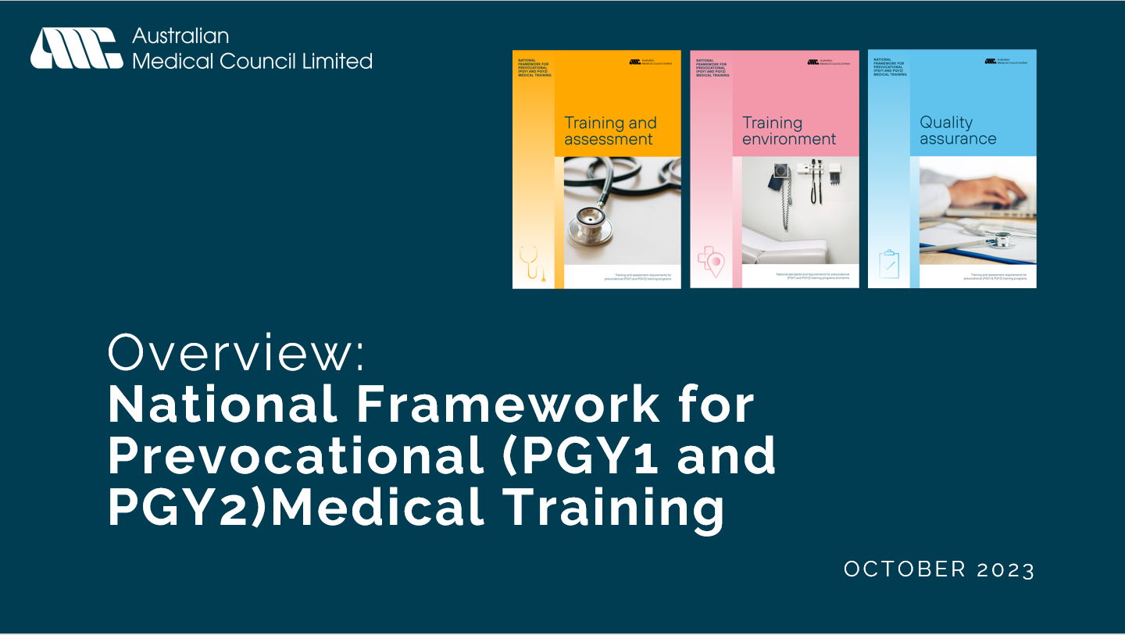 | National Framework for Prevocational (PGY1 & PGY2) Medical Training
2 | 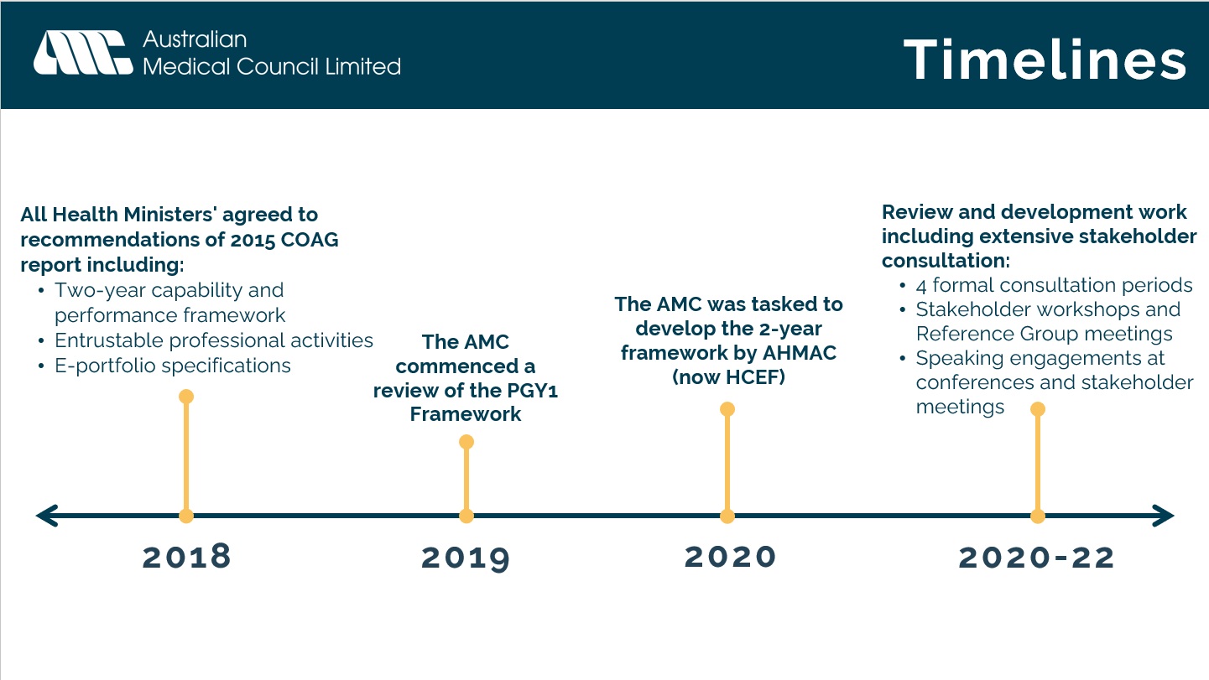 | Timeline and drivers of the revision of the National Framework:  - In 2018 all Health Ministers' agreed to recommendations of 2015 COAG report including: Two-year capability and performance framework Entrustable professional activities E-portfolio specifications.  - In 2019 the AMC commenced a review of the PGY1 Framework  - In 2020 the AMC was tasked to develop the two-year framework by AHMAC (now HCEF)  - Through 2020-22, the AMC conducted review and development work including extensive stakeholder consultation: 4 formal consultation periods Stakeholder workshops and Reference Group meetings Speaking engagements at conferences and stakeholder meetings
3 | 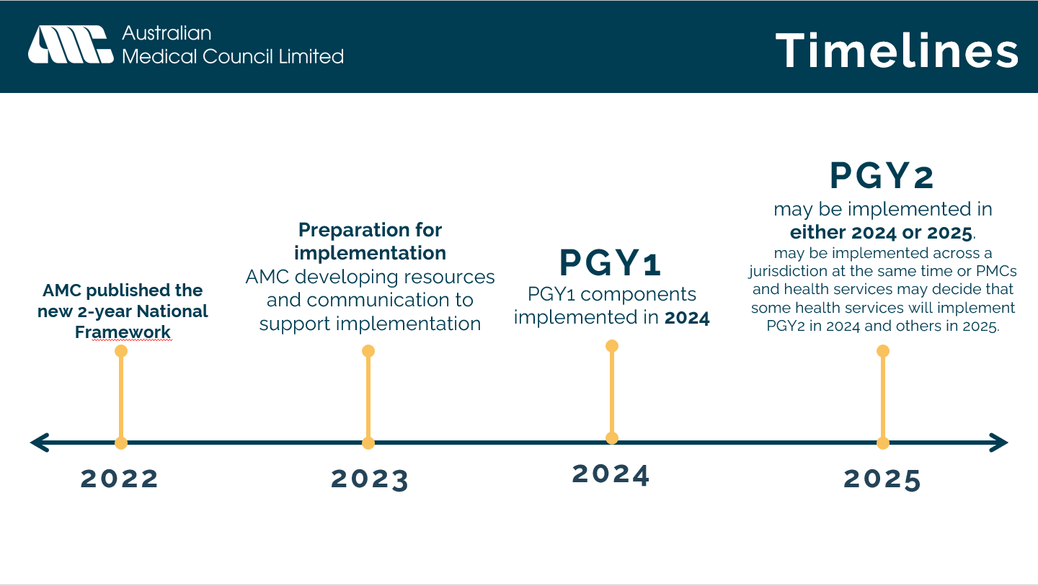 | Timeline and drivers of the revision of the National Framework:  - The AMC published the revised two-year framework in 2022.  - PGY1 components implemented in 2024.  - PGY2 may be implemented in either 2024 or 2025.  - may be implemented across a jurisdiction at the same time or PMCs and health services may decide that some health services will implement PGY2 in 2024 and others in 2025.
4 | 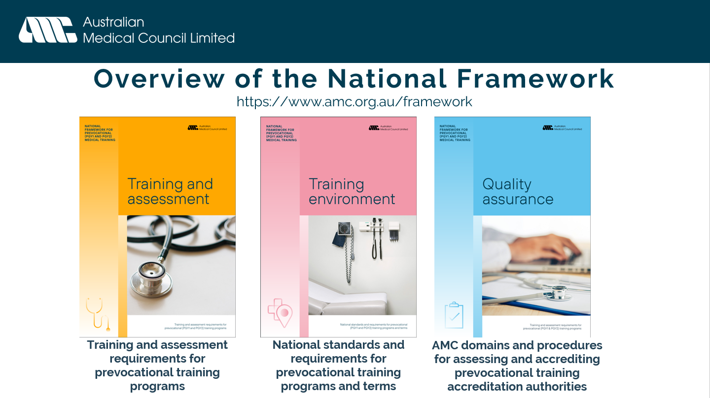 | The revised National Framework includes three documents:  - Training and assessment requirements for prevocational training programs  - National standards and requirements for prevocational training programs and terms  - AMC domains and procedures for assessing and accrediting prevocational training accreditation authorities
5 | 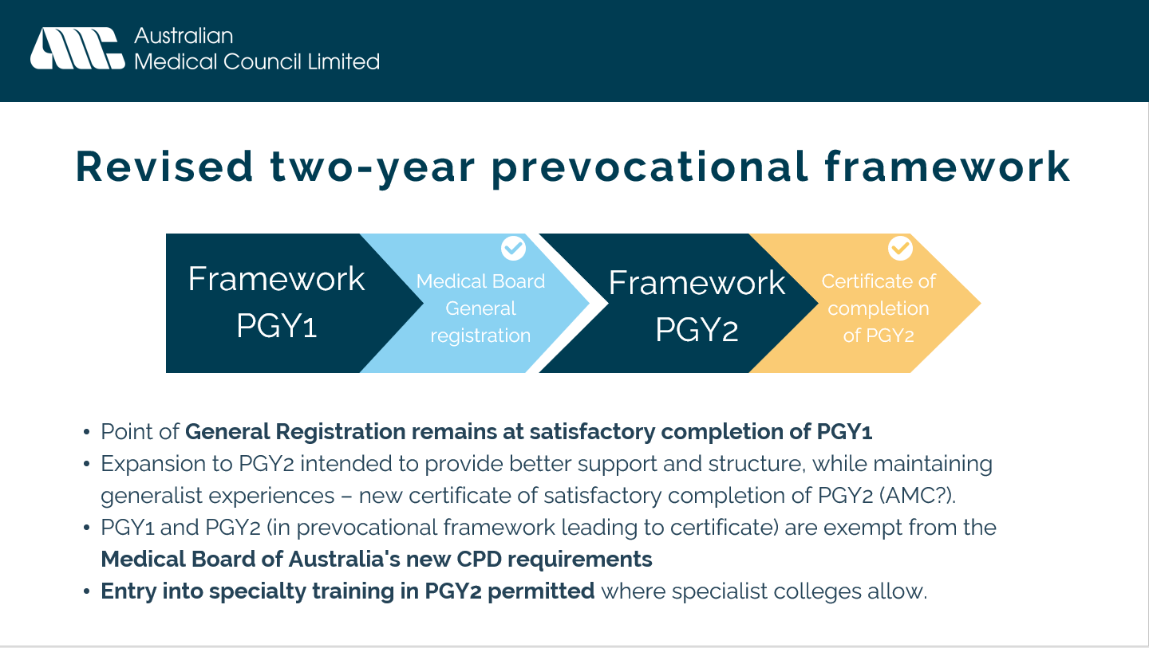 | Point of General Registration remains at satisfactory completion of PGY1.  Entry into specialty training in PGY2 permitted where specialist colleges allow.  Expansion to PGY2 intended to provide better support and structure, while maintaining generalist experiences.  PGY1 and PGY2 (in prevocational framework leading to certificate) will be exempt from Medical Board of Australia's new CPD requirements.
6 | 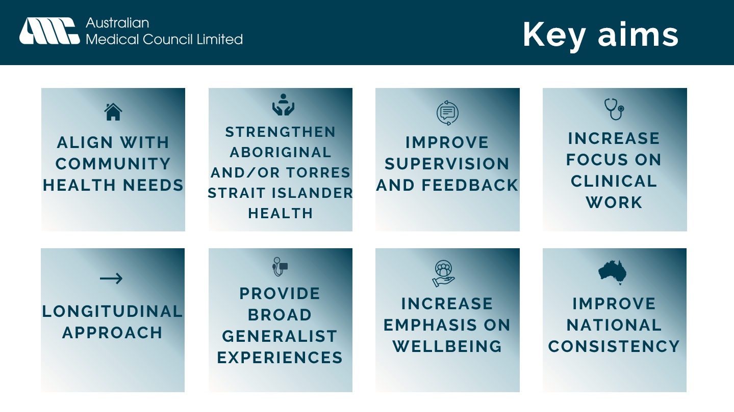 | Key aims of the Framework review.  Align with community health needs:  - Increased flexibility for learning in expanded settings new clinical experience categories focus of care types - inc. Chronic illness.  Strengthen Aboriginal and Torres Strait Islander health.  - New and strengthened outcomes and standards to promote the health & wellbeing of Aboriginal and Torres Strait Islander patients and doctors.  - Observable behaviours within the EPAs  Improve supervision and feedback.  - Revised standards regarding supervisor training and support  - EPAs emphasise observed practice and feedback discussions.  - Formalising the role of the registrar  Increase focus on clinical work.  - EPAs to anchor the prevocational years in clinical work.  - Clinical experience categories to identify the main thrust of the clinical work undertaken by a prevocational doctor within a term.  Longitudinal approach  - Expansion to PGY2  - Focus on programs rather than terms.  - Introduction of the e-portfolio, a tool to track progression overtime.  Provide broad generalist experiences.  - Increased flexibility for learning in expanded settings  - EPAs that can be undertaken in any clinical setting  - Program and term requirements to ensure breadth.  Increased emphasis on wellbeing  - Strengthened wellbeing standards.  - Revised improving performance process emphasising early identification and support.  Improve national consistency.  - Mandated national standards
Section 2: Overview of Framework sections and changes
7 | 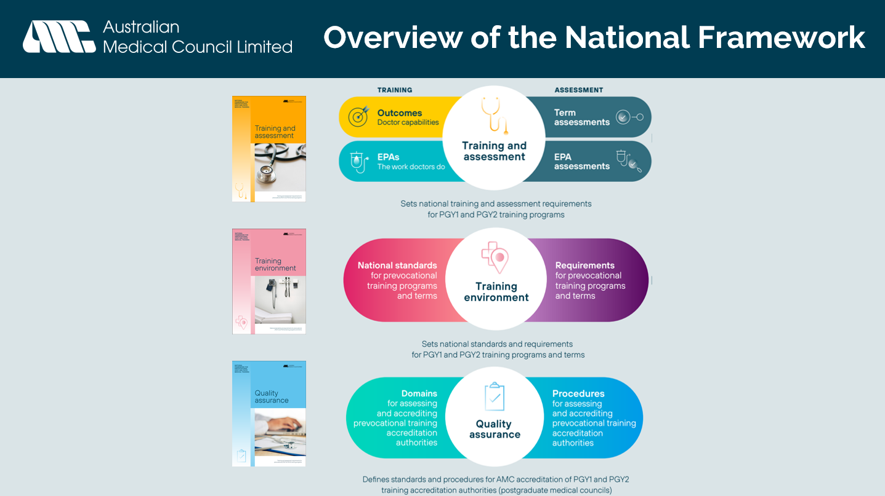 | This diagram shows a further breakdown of what sections are included within the Framework documents.  The following slides will look at each of these sections in a bit more detail.
8 | 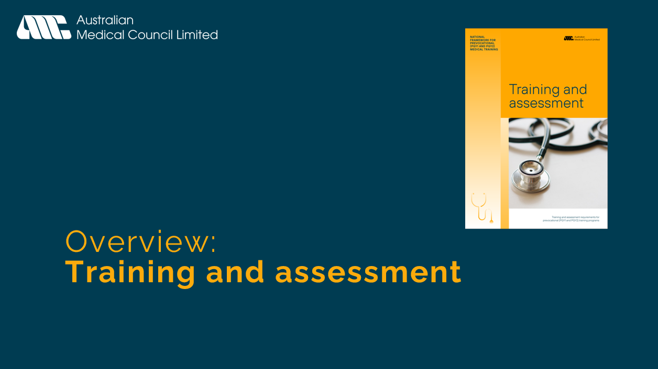 | Holding slide
9 | 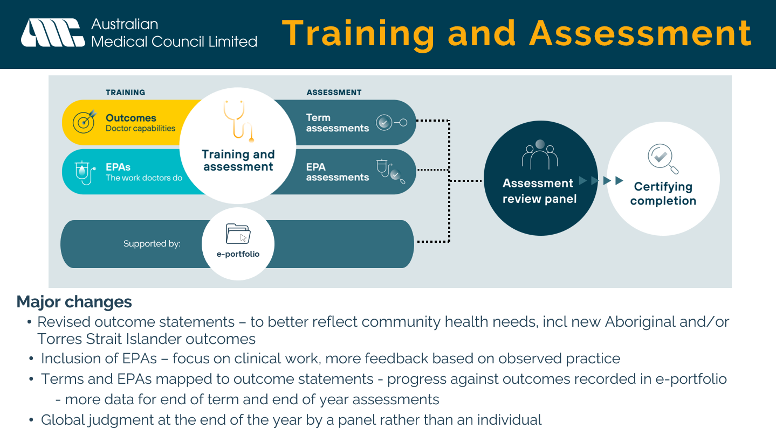 | Overview of Training and assessment  The training component comprises prevocational outcomes that describe the capabilities of the doctor, and the EPAs that describe the work prevocational doctors do.  The assessment component comprises mid and end of term assessments and EPA assessments.  Data points from assessment activities inform progression decisions in certifying completion of PGY1 and PGY2 made by the assessment review panel.  The training and assessment component is supported by the e-portfolio.  Major changes include:  - Outcome statements have been revised to better reflect community needs. New Aboriginal and Torres Strait Islander health related outcome statements have been included.  - The four existing Domains have been reordered to better reflect the work of PGY1 and PGY2 doctors – The prevocational doctor as a Practitioner is now Domain 1.  - Four new Entrustable professional activities (EPAs) have been introduced. The describe key work tasks of PGY1 and PGY2 doctors, they are mapped to the outcome statements and anchor the prevocational years in clinical work.  - Global judgment at the end of the year by a panel rather than an individual  Note: Items in this section are described in full in Training and assessment requirements for prevocational training programs
10 | 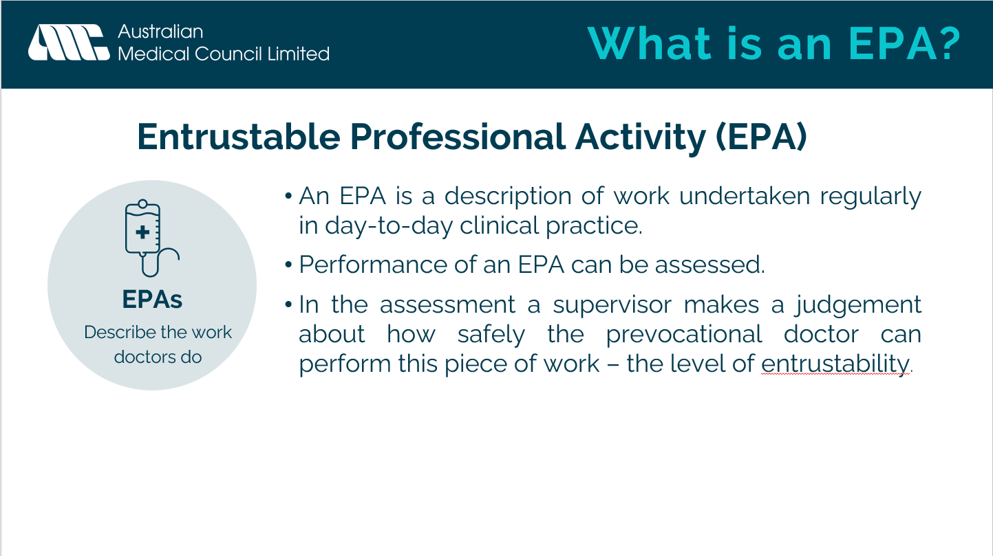 | What is an EPA?  An EPA is a description of work that you undertake regularly in your day-to-day clinical practice.  The EPA in itself is not an assessment; however, your performance of an EPA can be assessed.  In the assessment your supervisor makes a judgement about how safely you can perform this piece of work for example with minimal, proximal, or direct supervision – your level of entrustability.
11 | 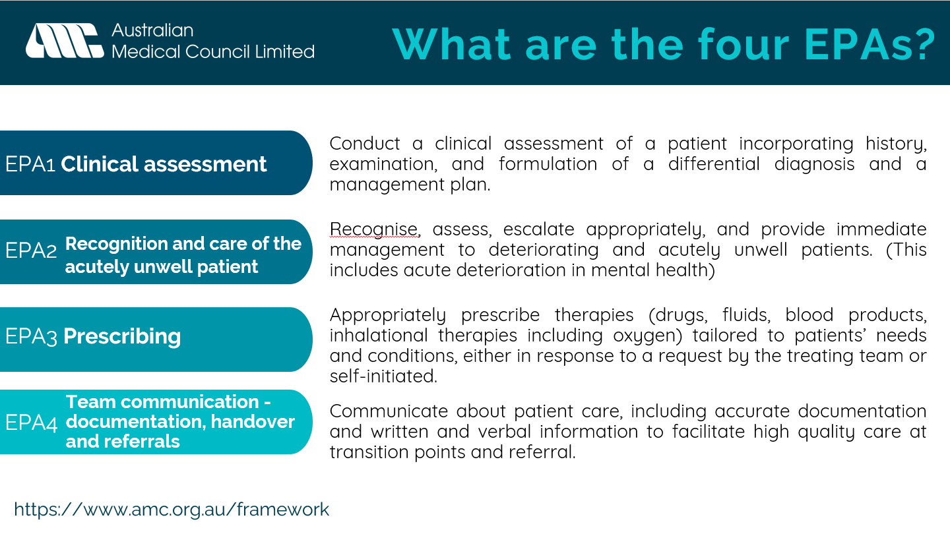 | What are the four EPAs?  - EPA 1 Clinical assessment: Conduct a clinical assessment of a patient incorporating history, examination, and formulation of a differential diagnosis and a management plan.  - EPA 2 Recognition and care of the acutely unwell patient: Recognise, assess, escalate appropriately, and provide immediate management to deteriorating and acutely unwell patients. (This includes acute deterioration in mental health)  - EPA 3 Prescribing: Appropriately prescribe therapies (drugs, fluids, blood products, inhalational therapies including oxygen) tailored to patients’ needs and conditions, either in response to a request by the treating team or self-initiated.  - EPA 4 Team communication - documentation, handover, and referrals: Communicate about patient care, including accurate documentation and written and verbal information to facilitate high quality care at transition points and referral.
12 | 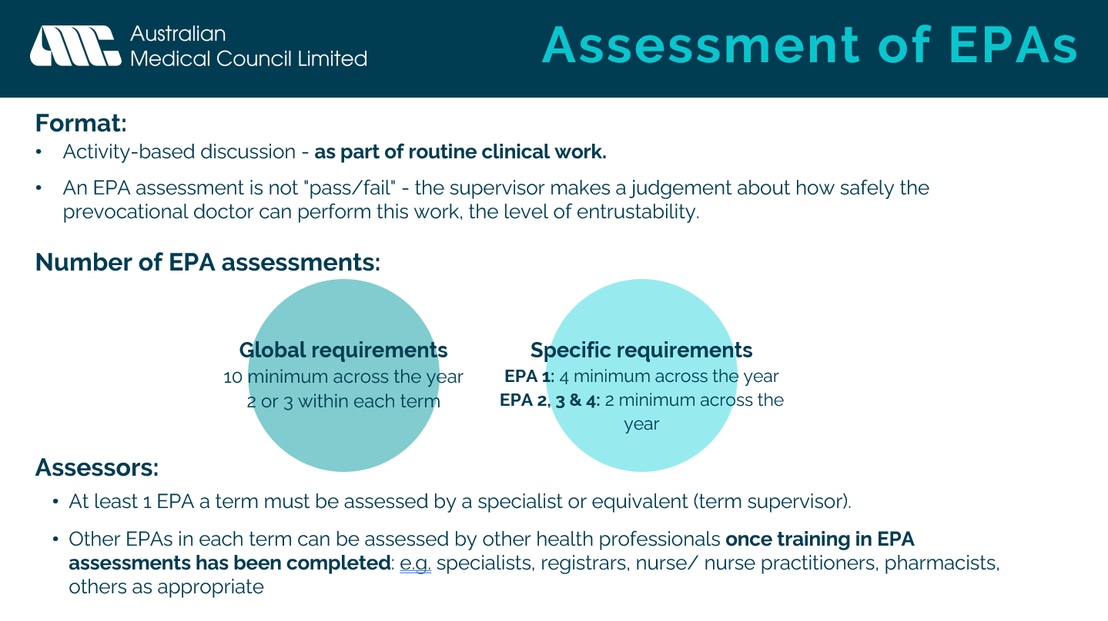 | Assessment of EPAs  - Format:  - The format of the assessment is an activity-based discussion as part of routine clinical work.  - An EPA assessment is not a “pass/fail” assessment. At the end of each year your health service’s Assessment Review Panel will make a global judgement on whether you have reached the required standard and achieved all the prevocational outcome statements. The panel will review the EPA assessments but there is no requirement to ‘pass’ a minimum number of assessments.  - Number of EPA assessments:  - Across the year you must complete a minimum of 10 EPA assessments.  - Within the term you must complete a minimum of 2 EPA assessments (1x EPA 1 and 1 or 2x EPA 2-4)  - Overall, you will complete a minimum of 4 assessments of EPA 1and two assessments of EPAs 2, 3 and 4 in each year.  - However, to improve your clinical skills you can complete as many EPA assessments as you would like throughout the year.  - Assessors:  - At least one EPA in each term must be assessed by a specialist or equivalent. Other EPAs in each term can be assessed by specialists, registrars, nurse/ nurse practitioners, pharmacists, or other health professionals as appropriate.  Note: EPA assessments are not a mandatory part of formal assessment in 2024. Some health services may choose to implement EPA assessments in 2024. Assessment of EPAs will become mandatory with the introduction of a national e-portfolio.
13 | 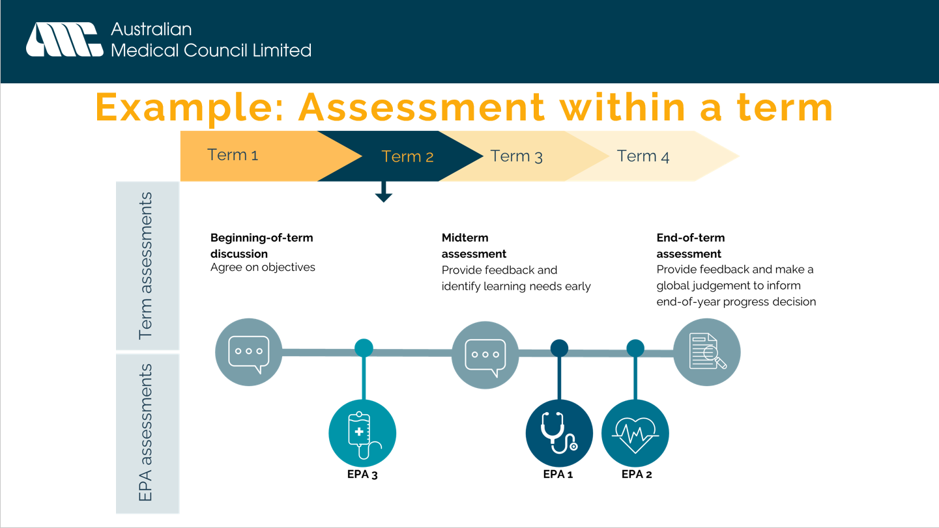 | For example, this is how assessment across one term may look:  - A Beginning-of-term discussion to agree on objectives within the term.  - An assessment of performance of EPA 3 – Prescribing  - A midterm assessment to provide feedback and identify any learning needs early within the term.  - An assessment of performance of EPA 1 – Clinical Assessment  - An assessment of performance of EPA 2 – Recognition and care of the acutely unwell patient  - An End-of-term assessment to provide feedback and to make a global judgement to inform the Assessment Review Panel’s end-of-year progress decision.  Note: EPA assessments are not a mandatory part of formal assessment in 2024. Some health services may choose to implement EPA assessments in 2024. Assessment of EPAs will become mandatory with the introduction of a national e-portfolio.
14 | 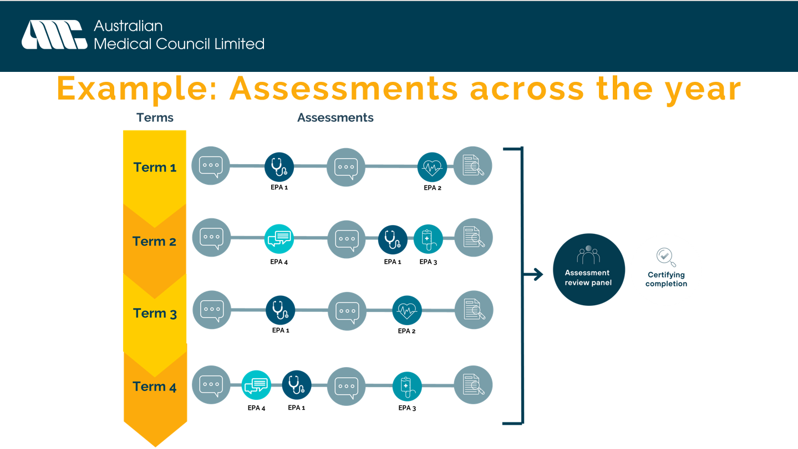 | The graphic on this slide is an example of how assessment might look across the year. Increased data points help inform a global judgement at the end of the year.  Note: EPA assessments are not a mandatory part of formal assessment in 2024. Some health services may choose to implement EPA assessments in 2024. Assessment of EPAs will become mandatory with the introduction of a national e-portfolio.
15 | 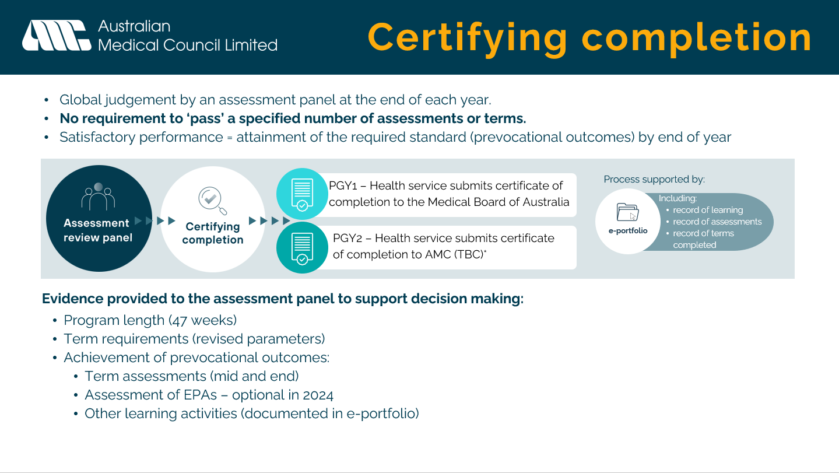 | New requirement for a global judgement by an assessment panel at the end of each year. Satisfactory performance is judged on attainment of the required standard by end of year rather than a requirement to pass a specified number of assessments or terms.  At the end of PGY1 the health service submits certificate of completion to the Medical Board of Australia  At the end of PGY2 the health service submits certificate of completion to AMC (process TBC)  Evidence provided to the assessment panel to support decision making includes:  - Program length (47 weeks)  - Term requirements (revised parameters)  - Completion of the outcomes  - Term assessments (mid and end)  - Assessment of EPAs  The assessment panel does not need to discuss all prevocational doctors in detail. To streamline the process, the panel might consider the evidence in varying levels of detail, depending on the outcomes of assessments.  The e-portfolio will support the certifying completion process
16 | 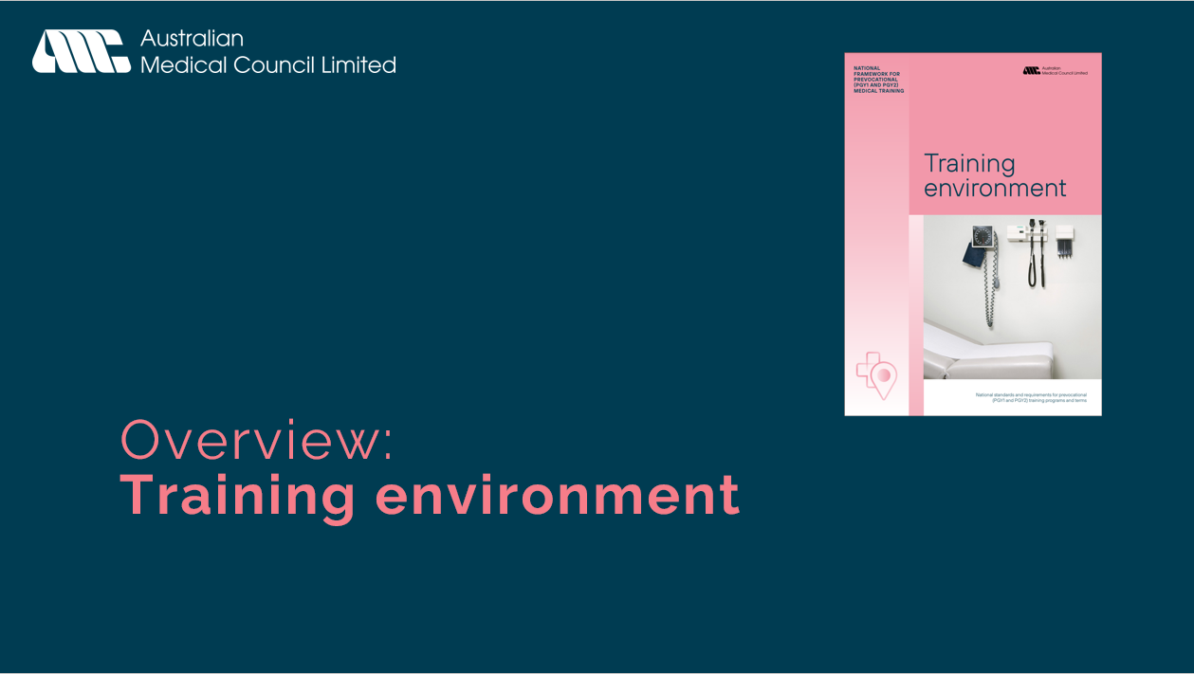 | Holding slide
17 | 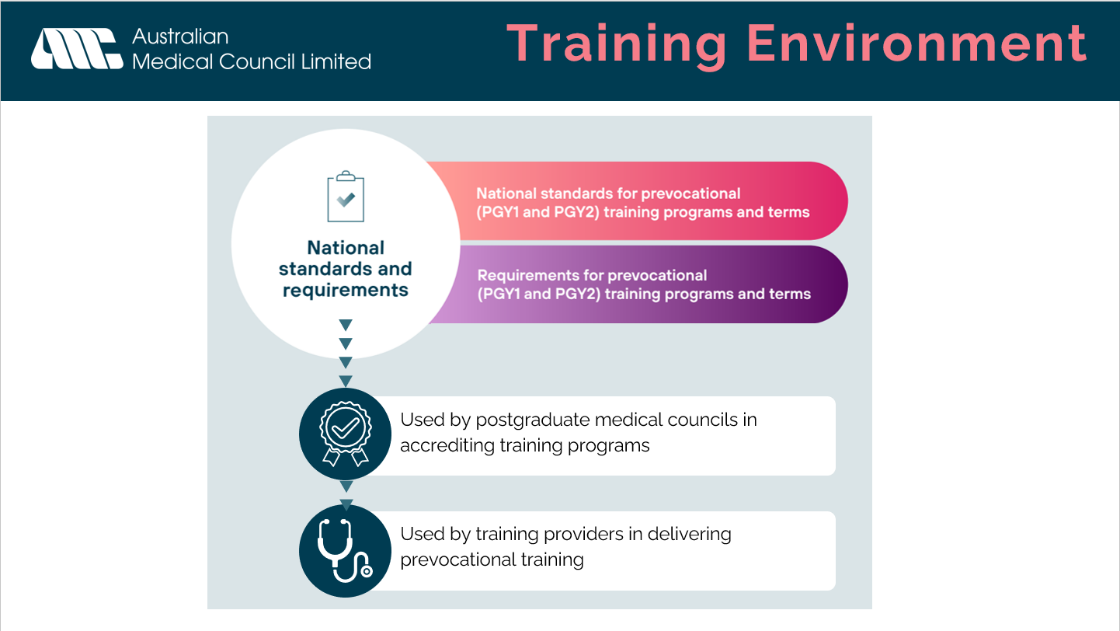 | The Training environment component comprises two main sections.  - National standards for prevocational training programs and terms  - Requirements for prevocational training programs and terms  This document is used by postgraduate medical councils in accrediting training programs and by training providers in delivering prevocational training.  Note: Items in this section are described in full in National standards and requirements for prevocational training programs and terms and AMC domains and procedures for assessing and accrediting prevocational training accreditation authorities
18 | 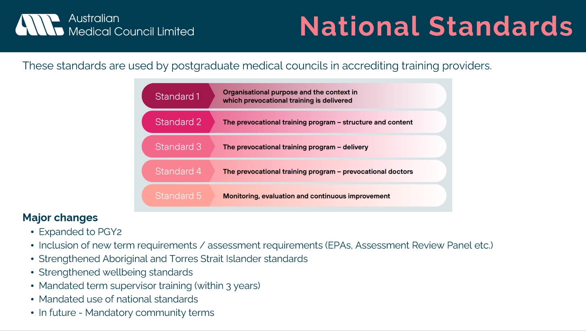 | The national standards are used by postgraduate medical councils in accrediting training providers.  Major changes include:  - Expanded to PGY2  - Inclusion of new term requirements / assessment requirements (EPAs, Assessment Review Panel etc.)  - Strengthened Aboriginal and Torres Strait Islander standards.  - Strengthened wellbeing standards.  - Mandated term supervisor training (within 3 years)  - Mandated use of national standards  - In future - mandatory community terms
19 | 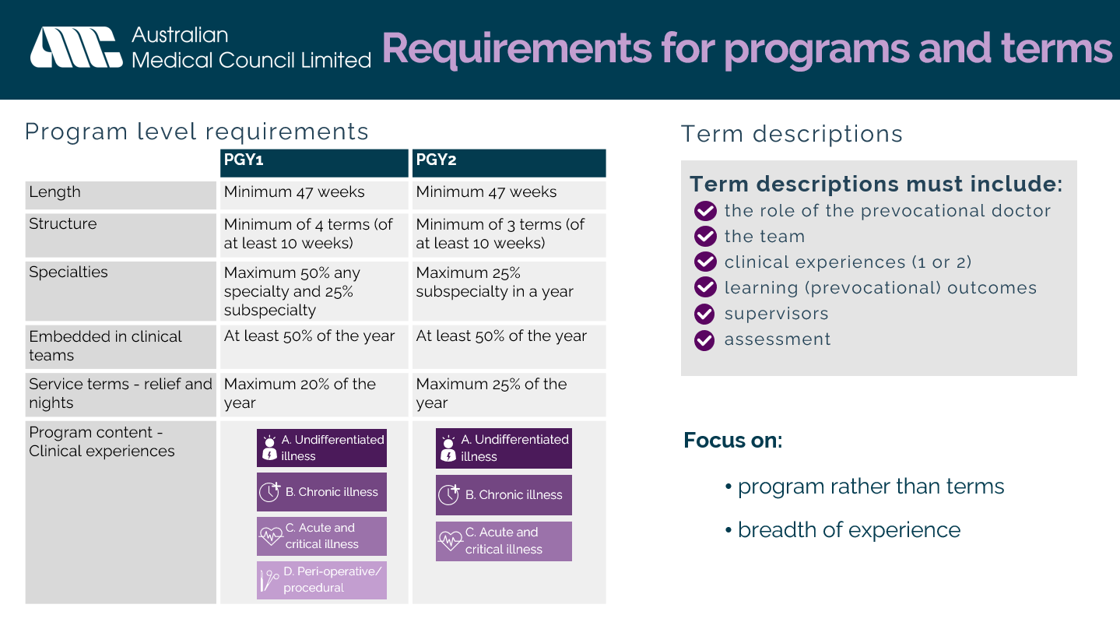 | Requirements for programs and terms  Focus has shifted to programs rather than terms; program and term requirements have been separated out.  New requirements that will ensure a breadth of experience, more flexibility, and a focus on quality of learning:  - Program length  - Structure (number of terms)  - Specialties. Note, definition of specialties can be found in the glossaries of the Framework documents.  - Embedded in clinical teams.  - Service terms – relief and nights. Note, definition of service terms can be found din the glossaries of the Framework documents.  - Program content - Clinical experiences. The primary focus of the clinical experience that the prevocational doctor is engaged with during the term. Only one or two clinical experience categories can be assigned to each term to ensure breadth across the program.  Term descriptions must define the term, the team, the role of the prevocational doctor, the clinical experiences and learning outcomes.
20 | 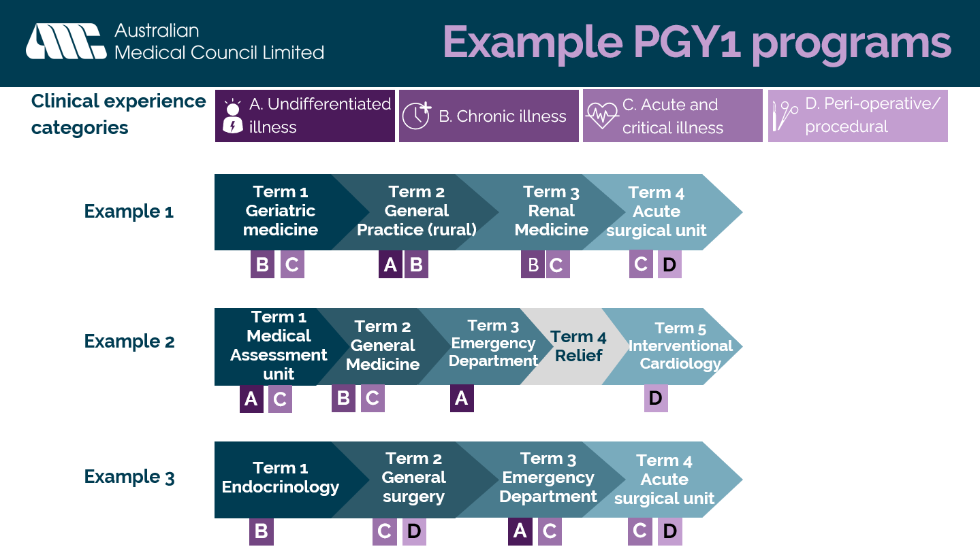 | Graphic provides examples of PGY1 programs and flexibility within National Framework  These examples may or may not be appropriate in every health service. All individual terms and programs need to be approved by the relevant PMC. Program and term requirements are not to be read in isolation; all example programs listed would have to meet all other requirements in addition to the clinical exposure requirements
21 | 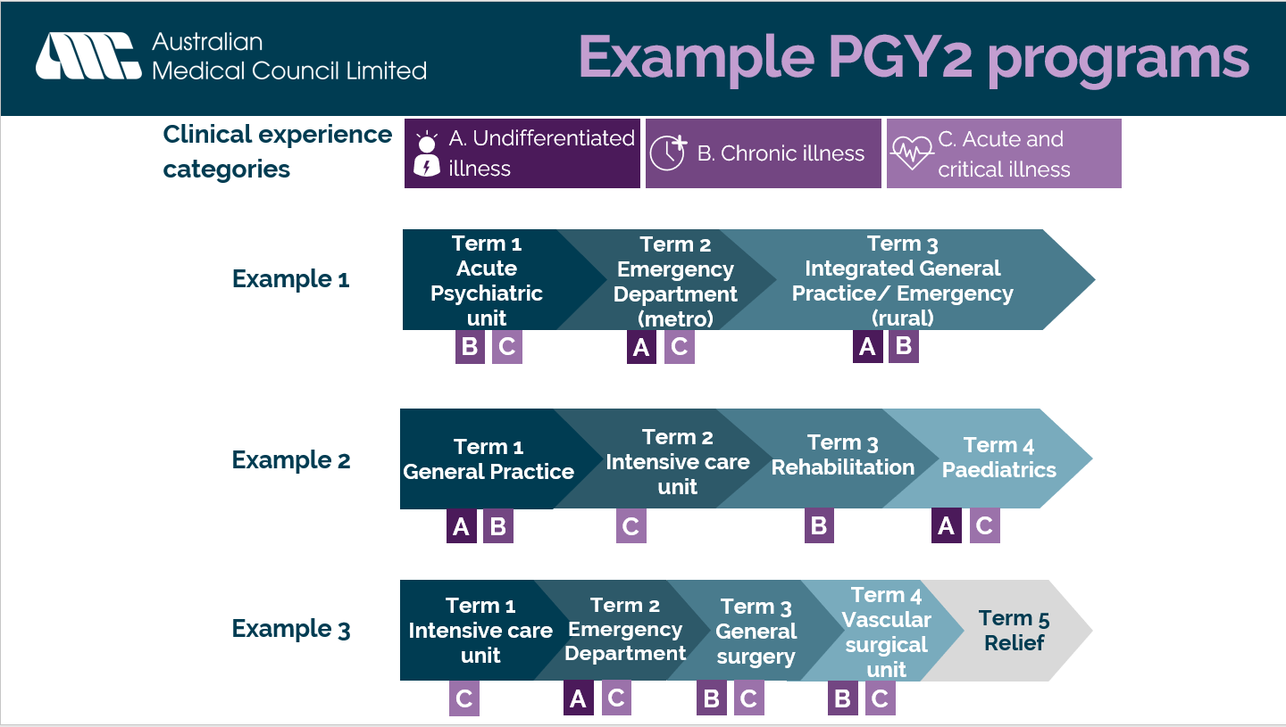 | Graphic provides examples of PGY2 programs and flexibility within National Framework  These examples may or may not be appropriate in every health service. All individual terms and programs need to be approved by the relevant PMC. Program and term requirements are not to be read in isolation; all example programs listed would have to meet all other requirements in addition to the clinical exposure requirements
22 | 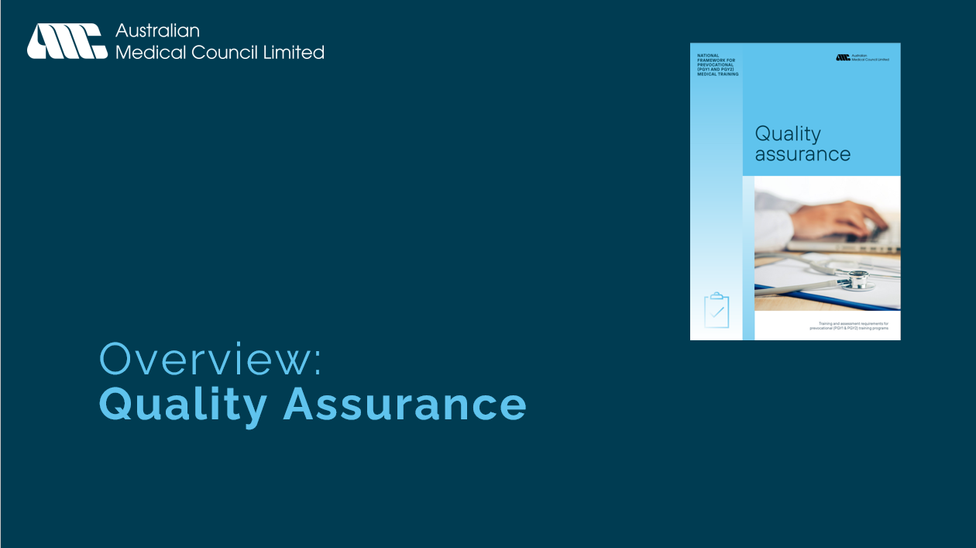 | Holding slide
23 | 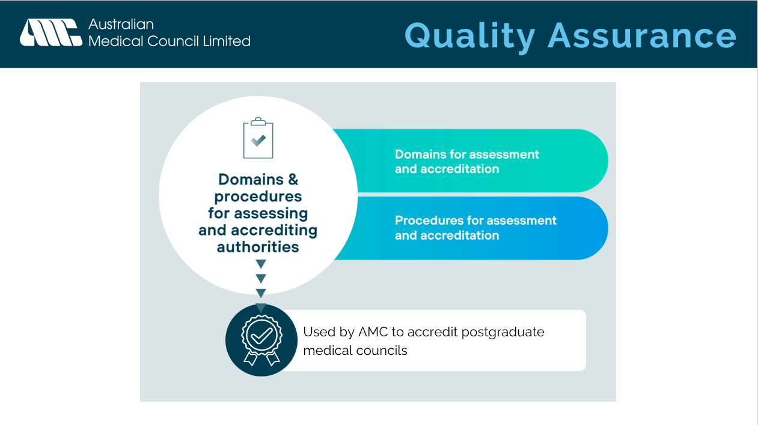 | The Training environment component comprises two main sections.  - Domains for assessing and accrediting prevocational training accreditation authorities.  - Procedures for assessing and accrediting prevocational training accreditation authorities.  This document is used by the AMC to accredit prevocational training accreditation authorities.  Note: Items in this section are described in full in AMC domains and procedures for assessing and accrediting prevocational training accreditation authorities
24 | 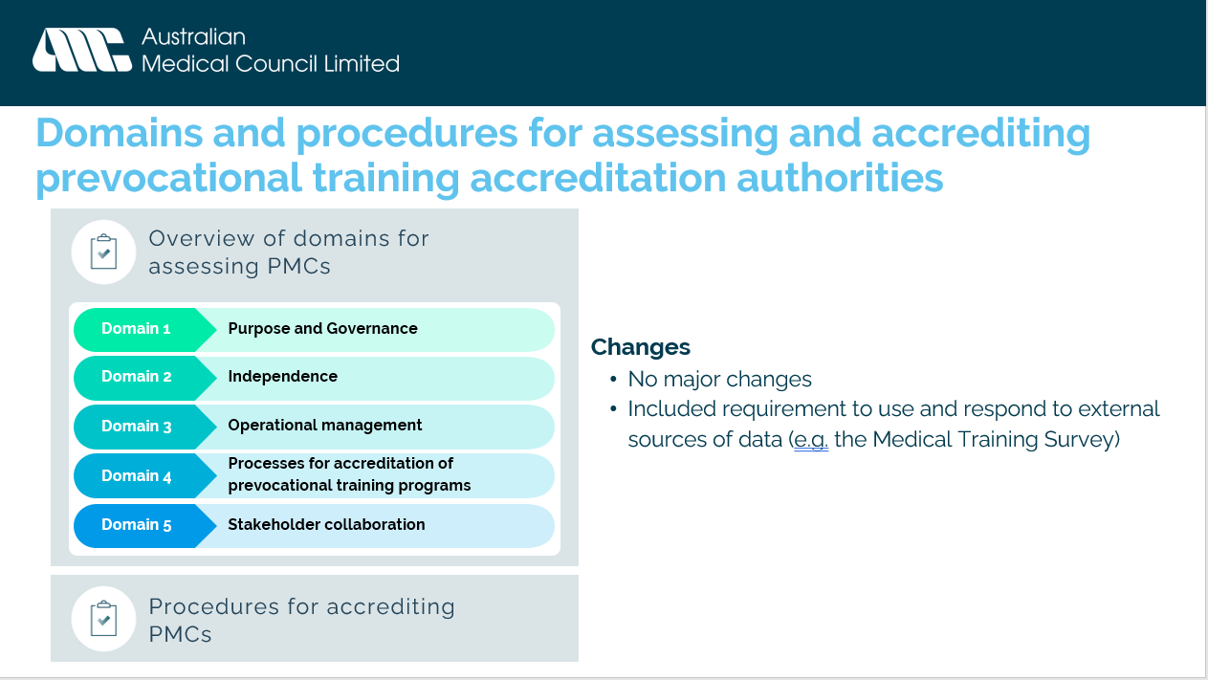 | No major changes were made to the Domains or the Procedures:  - New Domain “Purpose” combined with existing Domain 1 “Governance”.  - Included requirement to use and respond to external sources of data with the Medical Training Survey included as an example
25 |  | Holding slide
26 | 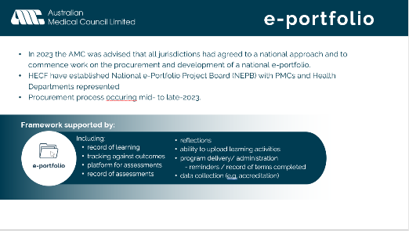 | The AMC was tasked by Health ministers to develop specifications for an e-portfolio to support the revised two-year framework.  During consultation periods there was strong stakeholder support for a national e-portfolio system.  In 2023 the AMC was advised that all jurisdictions had agreed to a national approach and to commence work on the procurement and development of a national e-portfolio.  HECF have established National e-Portfolio Project Board (NEPB) with PMCs and Health Departments represented.  Procurement process occurring mid- to late-2023.  The e-portfolio will support the revised Framework with several functions including:  - Tracking against outcomes  - record of learning  - platform for assessments  - record of assessments  - reflections  - ability to upload learning activities.  - program delivery/ administration  - record of terms completed.  - data collection
Section 3: Preparing for implementaion – available resources
27 | 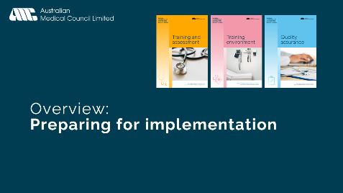 | Holding slide
28 | 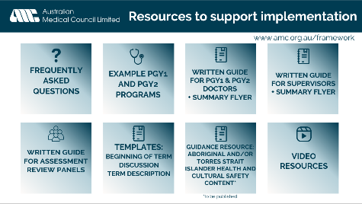 | This section of the presentation runs through resources that are available on the AMC website at www.amc.org.au/framework. This slide is an overview, some further details, and images of some of the resources are on the following slides, individuals may choose what resources they would like to go have a closer look at.  - Frequently asked questions (ongoing updates)  - Example PGY1 and PGY2 programs  - Written guides  - PGY1 and PGY2 doctors  - Supervisors  - Assessment review panels  - Aboriginal and/or Torres Strait Islander health and cultural safety content. This document is not yet published. This resource will provide:  - a comparison of the current and new/revised standards and outcomes  - example evidence that may illustrate meeting each standard, or a feature of training or assessment that may illustrate the meeting of each outcome.  - examples of existing initiatives along the medical education continuum that have been developed locally with strong consultation with Aboriginal and/or Torres Strait Islander stakeholders, which may assist in meeting particular outcomes or standards.  - This will be a ‘living document’, additional examples will be added to the list as the AMC is made aware of additional initiatives. Note: This list of examples is not intended to specify ‘best-practice’ in any way.  - Templates  - Beginning of term discussion  - Term description  - Video resources  - Introduction to the National Framework (~10:00)  - Introduction to the EPAs (5:30)  - Assessment requirements in 2024 (3:04)  - Roleplay videos of example EPA assessment scenarios to assist with EPA assessor training will be published in 2023.
29 | 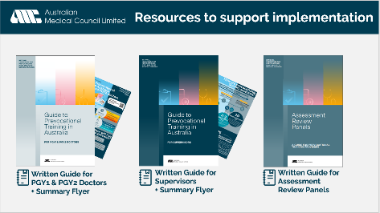 | Guides to prevocational training in Australia – one for PGY1 & PGY2 doctors, one for supervisors, both guides have an ‘at-a-glance’ flyer to communicate key information. These flyers can be viewed electronically or printed as posters.  Guide for assessment review panels – to assist health services in establishing a panel or repurposing an existing panel. Publication has been delayed slightly to ensure cultural safety content has been included appropriately. Will be published this month.
30 | 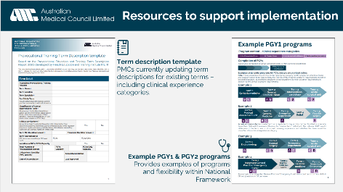 | Term description template – Not a mandated form, however some information within the form is mandatory to be tracked e.g., clinical experience classifications. In 2023, health services and PMCs are updating term descriptions for existing terms – including clinical experience categories.  Example PGY1 & PGY2 programs - Provides examples of programs that may or may not be appropriate in every health service. All individual terms and programs need to be approved by the relevant PMC. This document is intended as a guide to show the flexibility the revised Framework offers.
31 | 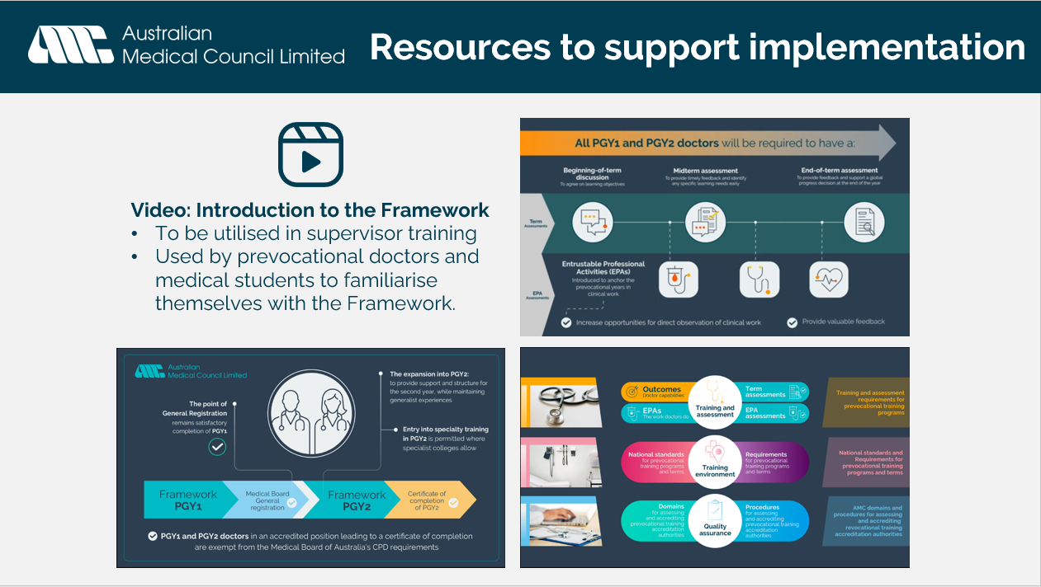 | Video: Introduction to the Framework (~10:00)  To be utilised in supervisor training  Used by prevocational doctors and medical students, or new supervisors to familiarise themselves with the Framework.  Includes an animated overview of the key components of the Framework, as well as some stakeholder perspectives about the opportunities the revised National Framework provides.
32 | 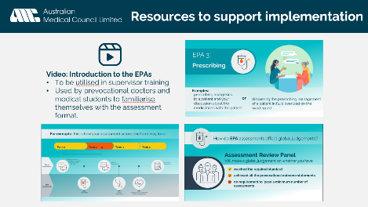 | Video: Introduction to the EPAs (5:30)  Covers what an EPA is, examples of each, how assessment looks across a term and how EPAs feed into global judgements of the assessment review panel.  This video could be utilised in supervisor training and/or used by prevocational doctors and medical students to familiarise themselves with the assessment format.
33 | 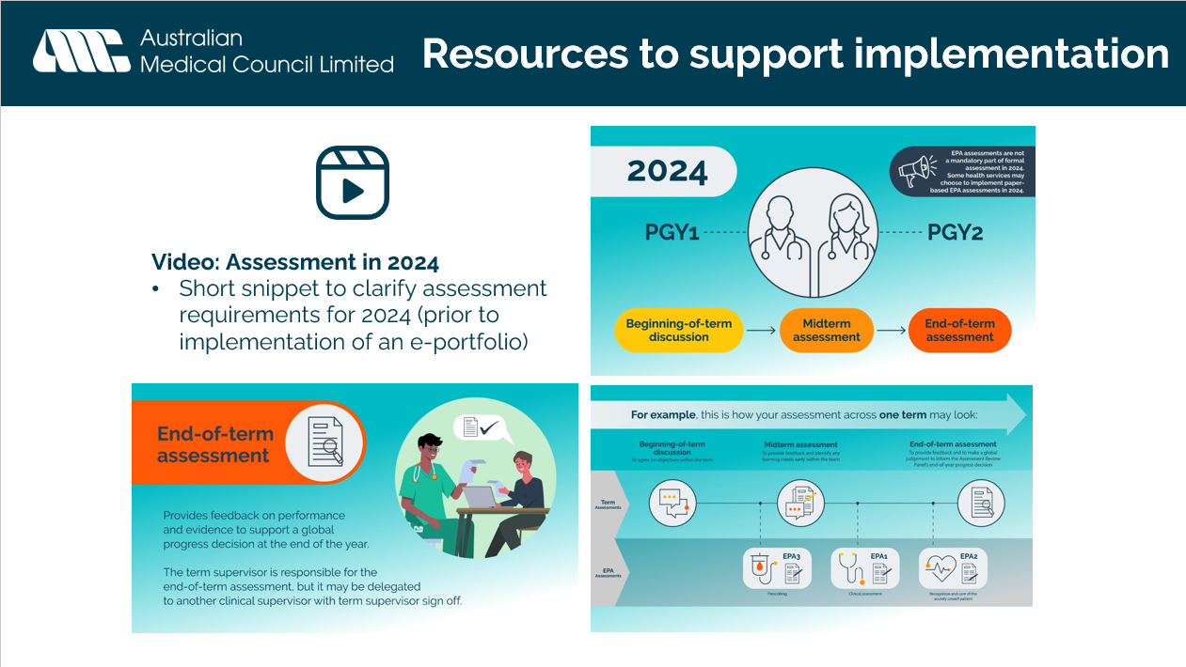 | Video: Assessment in 2024 (3:04)  Short video to clarify assessment requirements for 2024, prior to implementation of an e-portfolio.  To re-iterate, EPAs are not required as a formal part of assessment in 2024, some health services will conduct paper-based or electronic assessments on existing systems in 2024.
34 |  | Holding slide – questions.

